

CHANGING PLACES

DRAFT POLICY AND

GUIDANCE FOR CONSULTATION



|  |  |  |
| --- | --- | --- |
| Version Control | | |
| Version | Change | Date |
| 0.1 | Initial draft | 30 June 2020 |
| 0.2 | Minor updates | 29 Sept. 2020 |
| 0.3 | Minor updates from draft report meeting | 1 Oct. 2020 |
| 0.4 | Updated Changing Places numbers in NI and LCCC areas | 2 Oct 2020 |
| 0.5 | Minor updated formatting | 4 Oct 2020 |
| 0.6 | Terminology amended | 16 April 2021 |

**CONTENTS**

1. **Introduction**
2. **Background**
3. **Where should changing places facilities be provided**
4. **Legislative background**
5. **Matters to consider**
6. **Recommended approach for Lisburn and Castlereagh City Council**
7. **INTRODUCTION**

Whilst not yet a statutory requirement, the Councils Planning, Building Control Units and Community Plan should seek to promote and influence the provision of Changing Places Toilets amongst developers, its partners, and local businesses in relevant buildings across the Lisburn and Castlereagh City Council area.

This policy and guidance document sets out Lisburn and Castlereagh City Council’s commitment to providing Changing Places toilets (CPT) in public places in Council facilities and across the Council area. It should be read and considered in conjunction with all other relevant Council Policies e.g Safe Guarding Children and Vulnerable Adults Policy. We will also work with local partners and developers to influence and drive the Changing Places agenda forward and encourage others to install Changing Places toilets into buildings where reasonable. Changing Places toilets are necessary to meet the needs of many children and adults with disabilities, their families, carers/assistants and people with similar needs. The draft policy for consultation reflects the Council’s commitment to equality.

* 1. **Who is the Policy and Guidance for?**

This policy and guidance is for;

• People with disabilities, including children, and their families and carers/assistants

* Other people who require extra space, assistance or equipment to use toilet facilities; e.g. some older people or people with medical conditions

• Lisburn and Castlereagh City Council Elected Members and employees, in particular;

* Key decision makers
* People who design Council buildings or co-ordinate major refurbishment works
* Facilities management teams
* Service departments

• Partners, developers and other interested parties working with the Council

1. **BACKGROUND.**

Standard accessible toilets meet the needs of some people with disabilities – but not all. Research commissioned by Mencap has indicated that over 230,000 individuals in the UK need personal assistance to use the toilet or change, including for example people with profound and multiple learning disabilities, spinal injuries and individuals living with stroke.

Without appropriate facilities, carers are forced to change continence pads etc. on public toilet floors or wait until they go home. This is unhygienic, undignified and unacceptable.

A standard accessible WC is designed for independent use by an individual. Grab rails are located to the side and rear of the pan, aiding self-transfer between wheelchair and the WC. In some cases, a wheelchair user may be assisted, but there is usually insufficient room for two assistants. Standard accessible WCs are designed to facilitate access by a standard wheelchair, but are unlikely to accommodate a powered wheelchair, or those fitted with additional head or leg supports.

It is important therefore that individuals with profound, complex and multiple disabilities and impairments are able to safely, comfortably and hygienically spend time away from their home. Changing Places Toilets support this by providing sanitary facilities, with extra space and equipment that can be used by people who require the assistance of one or two carers/companions. As they are designed for assisted use they should supplement, not replace, standard unisex accessible toilets.

* 1. **What are Changing Places Toilets?**

Changing Places Toilets have a floor area of at least 3x4 metres with a ceiling height of 2.4 metres and provide a range of features including:

* Tracking hoist covering the whole room
* Adult changing bench which is adjustable and easy to clean
* Toilet with drop down support rails and 1m clearance each side (from centre of pan)
* (Optional) adjustable shower (hose to reach centre of bench)
* Adjustable height sink
* Privacy curtain/screen
* Alarm pull cords and reset button
* Comfortable temperature for undressing
* Welcoming and interesting decoration with visual contrast to highlight equipment, door frames and door handles

Typical Changing Places Toilet layout



The range of people who might use CPTs include:

* People with profound and multiple learning disabilities
* People with conditions that may affect their movement, including cerebral palsy, multiple sclerosis, motor neurone disease
* People with head injuries or severe spinal injuries
* People living with stroke
* Older people who require assistance
* People who are unable to transfer independently or have no sitting balance need additional facilities such as a ceiling track hoist to transfer between their wheelchair, the WC and an adult sized changing bench;
* People with multiple learning disabilities
* People who are doubly incontinent
* People who have total dependency on assistants.

Anyone who might require to use changing places needs access to facilities where they can be changed with dignity, and where assistants are able to use a hoist and other equipment to provide appropriate and safe care.

CP facilities also allow assistants to use the toilet, without leaving a person with disabilities unattended. This is not possible in standard toilet facilities which do not provide a privacy screen or enough space. A privacy screen must be included in all CPTs.

1. **WHERE SHOULD CHANGING PLACES FACILITIES BE PROVIDED**

BS 8300 recommends that CPT facilities should be provided in buildings and locations where large numbers of people may visit, such as major entertainment venues, as well as places people may visit for several hours at a time, such as schools or colleges.

A CPT facility should be provided in:

* major transport terminals or interchanges such as airports, large railway and bus stations
* motorway service stations
* sport and leisure facilities, including entertainment arenas, stadiums, large

hotels

* large theatres and multiplex cinemas
* cultural centres such as museums, concert halls and art galleries
* shopping centres, large retail developments and Shopmobility centres
* key public buildings within town centres such as town halls, civic centres
* principal public libraries
* educational establishments, including universities
* health facilities such as hospitals, health centres and doctors surgeries.

1. **LEGISLATIVE BACKGROUND**
   1. **Disability Discrimination Act 1995 (Northern Ireland)**

Under the Disability Discrimination Act (DDA), employers and service providers have the positive duty to make reasonable adjustments to policies and premises in order to provide people with disabilities access to goods, facilities, services or premises.

A service provider may need to change a practice, policy or procedure which makes it impossible or unreasonably difficult for people with disabilities to access their services. They may also have to make adjustments where a physical feature makes it impossible or unreasonably difficult for a disabled person to use a service.

The Equality Commission for Northern Ireland provides the following guidance on duties in relation to the provision of goods, facilities and services.

The DDA makes it unlawful for those providing goods, facilities or services to the public to discriminate against a disabled person for a reason related to their disability, in certain circumstances. It is unlawful for a provider of services to discriminate against a person with disabilities in:

* refusing to provide, or deliberately not providing, to a person with disabilities, any service which is provided to members of the public
* failing to make a reasonable adjustment which makes it impossible or unreasonably difficult for a person with disabilities to make use of any such service, and the failure cannot be justified
* the standard of service provided to a person with disabilities or the manner

in which the service is provided

* the terms on which the service is provided.

Public bodies in Northern Ireland have additional duties to promote equality of

Opportunity and Good Relations under Section 75 of the Northern Ireland Act 1998.

They must also meet duties under the Disability Discrimination Act to promote positive attitudes towards disabled people and to encourage the participation of disabled people in public life.

**4.2 Design guidance and codes of practice, British Standard (BS) 8300**

British Standard 8300:2018: Design of buildings and their approaches to meet the needs of disabled people, provides guidance on good practice for the design of new buildings and their approaches to meet the needs of people with disabilities. As a code of practice, this British Standard takes the form of guidance and recommendations.

The guidance in this standard covers a wide range of impairments and the use of the built environment by people with disabilities who may be residents, visitors, spectators, customers, employees, or participants in sports events, performances and conferences, and recommends that Changing Places toilets should be provided in larger buildings and complexes, such as previously mentioned in 3 above. It also provides information and guidance on installing Changing Places toilets.

**4.3 Building Regulations Northern Ireland**

Technical Booklet R 2012 – Access to and use of buildings Section 6, Sanitary accommodation, covers the provision of sanitary and changing facilities in dwellings and nondomestic buildings, Appendix A: Informative – facilities for people with profound and multiple learning disabilities, includes recommendations for changing places facilities:

“*People with profound and multiple learning disabilities, who require the help of up to two assistants, need a facility that is a combined toilet, shower and changing room. Such facilities require extra space to accommodate people, often using large wheelchairs having elevated leg rests, a reclining facility or integral oxygen cylinders, and space to fit slings for use with a hoist. It also needs to be possible for a wheelchair to remain within the facility when not in use without compromising the safe access and use of the equipment. A Changing Places toilet includes such extra space and facilities.”*

**4.4 Health and safety.**

One of the grounds capable of justifying less favourable treatment, and relevant to public Changing Places toilets, is that of health and safety. The Act states: “in any case, [where the less favourable treatment] is necessary in order not to endanger the health or safety of any person (which may include that of the disabled person)” (s.20).

There are clearly very real health and safety issues around the use of hoists and changing benches in public toilets. However, if a provider were to put forward such an argument, it would have to show that its health and safety argument was based on proper and well-informed risk assessment.

1. **MATTERS TO CONSIDER WHEN INFORMING A DECISION TO PROVIDE A CHANGING PLACES TOILET**

Over 1,450 Changing Places facilities have been installed across the UK and Ireland, forty-three sites in Northern Ireland; sixteen of these are located within the greater Belfast area; including four within the LCCC area (Island Civic Centre, HRP Hillsborough, Mobile Unit at RUAS Site and Highrise Sports and Activity Centre, Lisburn). A socially inclusive and equality conscious Lisburn and Castlereagh needs to consider the provision of accessibility for all visitors and residents.

Without Changing Places toilets, the person with disabilities is put at risk, and families are forced to risk their own health and safety by changing their daughter or son, other family members and friends on a toilet floor. This is dangerous, unhygienic and undignified.

It is now accepted and expected that everyone has a right to live in the community, to move around within it and access all its facilities. Government policy promotes the idea of ‘community participation’ and ‘active citizenship’, but for some people with disabilities the lack of a fully accessible toilet is denying them this right.

Although the numbers are increasing, there are still not enough Changing Places toilets. Providing these toilets in public places would make a dramatic difference to the lives of thousands of people who desperately need these facilities. As previously mentioned recent research by Mencap found that over 230,000 people in the UK with severe disabilities, including those with profound and multiple learning disabilities do not have access to public toilet facilities that meet their needs. There are around 40,000 people with profound and multiple learning disabilities, the majority of whom need Changing Places toilets. Many other people also have similar needs.

This means that almost a quarter of a million people in the UK will benefit from the increased numbers of Changing Places toilets. Their families and carers also need Changing Places toilets so they can go out in the community with their son or daughter, other family members and friends. If such toilets are provided, not only do people with disabilities have a level of provision comparable to other people (so that they can go out), the pressure on carers and families is also greatly reduced.

It should be accepted however, that not all buildings would require a Changing Places toilet to be provided. For example one facility within a larger shopping, entertainment centre or complex would suffice or a facility within a reasonable geographical area.

1. **Costs**

In a time when Councils are facing ever increasing pressures on its finances, cost is always a factor that needs to be carefully considered but this should not be the only consideration. Refer to Appendix 2 for typical cost information.

1. **Investment priority & community benefit**

The projected frequency of use should inform the context of investment and priority. Public need should always be considered in conjunction with the reasonable expectation of facilities, practicalities of provision and expenditure.

1. **Benefits that Changing Places could bring for the Council**

There are many benefits that a Changing Places toilet could bring to the Council and its wider area and some of these include:

* **Increased Revenue** – Quick example and calculation of increased revenue: If our facilities include a quality Changing Places this could potentially attract say 50 new customers to our business, if they visited three times a year and spent an average of £100 per visit and if the customer retention was 5 years that would be a total of an extra £75,000 of extra revenue.  This gives you some idea of the positive impact this could have by simply having the correct facilities.
* **Extra USP.**By installing a Changing Places the Council can demonstrate its care for the disabled, and stand head and shoulders above its competitors and marketing point.
* **Increase our market size**. By opening our facility up to a bigger market, we have more opportunity if increasing revenue.
* **Referrals** – Customers talk! Persons with additional needs are no different, they will often speak with others about their experience at our facilities and make recommendations. Make sure we are spoken of positively.
* **Lifetime Value** of loyal customers that enjoy the benefits of our facilities.
* **Compliance.**Apart from all of the above, you also have a statutory duty under the DDA to ensure our premises are accessible. Don’t be in the news for the wrong reasons!
* **Customer Benefits.** A Changing Places toilet can give people with disabilities a new-found freedom as they are able to stay away from home longer, knowing that they can visit a safe, hygienic toilet.
* **Industry Benefits**. Thousands of businesses across nearly every sector in the UK could benefit from installing a Changing Places toilet. Benefit from an increased good reputation, more visitors and boosted profits.
* **The Purple Pound**. The ‘purple pound’ is combined spending power of people with disabilities in the UK. At last estimate, it has a value of £212 billion in the British economy. This represents a huge amount of new custom for UK businesses – at least for those that are accessible to disabled people, including those with profound or severe disabilities.

1. **Location of facilities**

When considering the need for a CPT be aware that not every building or premises will require one to be provided. Consider if other CPT facilities are nearby within reasonable walking distance for example; or a public hub available centrally e.g. within a large shopping complex. Have a clear rationale for your decision.

1. **Management and maintenance of facilities**

How the facility will be managed and maintained after installation needs to be considered at the outset of any proposal to install a Changing Places toilet. It is likely that costs will be incurred in terms of cleaning and maintenance e.g. of hoist systems, and this may have financial implications if not considered early on. Generally, management and maintenance responsibilities will lie with the Site Operators facilities management team for that establishment, as it does for other equipment and cleaning regimes.

Removal of sanitary waste will need to be programmed in, as will refill of specialist equipment such as the wide tear off paper roll.

Training should be given to staff in the establishment on how and when to put the hoist in the charging position, how to identify any problems with the facility and who to contact in the event of a problem/fault reporting procedures.

Staff working in the building in which the Changing Places is located should not need to be trained on the actual use of equipment – if people wish to use the facility and the equipment within it but are unsure about how to use it, they should be advised not to use it at all.

1. **RECOMMENDED APPROACH FOR LISBURN AND CASTLEREAGH CITY COUNCIL**

Following the publication of the results on Consultation on Introduction of Provisions for Changing Places Toilets within building regulations, undertaken by the Scottish Government, responses indicated overwhelmingly that introduction of provision of CPTs through building regulations is seen as beneficial, both in increasing the number of facilities and in raising awareness of the need to consider such facilities in similar existing buildings.

The Finance Minister (Northern Ireland Assembly) in June 2020, has confirmed his commitment to including the need for CPT into NI Building Regulations. In the absence of more defined local regulation it is recommended that Lisburn and Castlereagh City Council adopts the following triggers when assessing the need for Changing Places Toilets within its own building ownership. Were the Council is not the building owner it should endeavour to adopt an influencing role and encourage facility owners or developers to provide a Changing Places toilet within the guidance triggers suggested.

Provision of a CPT should be in addition to, not instead of the provision of standard and accessible sanitary accommodation. A CPT should be located to provide easy access for users, taking into account factors such as security or payment barriers and the access route to and within the building.

**New Construction**

Subject to subsequent statutory provision that may be introduced over time a Changing Places Toilet should be provided were reasonable on construction of:

1. A retail building (shop), assembly building or entertainment building, or a building combining any of these uses, ***this would include Council facilities that incorporate these functions****,* sport and leisure buildings which:

* is over 5,000 m²; or
* has a capacity of more than 1,000 persons; or
* contains a swimming pool; or

b) A hospital; or

c) A secondary school providing community facilities.

**Conversion or Extension**

Where a Changing Places Toilet is not already present within a building, one should be provided if it is reasonable and practicable to do so: where a building in any of the above categories is created by conversion or where such a building is extended such that its gross floor area increases by 25% or more and its floor area exceeds. 5,000m².

**Layout and facilities**

A CPT should provide adequate space to allow a user to be assisted by carers. It should be a minimum of 3 m wide by 4 m long, with a minimum ceiling height of 2.4 m and a door with a minimum clear opening width of 1 m. **Refer to Appendix 1**.

Floor surfaces should have a non-slip finish. The room should include the following sanitary facilities and fixtures:

* a peninsular WC;
* a height adjustable wash hand basin;
* a ceiling-mounted tracking hoist;
* a height adjustable adult sized changing bench (minimum length 1.8 m);
* a retractable privacy screen;
* grab rails to assist in use of facilities;
* a call assistance system; and
* within a building that includes other changing facilities for users, such as swimming pools/leisure centres, the provision of a wall-mounted shower and floor drainage

Coat hooks, mirrors, toilet paper dispensers and other fixtures that may further assist in the use of accessible sanitary accommodation are outside the remit of the building standards.

Further information to assist in the planning, layout and delivery of a CPT can be found at the website of the Changing Places Consortium ( [www.changingplaces.org](http://www.changingplaces.org) ) and within BS 8300-2: 2018.

There may be some buildings which are relatively small in size, but which have substantial visitor numbers and therefore might justify provision of a Changing Places toilet. In these cases, visitor numbers might be a better metric for consideration as a trigger.

Where the space required for a full Changing Places toilet is not available or the cost is prohibitive due to potentially extensive building works to create the additional space, a smaller-sized one could be provided where achievable. It is proposed that an alternate of a minimum 3m by 3m (9m2) Changing Places toilet with a door with a minimum clear opening width of 1m and a minimum ceiling height of 2.4m.

A differentiated approach with a mix of triggers (including size, capacity and visitor numbers) depending on the type of building is proposed: as using only a size trigger could exclude certain buildings which should include Changing Places toilets.

When deciding where a Changing Places Toilet is to be provided a number of areas need to be considered.

* 1. Efforts to develop Changing Places will be focused on areas of high need, as identified in a Health Impact Assessment.
  2. Address the Councils Section 75 statutory duty as appropriate.
  3. Address the Councils Rural Needs statutory duty as appropriate.
  4. The financial impact of including Changing Places facilities.
  5. The reasonable and practicable impact of including Changing Places facilities.
  6. Economic Impact
  7. Community Benefit
  8. Triggers

**Remember**

In the absence of Changing Places facilities, people with disabilities and/or carers face:

* limiting what they drink to avoid needing the toilet when they are out – risking dehydration and urinary tract infections;
* sitting in soiled clothing or dirty nappies until a suitable toilet is found or they return home;
* having to change a loved one on a dirty toilet floor;
* manually lifting someone out of their wheelchair – risking safety
* reducing their time out of the house – restricting their social lives

**REFERENCES**

Changing Places: the practical guide has been produced by The Changing Place Consortium further details can be found at:

<http://www.changing-places.org/LinkClick.aspx?fileticket=YEDKVYyX8TE%3d&tabid=38>

Legal framework concerning provision of Changing Places public toilets Factsheet (Changing Places Consortium)

<http://www.changing-places.org/portals/0/documents/legal/Changing_Places_legal_factsheet.pdf>

The Building Regulations (Northern Ireland) 2012 – Technical Booklet R

British Standard 8300:2018: Design of buildings and their approaches to meet the needs of disabled people

**Appendix 1.**

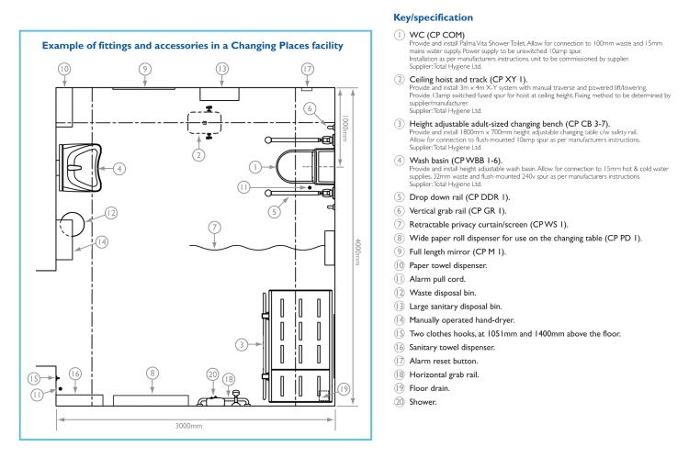

**Appendix 2**

**Introduction to Costs**

Estimated equipment costs for a Changing Places toilet can vary but are in the region of between £12,000 - £17,000 including VAT. However, equipment costs will vary depending on the specific equipment chosen. This Policy does not purport to give definitive cost advice for the whole Changing Places toilet because other costs involved will vary depending on the venue.

For example:

* building costs if structural changes need to be made to an existing building
* maintenance costs
* security costs.

It is cheaper to include Changing Places toilets at the planning and design stage as this will remove the need for structural changes to an existing building.

BSD commissioned the Building Research Establishment to undertake research in 2012 on Changing Places Toilets. The research covered the estimated costs for the inclusion of a CPT in different building types and was updated for Q4 2018. The research concluded that the cost is relative to the type of building. Accordingly, the costs vary and were established as:

* Allowance of £15,000 for external drainage, plumber work and water supply (for all building types)
* Allowance of £15,000 for equipment (for all building types, 2020 figures)
* Cost per square metre of floor area, dependant on building type, examples being:

|  |  |
| --- | --- |
| * Retail (unit) | £ 1,100 m 2 |
| * Leisure | £ 1,350 m 2 |
| * Retail (Mall) | £1,650 m 2 |
| * Education | £ 1,850 m 2 |
| * Health (hospital) | £ 2,300 m 2 |

Based on estimated costs undertaken by the Councils Assets Unit for a number of scenario options,

* The overall capital cost for the proposed additional sanitary accommodation may fall in a range from £41,700 (retail unit) to £56,100 (hospital) Costs on average £50,000 per installation in new build properties (dependant on building type).
* CPT within an existing building. Estimate is based on converting an existing room within a building to a changing places room and assumes that there are no structural alterations to be made. The cost of providing this is estimated at £29,400 (2020).
* Stand-alone traditional build changing room. The cost of providing this fully operational building is estimated at £124,800 (2020).
* Stand-alone traditional build changing room with separate male and female accessible disabled toilets. The cost of providing this fully operational building is estimated at £171,800 (2020).
* Cost of a modular self-contained standalone facility with separate male and female accessible toilets. The cost of providing this fully operational building is estimated at £128,370 (2020). See Appendix 3 example modular unit.
* Cost in operation – It is estimated that annual operational costs, including maintenance, servicing, cleaning and allowance for replacement of equipment (£12,000 - 12 year life) and sanitary facilities (£1,500 - 20 year life) would be approximately £2,500.

Note cost estimates should be considered according to the specific circumstances at the time of the project inception.

**Appendix 3.**

**Sample Changing Places Stand-alone Toilet Plan**

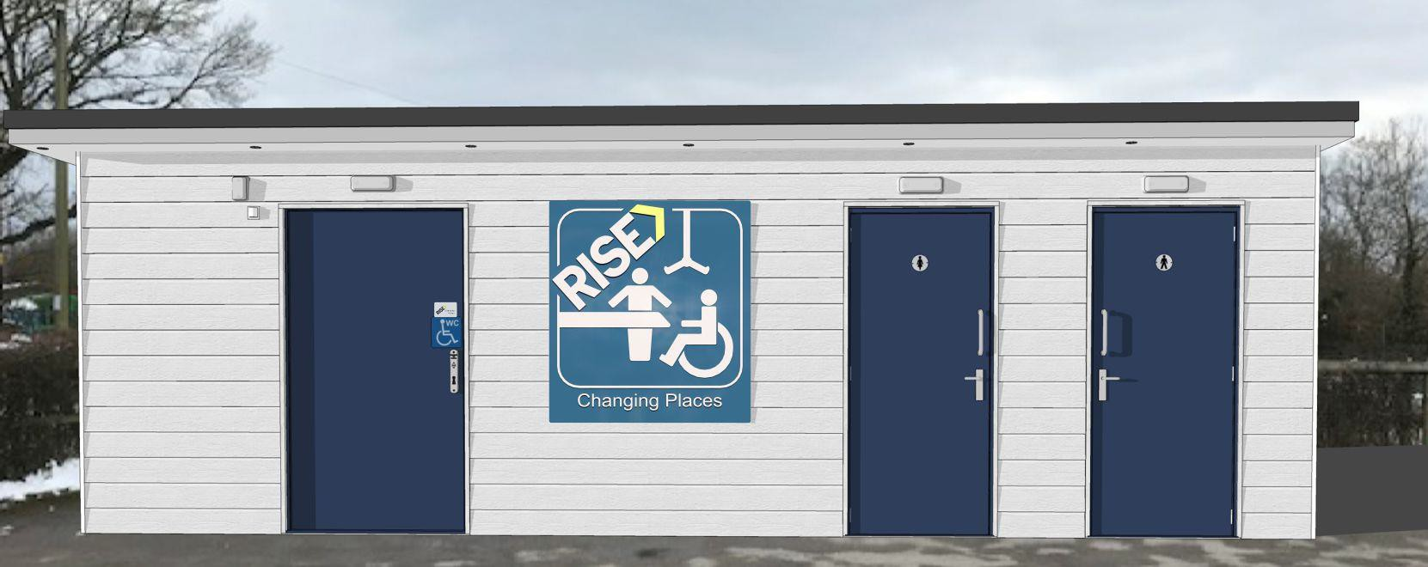



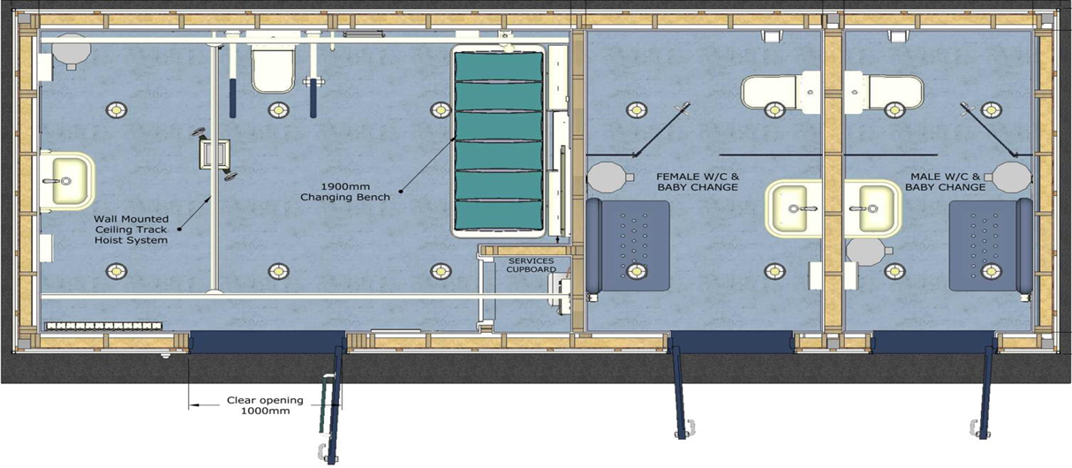

|  |  |  |
| --- | --- | --- |
| **EQUIPMENT SPECIFICATION** | | |
| X1 | Wc with lever flush | |
| X2 | Drop down hinged rails | |
| X4 | Vertical grab bars x4 horizontal | |
| X1 | Thermostatic basin mixer | |
| X2 | Robe hooks | |
| X1 | Alarm with pull cord & reset button | |
| X1 | None slip safety flooring | |
| X1 | Ceiling mount full room cover H rail system | |
| X1 | Powered hoist on hard wired control | |
| X1 | Height adjustable wash hand basin | |
| X1 | Full height wall mounted mirror | |
| X1 | Radar key entry system | |
| X1 | Rise and fall height adjustable bench | |
| X1 | Toilet roll dispenser | |
| X1 | Liquid soap dispenser | |
| X1 | Automatic hand dryer | |
| X1 | Large paper towel dispenser | |
| X1 | Paper towel dispenser | |
| X1 | Large waste bin | |
| X1 | Changing place W/C sign | |
| X1 | Timed heater | |
|  | **Female W/C 1880 x 3000mm internal** | |
| X1 | Close coupled pan cistern and seat cover | |
| X1 | Basin with semi pedestal with frame | |
| X1 | Liquid soap dispenser | |
| X1 | Paper towel dispenser | |
| X1 | Waste bin | |
| X1 | Timed heater | |
| X1 | Toilet roll dispenser | |
| X1 | Baby changing bench | |
| X1 | Cubicle doors | |
| X1 | Single tap soft touch timed flow | |
|  | Male W/C 1500 x 3000mm internal | |
| X1 | Close coupled pan cistern and seat cover | |
| X1 | Basin with semi pedestal with frame | |
| X1 | Single tap soft touch timed flow | |
| X1 | Liquid soap dispenser | |
| X1 | Baby changing bench | |
| X1 | Paper towel dispenser | |
| X1 | Cubicle doors | |
| X1 | Timed heater | |
| X1 | Toilet roll dispenser | |
| X1 | Waste bin | |
| **CHANGING PLACE BUILD SPECIFICATION** | | | |
| ***DETAIL*** | | | ***SPECIFICATION*** |
| Roof | | | EPDM Firestone rubber roof |
| Internal walls | | | High impact 10mm multi panel |
| External finish | | | Clad weatherboard |
| Internal flooring | | | Poly safe Hydro anti slip flooring |
| Lighting | | | LED / PIR emergency flush mounted down spotlights sensor |
| Lighting | | | Canopy lighting |
| Heating | | | Controlled fan heater |
| Extraction | | | TX6WL wall fan with PIR and overrun timer set for 20 mins.) |
| Services | | | From existing |