Bristol City Council, North Somerset Council and South Gloucestershire Council
and
NHS Bristol, North Somerset & South Gloucestershire CCG

Commissioning Strategy

Special Educational Needs and Disability (SEND) Information, Advice and Support Service (IASS) 2023-2026

Contents
1. Background 4
2. Legal and Policy Context 4
2.1 The Legal Context: 4
2.2 The Policy Context: 4
2.2. Bristol: 4
Bristol Corporate Strategy 2022-2027 4
Bristol’s Belonging Strategy for Children and Young People 6
Bristol Joint Commissioning Strategy 8
2.2.2 North Somerset: 8
North Somerset Corporate Plan 2020-24 8
North Somerset SEND Strategy 10
SEND Coproduction Charter 10
Education Provision in North Somerset, a Commissioning Strategy 2021-2024 11
2.2.3 South Gloucestershire: 11
South Gloucestershire Council Plan 2020-24 11
SEND strategy 2018-23 13
3. Current SEND Information, Advice and Support Service 14
3.1 The Bristol Context; Funding 14
3.2 The North Somerset Context; Funding 15
3.3 The South Gloucestershire context; Funding 15
3.4 Current Provision 16
4. Needs Analysis 16
4.1 Children and Young People in Bristol 16
4.1.2 Deprivation 16
4.1.3 Children and young people living in Bristol with a Special Educational Needs and/or Disability 16
4.1.4 Gender 17
4.1.5 Ethnicity 17
4.2 Children and Young People in North Somerset 18
4.2.1 Children and Young People in Education: 18
4.2.2 Placements: 19
4.2.3 Exclusions: 19
4.2.4 Gender: 20
4.2.5 Social Care Flags: 20
4.2.6 Free School Meals and SEN Provision: 20
4.2.7 Ethnicity: 20
4.3 Children and Young People in South Gloucestershire 24
4.3.1 Deprivation 24
4.3.2 Children and young people living in South Gloucestershire with a Special Educational Needs and/or Disability 24
4.3.3 Gender 24
5. Commissioning Plan 24
5.1 Context 24
5.2 Objectives 25
5.3 Overview of service to be commissioned. 25
5.4 Partnership Working 26
5.5 Outcomes 26
6. Purchasing Plan 28
6.1 Investment 28
6.2 Procurement 29
9. Timetable 29
10. TUPE 29
11. Social Value 30
12. Contract Management 30

1. Background
All Local Authorities have a legislative duty under The Children Act 2014 to provide impartial, confidential and accessible information, advice and support to the parents of children with special educational needs and/or disability as well as to young people (age 16+) with special educational needs and/or disability. This includes advice on education, social care and health related topics.
This Commissioning Plan outlines the proposal to commission a SEND information, advice and support service from 2023-2026. The service will cover Bristol, North Somerset and South Gloucestershire. Bristol City Council will be the lead commissioner and we will work with our health partner- NHS Bristol, North Somerset and South Gloucestershire Clinical Commissioning Group.

2. Legal and Policy Context

2.1 The Legal Context:
The Children Act 2014 and SEND Code of Practice 2015 (2:1) outlines that local authorities must: “arrange for children with SEN or disabilities for whom they are responsible and their parents, and young people with SEN or disabilities for whom they are responsible, to be provided with information and advice about matters relating to their SEN or disabilities, including matters relating to health and social care.”
“Information, Advice and Support Services should be impartial, confidential and accessible and should have the capacity to handle face-to-face, telephone and electronic enquiries.”
“In carrying out their duties under Part 3 of the Children and Families Act 2014, local authorities must have regard to the importance of providing children and their parents and young people with the information and support necessary to participate in decisions”

2.2 The Policy Context:

2.2. Bristol:

Bristol Corporate Strategy 2022-2027
The Bristol Corporate Strategy sets out our contribution to the city and is the Council’s main strategic document. The Corporate Strategy outlines a vision of driving an inclusive, sustainable, and healthy city of hope and aspiration where everyone can share the city’s success. It also describes the activities we must do by law.
The Strategic Themes and Priorities are as follows:

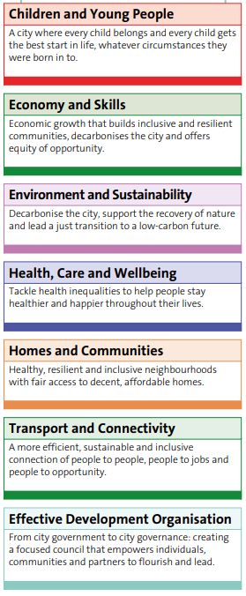
For children and young People, the strategy sets out four key themes:
Child Friendly City - Children and young people are supported by the city, their community, and the council to have the best possible start in life. They can reach their full potential and are kept safe from and supported to overcome violence, abuse, and other adverse childhood experiences, whatever the circumstances of their birth.
Supported to thrive - Children, young people, parents, and carers have access to and benefit from lifelong services – such as Family Hubs, parenting and community learning courses and Youth Zones – that support them to thrive.
Equity in education - Help improve educational outcomes, value diversity, and reduce educational inequality at all stages of education. Work with education providers to become an inclusive, zero-exclusion city, making sure high quality specialist provision is effectively targeted. Ensure that the system can meet the needs of COVID-19 recovery and provides children and young people with the academic, social, and emotional development they need.
Intergenerational equality - Lead city-wide approaches to tackling the root causes of structural inequality, breaking cycles of disadvantage, poverty, and trauma across generations to improve health and life opportunities.

Bristol’s Belonging Strategy for Children and Young People
Our Belonging in Education Strategy outlines our vision, values and strategic priorities for developing our services and meeting the needs of children and young people with SEND.
The principles that guide how services, children, young people and families work together are:
- Trusted relationships.
- Trauma informed approach
- Think Family and focus on family strengths.
- Work together in partnership
- Equality

Our strategy has three key themes:
- Building trusting relationships.
Priorities | Outcomes (2021-24)
Advocate for those who face the greatest risks | Bristol organisations working for the benefit of children, young people, and their families are recognised as being a positive influence on inclusion
Ensure mistakes are owned and dealt with in an open and transparent way | The way organisations work with one another, and with families has improved
Embed restorative approaches in our system to repair relationships | The use of restorative approaches to reduce conflict and heal harm have become normal practice in Bristol
Build relationships with organisations that share our values | Bristol organisations work collaboratively with organisations outside of the city boundaries to improve knowledge and understanding of inclusion
Communicate our successes, and our shortcomings | Bristol has a clear and transparent communication strategy to ensure a consistent narrative around inclusion and education
Deliver on promises we make to children, young people, and their families | Children, young people, and their families trust that the education system is working in their best interests

- Learning from one another
Priorities | Outcomes (2021-24)
Develop a set of shared values, behaviours and understandings that underpin how we work with families and partners | The Bristol education system has developed a set of shared values, behaviours and understandings related to inclusion
Ensure children, young people and their families’ views and wishes are an integral part of our decision-making process | Children, young people, and their families feel part of the solution and are active partners in decision making
Increase the number of education settings that take a trauma informed approach | Children and young people are supported at an earlier stage to minimise risk and harm
Take significant steps to increase the diversity of our education workforce ensuring our education voice and content is representative of Bristol’s diversity | The Bristol education workforce is starting to represent the diversity of the children and young people in the classroom
Embed an evidence informed approach to school improvement to maximise the impact of SEND and Pupil Premium funding | The Bristol education system can demonstrate a significant improvement in education outcomes for Bristol children, particularly those from disadvantaged backgrounds, or those with additional learning needs

- Creating an effective structure
Priorities | Outcomes (2021-24)
Improve the efficiency and quality of our Education Health and Care planning (EHCP) process | Bristol partners have improved the speed and quality of the EHCP process, in line with best practice guidance
Improving educational transition points | Children and young people find it easier to transition through educational phases
Develop and implement an inclusive governance framework to tackle poor attainment and attendance, and high exclusions | Bristol has an education governance system with clear and consistent accountability for inclusion
Standardise the decision-making process for managed moves between schools, and placements into alternative learning provisions. Ensure they are only used when in the best interest of the child | School moves are minimised and agreed only in the best interest of the child, in a way that is consistent, transparent, and fair
Transform Bristol City Council’s Department for Education and Skills to improve efficiency and performance | Bristol City Council’s Department for Education and Skills is recognised as being more efficient and effective in the delivery of statutory functions
Improve the accuracy of our inclusion data and increase the role it plays in our decision making | Inclusion data is accurate and consistently used in decision making
Standardise procedures to ensure sufficiency of specialist placements for children and young people | There is a standardised procedure to ensure year-on-year Bristol has sufficient specialist places that meet the needs of children and young people
Improve the way we share best practice to ensure every child in Bristol can benefit from inclusive and evidenced based classroom teaching and practice | Bristol has developed and shared a range of toolkits to demonstrate best practice for inclusion in education

Bristol Joint Commissioning Strategy
Our Joint Commissioning Strategy outlines our joint commissioning approach to deliver on the strategic aims and ambitions for our children and young people with SEND.
It shows how we'll work together with NHS Bristol, North Somerset and South Gloucestershire Clinical Commissioning Group to work to plan, commission and deliver services in a holistic and joined up way across education, health and care.
Joint Commissioning allows us to improve outcomes by enabling us to operate more effectively through earlier identification and longer-term planning.

How will we know when we have good joint commissioning?
We will see positive outcomes for children and young people with SEND and their families:
- Services will be joined-up, consistent, designed around needs and co-produced with families
- Services will be easy to understand, access and navigate
- Young people will have a positive experience transitioning into adulthood and increased independence
- High levels of satisfaction will be reported from children, young people and families
- Children, young people and their families will have choice and control over their support and the services they receive
- Children and young people will make progress towards the outcomes in their EHCP.

2.2.2 North Somerset:

North Somerset Corporate Plan 2020-24
The Corporate Plan is our overarching strategic document in North Somerset. It is the only plan which covers the full range of our responsibilities and is an important tool to help focus our effort and resources on the right things.
Our vision for an open, fairer, greener North Somerset is ambitious and to help us focus on the right things we have set ourselves three broad aims, each with a set of priorities.
- A thriving and sustainable place
- A council which empowers and cares about people
- An open and enabling organisation
Our values are:
- We act with integrity
- We respect each other
- We innovate
- We care
- We collaborate
For the purposes of the SENDIAS Service recommissioning relevant priorities are detailed below, but the full Corporate Plan, along with a dashboard can be viewed here.
Under our aim of being a council which cares and empowers people; we have a priority of protecting the most vulnerable people in our society.
By 2024 we want children and adults who need the most support consistently receive good quality services, which keep them safe and promote their wellbeing, whether provided by the council, other public services, voluntary organisations or private care providers.
Commitments we have made in 2021/22 to help achieve this include:
- We will ensure children, young people and their families are actively involved in service development, delivery and individual decisions in relation to their lives and life chance.
- We will ensure consistency of high-quality practice and performance for all children and families, ensuring that the voice of the child is central.
- We will ensure people have more options for accessing assessments and support and can get the right response more quickly and conveniently, more efficient processes help meet demand.
- We will ensure robust and effective quality assurance and performance activity and monitoring is in place across Children’s Services.
- We will implement the SEND Strategy and deliver on any in-year actions we have identified in the action plan.
Other relevant strategies are:
North Somerset SEND Strategy (NSC are in the process of writing a Joint SEND Commissioning Strategy)
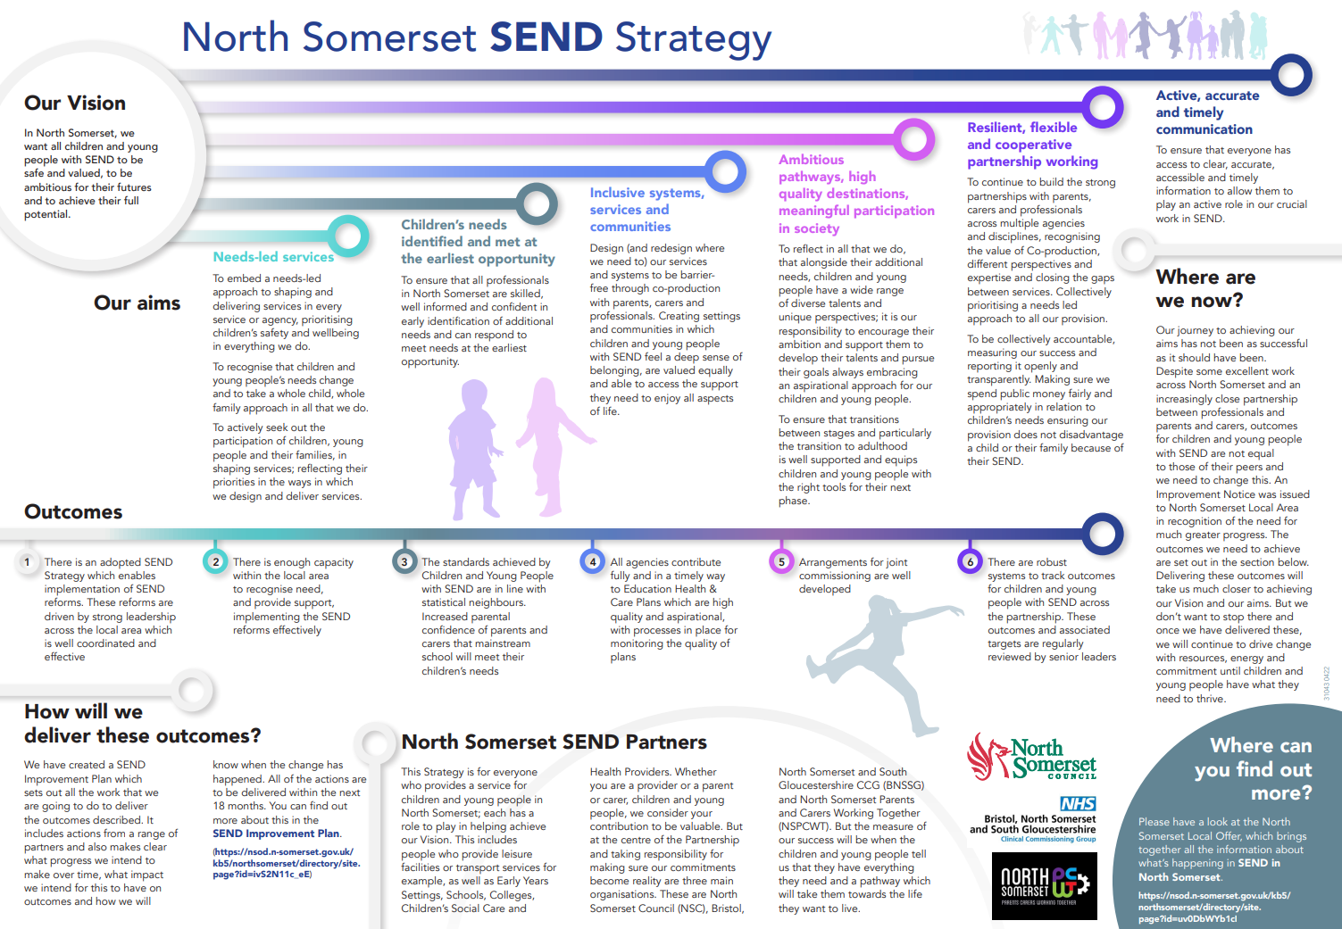

SEND Coproduction Charter
North Somerset Council have a SEND Coproduction Charter, which is also being refreshed and updated, but currently includes:
We commit to working together to ensure that the principles of effective co-production underpin the shaping and improvement of our services in the local area. We recognise that true co-production is taking place when we are all able to agree with the following statements:

• "I am an equal partner in the local area"
• "I am able to participate in every stage of processes which affect me"
• "I feel that my views and experiences are represented"
• "I am prepared to consider new approaches and to work in different ways to achieve the best outcomes"
• "I receive clear information, how and when I expect to, and in a way that works for me”
• "I am able to actively participate in meetings and other events"
• "My contributions are recognised and valued "
• "I am supported to actively and meaningfully participate in and or facilitate Coproduction activity" To ensure that genuine co-production takes place in North Somerset, we agree that:
• The best starting place for co-production is always at the beginning of any plan or project.
• From the outset, we will consider “who do we need to involve” and we will make contact at the first opportunity. We will always ask ourselves “who have we missed?” throughout our projects.
• We will approach working together without a pre-determined agenda and we will build our view together with children with SEND and their families.
• We will directly involve children with SEND, their parents and people who work with them in all aspects of a service: planning, development, delivery and review.
• We will ensure that everything in the co-production process is accessible to everyone taking part.
• We will begin any work together by agreeing what we think a successful outcome would look like and working to achieve this together.
• We will agree exactly what the focus and purpose of the project is - what can be considered and what is not being considered.
• We will agree to keep things private, recognising that people may wish to use their confidential personal experiences to support their views.
• We recognise that being involved in co-production does not prevent anyone who takes part from expressing views about what is decided at the end of the process.
• We will ensure that everyone gets the same information in a way they can access it.
• We will ensure that no group or person is more important than anyone else – recognising that everyone can contribute given the right support.
• We will facilitate discussion and actively listen – checking our understanding of views.
• We will always report back to everyone who took part on how things progress and will ensure people can see the impact and outcome of our work.
• We will review how well we are embedding co-production as part of our annual self-evaluation, and we will always challenge ourselves to improve.

Education Provision in North Somerset, a Commissioning Strategy 2021-2024
Education Provision in North Somerset, a Commissioning Strategy 2021-2024 in relation to providing appropriate places for children in North Somerset.

2.2.3 South Gloucestershire:

South Gloucestershire Council Plan 2020-24
South Gloucestershire's main strategic plan is based around four key priorities. South Gloucestershire has long been recognised as ‘a great place to live and work’. The Council Plan sets out how we will build on and deliver this vision, highlighting:
* what we will focus on
* how we will work, and
* how we will measure performance.

Priority | Our Commitments
Priority 1  Creating the best start in life for our children and young people | 1. We will raise educational outcomes  2. We will ensure that children and young people are supported in their early years  3. We will work to eliminate child poverty across South Gloucestershire  4. We will support all children and young people to achieve positive mental health and wellbeing  5. We will provide appropriate support to facilitate choices for children with a learning difficulty  6. We will provide the best support possible to those children and young people we are responsible for in care, as they leave care and beyond as they begin independent lives
Priority 2  Identifying and supporting those most in need and helping people to help themselves | 7. We will ensure people have access to the best possible information, advice, and guidance to support themselves and their families  8. We will shift the balance of support towards prevention  9. We will support the most vulnerable adults to maintain and promote their independence  10. We will enable communities to work together to help improve their lives and address the problems that are important to them  11. We will ensure that people feel safeguarded and supported in our care, at home and in their communities
Priority 3  Promoting sustainable inclusive communities, infrastructure and growth | 12. We will clean streets and maintain roads effectively  13. We will lead the response to the climate emergency and deliver on our commitments  14. We will promote clean, affordable, high quality design of new and existing communities  15. We will plan to join up housing and appropriate infrastructure such as schools and transport networks that make it easier for people to get around, prioritising sustainable and low carbon travel choices  16. We will enable people and business to recover and thrive within cohesive communities that value diversity
Priority 4  Realising the full potential of our people and delivering value for money | 17. We will demonstrate how well we deliver value for money in the services we provide and commission from others  18. We will increase our commercial operations to generate income to support council services and use our assets for maximum benefit to our communities  19. We will work as one council providing staff with the skills, tools, and support to perform at their best, promote equality of opportunity for all and live our values  20. We will develop our digital infrastructure to support residents and staff in day-to-day life

SEND strategy 2018-23
Our vision for Children and Young People in South Gloucestershire is…
Enabling children with SEND to achieve their potential and aspirations in a caring and supportive community.
This aligns with the vision set out for all children in the Children, Young People and Family Plan 2016 -2020.
Enabling every child and young person to thrive. Children and young people should have a good start in life, be safe and do as well as they can, while being able to access support when necessary.

We will provide our children with the best START

Our Priorities:

The SEND Strategy will be implemented through the following six priorities. For each priority we have identified Key Themes. There will be an action plan to deliver each Key Theme. This will be displayed on the Local Offer. All local authorities must publish a Local Offer, setting out in one place information about support and opportunities available for children and young people in their area (from 0-25 years) who have Special Educational Needs and/or disabilities (SEND). How will you know we have been successful? We have included some examples for each priority.

A link to the full strategy can be found here: SEND Strategy 2018-23

3. Current SEND Information, Advice and Support Service

3.1 The Bristol Context; Funding
Historically, all Local Authorities in England have delivered a SEND Information, Advice and Support for parents and carers of children and young people with special educational needs and/or a disability (SEND) through a parent partnership service. In Bristol this service has been commissioned by Bristol City Council and delivered by SEND and You at the cost of £140,000.
An additional duty was introduced in The Children Act 2014 and SEND Code of Practice 2015 (2.1) stipulating that ‘Local Authorities must arrange for children with SEN or disabilities for whom they are responsible, and their parents, and young people with SEN or disabilities for whom they are responsible, to be provided with information and advice about matters relating to their SEN or disabilities, including matters relating to health and social care.’
The key changes from 2014 are that the service must:
- Provide SEND Information, Advice and Support to young people with SEND, in addition to parents and carers;
- Provide information on Health and Social Care services, in addition to Education Services.

In 2018 funding was increased for Bristol’s SEND Information Advice and Support Service from £54,716 to £140,000 per year with financial contributions from Bristol City Council (Education and Social Care) as well as Bristol, North Somerset, South Gloucestershire NHS; an increase of £85,284 per annum. We are proposing that the level funding remain as is for the duration of the new contract. This funding should enable the service to continue to meet the statutory duties to provide SEND Information, Advice and Support as required by the Children and Families Act 2014.

The North Somerset Context; Funding
The SENDIAS Service, delivered by SEND and You (SAY) have been funded £48,416 per annum by the Local Authority for some time, with a supplementary £20,000 contribution from the BNSSG CCG.
SAY were granted an increase in their North Somerset budget for this financial year (2022/2023) of £11,000 due to a successful pilot of having a SEN Support Practitioner in post in North Somerset. The provider has evidenced that the SEN Support Practitioner is making a real difference to families with SEN Children in terms of increases in parental knowledge and confidence to discuss the graduated approach with schools. This also benefits NSC as less numbers of those referred to the SEN Support Practitioner have gone onto make a full EHCP application than might have done otherwise. Schools are also supported to communicate with families and SENCo’s are appreciative of the intervention which helps to manage parental expectations.
SAY were also granted an uplift of £25,000 in 2023/2023 to allow for the service to continue operating at current levels.
Therefore, total spend from North Somerset for 2022/2023 is £104,416 per annum and enables the service to meet statutory duties whilst offering a value added extra in the SEN Support Practitioner.

3.3 The South Gloucestershire context; Funding
In 2022 funding was increased for South Gloucestershire’s SEND Information Advice and Support Service from £75,342 to £86,792 which includes a financial contribution from South Gloucestershire NHS Clinical Commissioning Group. We are proposing that the level of funding remain as is for the duration of the new contract. This funding should enable the service to meet the statutory duties.

3.4 Current Provision
The current provider runs a service that delivers impartial information, advice and support (IAS) on the full range of education, health and social care as defined in the SEND Code of Practice to the following service users:
- Children and young people 0-25 with (or may have) a Special Education Need and/or a Disability (SEND);
- Their parents, carers and families.

4. Needs Analysis

4.1 Children and Young People in Bristol
In Bristol there are 159,374 children and young people aged 0-25, this is 34% of the total population. Of this population, 69,412 are on roll at an educational setting5.
Bristol has a relatively young age profile with more children aged 0-15 than people aged 65. The population of Bristol is growing, and it is projected that the child population will continue to grow in line with the total population, which suggests that demand for services will rise accordingly.

4.1.2 Deprivation
In Bristol 17,200 children - 20% of all children – live in income deprived households. On a ward basis, the greatest levels of deprivation in Bristol are in the wards of Hartcliffe & Withywood, Lawrence Hill and Hengrove & Whitchurch Park. A substantially higher proportion of individuals who live in families with disabled members live in poverty, compared to individuals who live in families where no one is disabled.

4.1.3 Children and young people living in Bristol with a Special Educational Needs and/or Disability
As of January 2021, there are 11,758 pupils with a special educational need in Bristol, this is 13.7% of those on roll at a school.
There are 2217 pupils with Education Health and Care Plans (ECHP) on roll in Bristol schools; this is 3.2% of pupils on roll. The proportion of children with an EHCP in primary schools has increased in the last year to be greater than the proportion in secondary schools.
In the last year, the number of pupils with identified special education needs in a Bristol school has increased from 11,063 in 2020 to 11,758 pupils in 2021, an increase of 6% (695 more pupils classified as SEN): Breaking down SEN into two subgroups (EHC Plans and SEN support) this year, the increase in Bristol is driven by a rise in number of pupils with an EHC Plan (+25% or 439 pupils). There has been a slight increase in pupils receiving SEN support (+3.0% or 256 pupils).

4.1.4 Gender
In Bristol the child population is 48.7% female and 51.3% are male. Nationally in the adult population slightly more women have disabilities than men, but amongst the 0-25 age range there are more boys with disabilities than girls.
In Bristol, there are more males with SEN or an EHCP than females reflecting a male dominated population than within the overall age group, which is more evenly split. 16.7% of boys in Bristol schools received SEN support compared to 10% of girls, and 5% of boys in Bristol schools had an EHCP compared to 1.9% of girls.

4.1.5 Ethnicity
The latest school census data (Jan 2021) details ethnicity amongst SEN support and EHCPs. Black Caribbean pupils in Bristol are more likely to have an EHCP than other ethnic groups (5.9%). Travellers of Irish heritage, Black Caribbean and Gypsy Roma pupils are significantly more likely to receive SEN support in school (22%, 21.9% and 21.8% respectively)
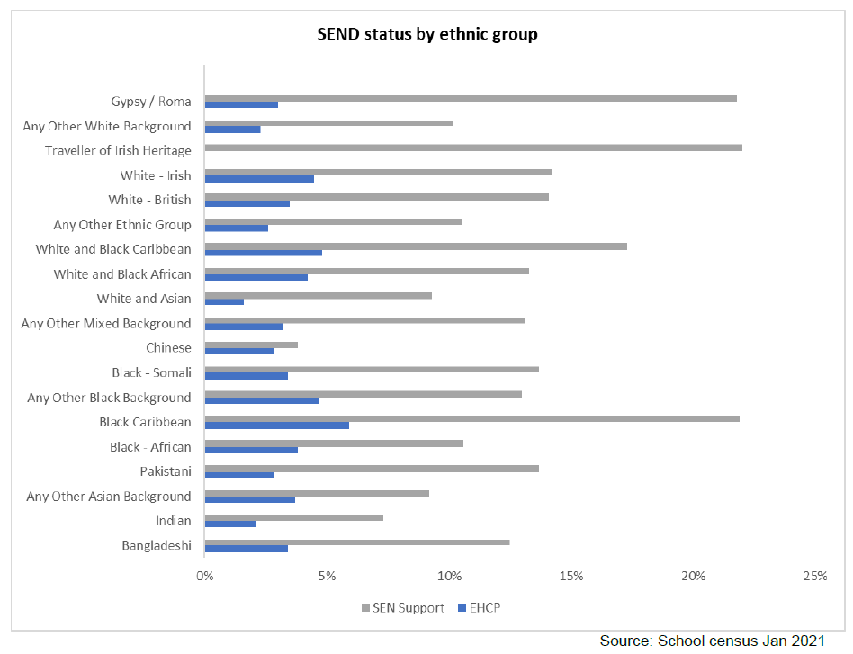

4.2 Children and Young People in North Somerset

Summary
North Somerset Council Unitary Authority covers an area of approximately 145 square miles bordering the local government areas of Bristol, Bath & North East Somerset and Somerset. The total resident population in 2011 was 202,600 however, the 2020 ONS mid-year estimates has the overall resident population as 215,574. The four main towns are Weston-Super-Mare (population of 76,143), Clevedon (21,281), Nailsea (15,630) and Portishead (23,699). Nearly two thirds of North Somerset’s population live in one of these four towns.
- North Somerset has a 0-18-year-old population of 46,010 (ONS mid-year estimates 2020) accounting for 21.3% of the whole population.
- The resident population is less ethnically diverse than England and Wales as a whole; in 2011, 3% of North Somerset’s population classified themselves as BME, compared with 5% in the South West and 15% across England.
- North Somerset has 8 LSOA’s in the 10% most deprived nationally and 25 in the 10% least deprived nationally according to the 2019 indices of deprivation. In terms of the link between deprivation and SEND, the figures do not show greater need in areas of deprivation in North Somerset.

4.2.1 Children and Young People in Education:
In North Somerset we had 30,970 children and young people registered and on school rolls in January 2021 (from nursery to year 13). The number of children with SEND increased by 7.8% and the number of children with an EHCP increased by over 30% from 2020 to 2021. SEND Children relate to those with SEN Support as well as those with an EHC Plan.
 | Jan-2021 | Jan-2020 | Increase
Number of children on rolls in North Somerset Schools | 30970 | 30898 | 0.23%
Number of children with SEND | 4393 | 4075 | 7.80%
Number of children with EHCP | 747 | 574 | 30.10%

The Biggest category for SEND support is Specific Learning Difficulty (24.4%), whilst the biggest category for EHCP support is Autistic spectrum disorder (24.1%).
Primary need | No. SEN support |  | No. EHCP
 | No | % | No | %
Autistic spectrum disorder | 158 | 4.3% | 180 | 24.1%
Hearing impairment | 52 | 1.4% | 20 | 2.7%
Moderate learning difficulty | 680 | 18.7% | 84 | 11.2%
Multi-sensory impairment | 10 | 0.3% | 1 | 0.1%
Other difficulty / disorder | 227 | 6.2% | 15 | 2.0%
Physical disability | 107 | 2.9% | 27 | 3.6%
Profound & multiple learning difficulty | 1 | 0.0% | 38 | 5.1%
SEN support but no specialist assessment of type of need | 161 | 4.4% | n/a | n/a
Severe learning difficulty | 10 | 0.3% | 89 | 11.9%
Social, emotional and mental health | 805 | 22.1% | 126 | 16.9%
Specific learning difficulty | 888 | 24.4% | 27 | 3.6%
Speech, language and communication needs | 510 | 14.0% | 132 | 17.7%
Visual impairment | 37 | 1.0% | 8 | 1.1%
Total | 3646 | 100.0% | 747 | 100.0%

4.2.2 Placements:
 |  |  |  |  |  |  | No on roll |  |  | No of EHCP |  | %
Mainstream schools |  |  |  |  |  |  | 30530 |  |  | 359 |  | 1.2%
Special schools |  |  |  |  |  |  | 382 |  |  | 382 |  | 100.0%
Alternative provision |  |  |  |  |  | PRU | 58 |  |  | 6 |  | 10.3%
 |  |  |  |  |  | EHE | 364 |  |  | 25 |  | 6.9%

Note: alternative provision includes EHCPs in NS PRU and EHE as of 21/01/2021 (Census day)

4.2.3 Exclusions:

 | 2020-21 Exclusions
 | EHCP |  | SEN Support |  | No SEN |  |  |  | Total
 | No | % | No | % | No |  |  | % | No |  | %
Permanent exclusions | 0 | 0.00% | 3 | 0.08% | 6 |  |  | 0.02% | 9 |  | 0.03%
Fixed exclusions | 71 | 9.50% | 450 | 12.34% | 610 |  |  | 2.30% | 1131 |  | 3.65%
SEN stage at the time of the exclusion

4.2.4 Gender:
In 2020/2021 63.8% of those with SEN Support were male, in comparison to 36.20% being female. In the same year those with an EHCP and/or statement of SEN 66.9% were male, in comparison to 33.10% being female.
 |  | 2015/16 | 2016/17 | 2017/18 | 2018/19 | 2019/20 | 2020/21
SEN Support | Boys | 65.50% | 66.20% | 66.50% | 65.60% | 65.80% | 63.80%
 | Girls | 34.50% | 33.80% | 33.50% | 34.40% | 34.20% | 36.20%
EHCP & Statement of SEN | Boys | 65.60% | 65.00% | 64.90% | 66.00% | 65.70% | 66.90%
 | Girls | 34.40% | 35.00% | 35.10% | 34.00% | 34.30% | 33.10%

4.2.5 Social Care Flags:
Children in care with EHCP | Care leavers with EHCP | CIN (children wih a plan) with EHCP | Children subject to a CP with an EHCP
28.5% | 10.53% | 41.08% | 6.85%

4.2.6 Free School Meals and SEN Provision:
SEN Provision | Eligible for free school meals | Percentage
E | 249 | 5.78%
K | 1032 | 23.96%
N | 3027 | 70.26%
Total | 4308 | 100.00%

4.2.7 Ethnicity:
Over 90% of children and young people with SEN are White, with under 5% being from mixed-dual backgrounds. Children and young people in North Somerset speak predominantly English at 93.66%, Polish being the next most frequently spoken language. There are many different languages spoken by children and young people in North Somerset but the numbers are not high.
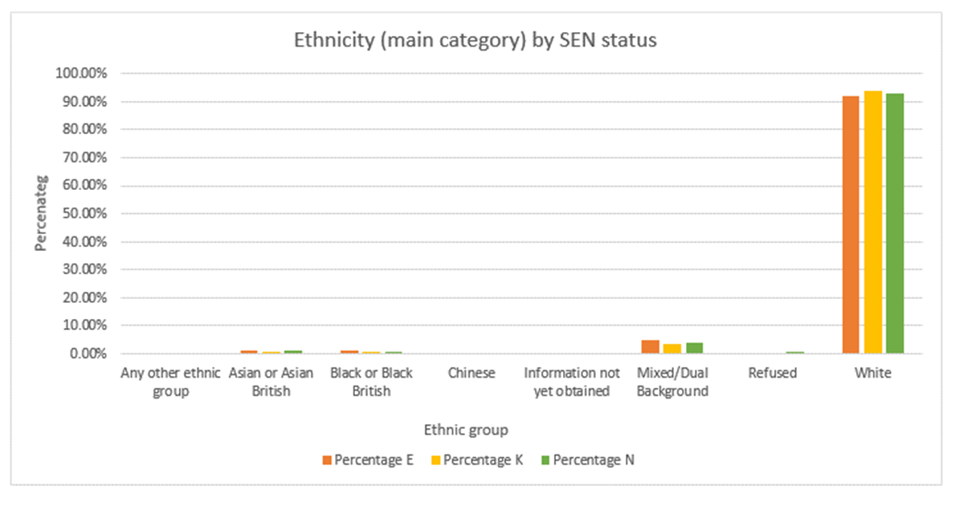
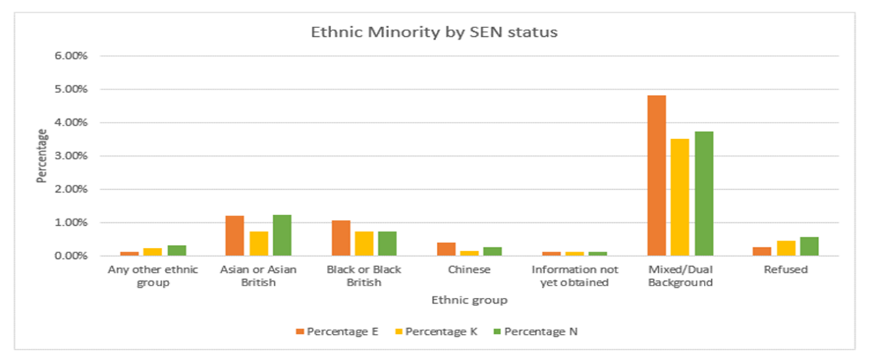
Language | No of pupils | %
English | 29005 | 93.66%
Polish | 446 | 1.44%
Other than English | 356 | 1.15%
Romanian | 98 | 0.32%
Bulgarian | 83 | 0.27%
Believed to be other than English | 61 | 0.20%
Believed to be English | 56 | 0.18%
Hungarian | 55 | 0.18%
Spanish | 54 | 0.17%
Malayalam | 51 | 0.16%
Somali | 51 | 0.16%
Bengali | 49 | 0.16%
Italian | 45 | 0.15%
French | 44 | 0.14%
Lithuanian | 41 | 0.13%
Portuguese | 39 | 0.13%
Arabic | 38 | 0.12%
Russian | 32 | 0.10%
Romanian (Romania) | 25 | 0.08%
Chinese | 21 | 0.07%
Chinese (Cantonese) | 19 | 0.06%
Slovak | 19 | 0.06%
Greek | 17 | 0.05%
Turkish | 17 | 0.05%
Albanian/Shqip | 13 | 0.04%
Panjabi | 12 | 0.04%
Tamil | 11 | 0.04%
Vietnamese | 11 | 0.04%
Dutch/Flemish | 10 | 0.03%
Refused | 10 | 0.03%
Chinese (Mandarin/Putonghua) | 9 | 0.03%
Filipino | 9 | 0.03%
Afrikaans | 8 | 0.03%
Czech | 8 | 0.03%
German | 8 | 0.03%
Information not obtained | 8 | 0.03%
Ukrainian | 8 | 0.03%
Urdu | 8 | 0.03%
Hindi | 7 | 0.02%
Kurdish | 7 | 0.02%
Bengali (any other) | 6 | 0.02%
Latvian | 6 | 0.02%
Other language | 6 | 0.02%
Japanese | 5 | 0.02%
Tagalog/Filipino | 5 | 0.02%
Thai | 5 | 0.02%
Arabic (any other) | 4 | 0.01%
Danish | 4 | 0.01%
Pashto/Pakhto | 4 | 0.01%
Sinhala | 4 | 0.01%
Swahili (any other) | 3 | 0.01%
Telugu | 3 | 0.01%
Wolof | 3 | 0.01%
Amharic | 2 | 0.01%
British Sign Language | 2 | 0.01%
Ebira | 2 | 0.01%
Efik-Ibibio | 2 | 0.01%
Farsi/Persian (any other) | 2 | 0.01%
Kurdish (Sorani) | 2 | 0.01%
Lingala | 2 | 0.01%
Luganda | 2 | 0.01%
Portuguese (any other) | 2 | 0.01%
Portuguese (Brazil) | 2 | 0.01%
Shona | 2 | 0.01%
Welsh/Cymraeg | 2 | 0.01%
Yoruba | 2 | 0.01%
Azeri | 1 | 0.00%
Classification pending | 1 | 0.00%
Greek (Cyprus) | 1 | 0.00%
Gujarati | 1 | 0.00%
Igbo | 1 | 0.00%
Lao | 1 | 0.00%
Lozi/Silozi | 1 | 0.00%
Marathi | 1 | 0.00%
Ndebele | 1 | 0.00%
Norwegian | 1 | 0.00%
Pahari/Himachali (India) | 1 | 0.00%
Persian/Farsi | 1 | 0.00%
Serbian/Croatian/Bosnian | 1 | 0.00%
Slovenian | 1 | 0.00%
Sotho/Sesotho | 1 | 0.00%
Sotho/Sesotho (Southern) | 1 | 0.00%
Swedish | 1 | 0.00%
Grand total | 30970 | 100.00%

Number of EHC plans according to the 2021 SEN2 return - Snapshot 21/01/2021
Source: 2021 SEN2 return
Age group (as of 31/08/20) | Number | Percentage
Under 5 | 42 | 3.26%
5 to 10 | 367 | 28.52%
11 to 15 | 469 | 36.44%
16 to 19 | 278 | 21.60%
20 to 25 | 131 | 10.18%
Total | 1287 | 100.00%
Number of EHCP plans issued (including exception cases)
Source: 2022 SEN return (2021 data), Capita (2022 data)
Year | Number
2021 | 308
2022 (01/01-20/05) | 74

4.3 Children and Young People in South Gloucestershire
In South Gloucestershire as of 2020, there were 83,821 children and young people ages 0-24, which is 29.1% of the total population (287,816). Latest projections suggest that the population of South Gloucestershire will rise to 354,300 in 2043, a 25.3% increase on the 2018 baseline (282,600).

4.3.1 Deprivation
Information taken from the Analysis of English Indices of Deprivation 2019, shows that South Gloucestershire is the 267th most deprived district in England (out of 317) in terms of this measure. This places the authority in the least deprived 20% in England, as it was in the ID2015 as well. However, it does have some sub-ward level ‘pockets of deprivation’ in some domains that feature on a national scale. The most deprived areas remain the Pendennis Road area of Staple Hill and the Mangotsfield Ward.

4.3.2 Children and young people living in South Gloucestershire with a Special Educational Needs and/or Disability
Overall, 15.2% of pupils in all South Gloucestershire Schools have special educational needs. This is just below the national average which is 15.8%. As of the end of January 2021, 2,249 children and young people 0-25 have an EHCP. In 2021 there were 241 new EHCP’s issued between March and December.

4.3.3 Gender
In South Gloucestershire there are significantly more boys than girls receiving both SEN support and with an EHCP. The table below shows that these figures have stayed relatively consistent since 2015.
Percentage of pupils with an EHC plan and SEN support by gender, 2015/16 to 2020/21¹⁷
 |  | 2015/16 | 2016/17 | 2017/18 | 2018/19 | 2019/20 | 2020/21
SEN Support | Boys | 65.2 | 66.9 | 66.2 | 66.6 | 65.8 | 66.4
 | Girls | 34.8 | 33.1 | 33.8 | 33.4 | 34.2 | 33.6
EHCP | Boys | 74.9 | 78 | 76.1 | 74.2 | 75 | 74.8
 | Girls | 25.1 | 22 | 23.9 | 25.8 | 25 | 25.2

5. Commissioning Plan

5.1 Context
- We know that the number of children and young people with SEN support and EHCPs has continued to increase over the last five years.
- We also know that the pressures on families are increasing within the context of decreasing public spending, which can mean that the implications of raising a disabled child are more acute.
- Bristol City Council, NHS Bristol, North Somerset and South Gloucestershire Clinical Commissioning Group, and partners are facing significant budget pressures and growing demand for services across the board.
- It is a local authority priority to try and reduce the number of tribunals and exclusions, these are both costly for the local authority and stressful for children, young people and their families. Exclusions from school are associated with poorer mental health and general wellbeing outcomes for children and young people.

5.2 Objectives
Bristol City Council, North Somerset Council and South Gloucestershire Council aims to commission a SENDIAS service that provides free, impartial, confidential and accurate information, advice and support about education, health and social care for children, young people (0-25) and their parents, carers or family on matters relating to special educational needs and disability (SEND).
The aim of the information, advice and support service is to:
- Promote independence and self-advocacy for children and young people with SEND, and their parents, carers and families. Advocacy means getting support from another person to help an individual to express their views and wishes and help them understand and exercise their rights. SENDIASS service will not fulfil the role of statutory advocates nor provide legal advocacy as provided by a lawyer.
- Ensure children and young people with SEND, and their parents, carers and families have access to high quality impartial, confidential and accurate on special educational needs and disability.
- Hear, understand and support children and young people with SEND, and their parents, carers and families and use this information to inform and influence the development of local SEND Policy and Practice.
- Deliver to Department for Education minimum standards, quality standards or any other standard developed for SENDIAS services based on the Children and Families Act (CFA) 2014, the SEND Code of Practice or other relevant body, subject to the agreement of Bristol City Council.

5.3 Overview of service to be commissioned.
We are proposing to commission a like for like service to the existing provision. The Information Advice and Support Service must:
  - Provide an all year-round flexible service which is open during normal office hours and includes a direct helpline, 24-hour answer machine and call back service and signposting service, including linking to the national SEND helpline.
  - To support parent, carers, children and young people directly in ensuring that the children and young people with special educational needs have equal educational opportunities.
  - To publicise the service and to provide parents, carers, young people and professionals in the local area with accurate unbiased information.
  - To provide training for parents, carers, and young people to enable parents of children with special educational needs and young people to support each other.
  - To encourage parents, carers, young people, voluntary groups, education settings (Early Years, School Age and Post 16/ GFE) and other Local Area professionals to work in collaboration in the interest of the children and young people and support the work of Local Authority services.
  - To voice the views of parents, carers and young people to ensure that these views are reflected in the development of local SEND Policy and Practice.

5.4 Partnership Working
The service will be jointly commissioned by Bristol City Council, North Somerset Council and South Gloucestershire Council; Bristol will be the lead commissioner for these services.
Jointly commissioning this service will benefit children and young people as it will allow the same quality service across areas. It will not only enable children and young people to move to neighbouring local authorities but will enable those who live within one area and go to school in another to access equivalent support.
Jointly commissioning this service will also allow us to better coordinate services and to plan in a way that improves population health and reduces inequalities between different groups. We will be able to improve population health, enhance productivity and help the NHS support broader social and economic development.
Joint commissioning will also help us to reduce duplication through joined up working and sharing of resources and information.

5.5 Outcomes
The service will work towards the overarching outcomes and priorities from Bristol’s Children and Young People’s Outcomes Framework 2020 – 2023 for children and young people 0-25 years who have Special Educational Needs and/or a disability (SEND).
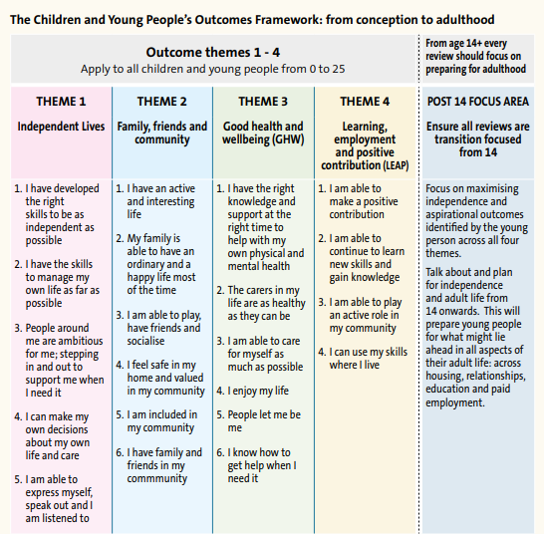
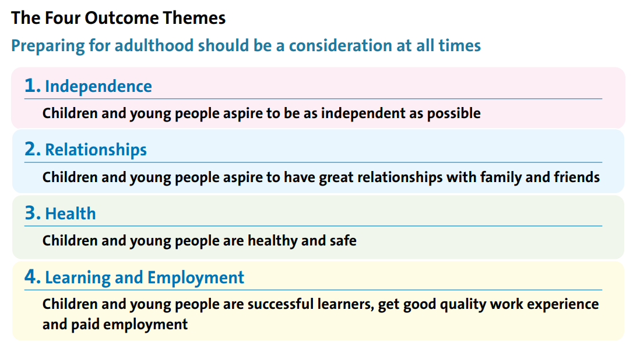

6. Purchasing Plan

6.1 Investment
£882,000 over 34 months.
Bristol City Council
Year | Dates | Annual Total:
Year 1 (12 months) | 01/04/23 – 31/03/24 | £140,000
Year 2 (12 months) | 01/04/24 – 31/03/25 | £140,000
Year 3 – Extension 12 months | 01/04/25 – 31/03/26 | £140,000
 | Overall value of the contribution | £420,000

North Somerset Council
Year | Dates | Annual Total:
Year 1 (12 months) | 01/04/23 – 31/03/24 | £104,416
Year 2 (12 months) | 01/04/24 – 31/03/25 | £104,416
Year 3 – Extension 12 months | 01/04/25 – 31/03/26 | £104,416
 | Overall value of the contribution | £313,248

South Gloucestershire Council
Year | Dates | Annual Total:
Year 1 (12 months) | 01/04/23 – 31/03/24 | £86,792
Year 2 (12 months) | 01/04/24 – 31/03/25 | £86,792
Year 3 – Extension 12 months | 01/04/25 – 31/03/26 | £86,792
 | Overall Value of the contribution | £260,376

Total investment
Year | Dates | Annual Total:
Year 1 (12 months) | 01/04/23 – 31/03/24 | £331,208
Year 2 (12 months) | 01/04/24 – 31/03/25 | £331,208
Year 3 – Extension 12 months | 01/04/25 – 31/03/26 | £331,208
 | Overall Value of the contract | £993,624

6.2 Procurement
Bristol City Council is procuring through an open tender procedure under the light-touch regime, as it is a social and education service above the OJEU threshold. We will engage a local suppliers for the provision of this service via Pro Contract as well as issuing a PIN to the wider market. We are proposing a two year initial contract with the option to extend for an additional year.

9. Timetable
The following is an indicative timetable and subject to change:
Key Milestone: | Start date: | Finish Date:
Consultation | 29/06/22 | 30/07/22
Final Commissioning Plan / You Said We Did Published | 21/10/22
Procurement Process | 01/11/22 | 09/12/22
Advise Suppliers | 16/12/22
Award | 19/12/22
Implementation | 02/01/23 | 30/03/23
Contract starts | 31/03/23

10. TUPE
Current and potential providers will need to be aware of the implications of the Transfer of Undertakings (Protection of Employment) Regulations 2006 (TUPE). When a service activity transfers from one provider to another, the relevant employees delivering that service transfer from the old to the new provider and must transfer on the same contractual terms and conditions of employment. The new provider/employer takes on all the liabilities arising from the original employment contracts. The council will obtain from current providers basis information about the employees who will potentially be affected by this commissioning process. Bidding providers will need to consider the cost and other implications of TUPE. The council will provide bidders with the information it has collected from current providers about the employees who will be potentially affected. Providers must seek their own legal and employment advice on TUPE. It is the responsibility of bidders/ providers to satisfy themselves regarding TUPE requirements.

11. Social Value
While these services provide intrinsic social value, we expect the successful provider to be able to create added social value which could include but is not limited to:
- offer of apprenticeships/ volunteering and work experience opportunities to people from the local area including
- developing opportunities for additional funding to be brought into the local area
- raising local public awareness of the challenges faced by disabled children and young people
- development of partnerships with other organisations to work together for the benefit of the community

All social value commitments will be monitored using the Social Value Portal. The successful bidder will be required to contract directly with the Social Value Portal and social value commitments will form part of the KPIs.
Further guidance is available here: https://www.bristol.gov.uk/documents/20182/239382/Social+Value+Policy+-+approved+March+2016-1.pdf/391b817b-55fc-40c3-8ea2-d3dfb07cc2a0

12. Contract Management
Contract management will be undertaken jointly by the three Local Authorities and the Clinical Commissioning Group, with Bristol City Council as lead. Ongoing contract management will be provided within existing resources by the SEND Business Unit and Strategic Commissioning Team.

https://www.bristol.gov.uk/documents/20182/33620/Corporate_Strategy_2022-27.pdf/64775487-6d75-004b-2f79-cc4037cf2010?t=1642610835516
Bristol’s Belonging Strategy for Children and Young People - Belonging in Education (bristolonecity.com)
Local Area Joint Commissioning Strategy for Special Educational Needs and Disability Services for Children and Young People in Bristol
https://www.n-somerset.gov.uk/sites/default/files/2022-03/corporate%20plan%202020-24.pdf
https://search3.openobjects.com/mediamanager/northsomerset/fsd/files/send_strategy_-_page_plan_acc.pdf
https://search3.openobjects.com/mediamanager/northsomerset/fsd/files/north_somerset_local_area_send_co-production_charter_-_2020.pdf
https://www.n-somerset.gov.uk/sites/default/files/2021-12/Education%20Commisioning%20Strategy%20book%20-%20acc.pdf
https://www.southglos.gov.uk/documents/SEND-Strategy-2018-23.pdf
BCC Insight, Performance and Intelligence (2021). The Population of Bristol September 2021 5 JSNA Health and Wellbeing Profile 2021/22
BCC (2021). Bristol Belonging Strategy: Belonging in the Community 2021 – 2024
Poverty in the UK Statistics – March 2021 Briefing Paper – House of Commons Library
Analysis of DfE Special Educational Needs (School Census) January 2021
The Population of Bristol - September 2020
Draft JSNA Health and Wellbeing Profile 2020/21 Special Educational Needs and Disability (SEND)
School Census Data 2021
JSNA Health and Wellbeing Profile 2021/22

