**Draft NFCC Grid Scale Energy Storage System Planning – Guidance for Fire and Rescue Services.   
*July 2024 Revision.***

The guidance is produced by the National Fire Chiefs Council (NFCC) for the use of Fire and Rescue Services (FRSs) and planners to support community and firefighter safety. It is intended to be informative, and this guidance does not constitute formal legal advice. All parties’ legal duties remain those specified by law.

This guidance relates to Battery Energy Storage Systems (BESS) which are deployed in open air environments with an energy capacity of 1 megawatt (MWh) or greater using lithium variant batteries. The principles contained within this guidance may also be relevant to other battery technologies, advice should however also be sought from a competent person.

The way FRSs use the guidance will be adapted based on local context. Local authority planning departments should, therefore, not use the guidance as a mandatory set of recommendations. Instead, discussions with the local FRS should take precedence.

1. **Introduction**

The UK has for many years generated electricity to the National Grid using predominantly coal, gas and nuclear fired power stations. With the move to reducing the amount of fossil fuels that are being used, 44% of our energy in the third quarter of 2023 was generated using renewable forms of energy such as solar, hydro or wind power[1]. However, unlike traditionally fuelled power stations, renewable energy sources such as wind and solar cannot simply be switched on to generate energy to meet the peaks and troughs of demand on the National Grid. Therefore, to ensure a stable grid and to cope with the fluctuations in demand, the energy needs to be captured and stored. Large batteries are being deployed as energy storage devices that can capture the energy in times of low demand and provide almost instantaneous support the National Grid at times of high demand.

These grid scale BESS are currently categorised as infrastructure projects and progress through the planning system, rather than via a Building Regulations (as amended) consultation process from building control bodies, whom FRSs work closely alongside.

In 2023, Planning Practice Guidance for Renewable Energy published on the Gov.UK website was updated and encourages early discussion between developers of BESS and planners as well as the local FRS.

NFCC recognises the need for BESS to support the UK Government strategic objectives of energy independence and security whilst the country is transitioning to an environment that is less reliant on fossil fuels.

However, the National Fire Chiefs Council hold concerns that there are no duties on the bodies receiving comments to respond, or to demonstrate how any FRSs concerns have been satisfied or addressed.

In referring to this guidance, NFCC seek to support FRSs to ensure they are aware of the location of all grid scale BESS in their area. This is to allow for effective operational pre planning to take place ensuring that FRS requirements are proportionate to the hazard and risk whilst not being overly burdensome to the developer of the BESS installation. It is hoped that the guidance will promote consistency of approach across FRS.

NFCC’s expectation is that a comprehensive risk management process supported with appropriate evidence will be undertaken by operators to identify hazards and risks specific to the facility and develop, implement, maintain and review risk controls. From this process a robust Risk Management Plan and Emergency Response Plan should be developed in conjunction with the local FRS.

This guidance supersedes and seeks to build on the original guidance document that was published in 2023 (Version 1). The guidance is based upon a range of supporting materials including academic research, national and international standards, case studies, and industry guidance (please refer to Bibliography). The content of this document is the result of analysis of that supporting material with subsequent professional judgement applied.

Every BESS installation will be different, and FRSs should not limit themselves to the content of this guidance. Where deviation from this guidance is required, advice must be sought from a competent person.

1. **Scope**

NFCC recognises that BESS may also be deployed to support industry where there is not a National Grid connection, for example, where a site has their own methods of generating energy and have a desire to store it. The principles of this guidance may also be relevant to be used in such cases.

Likewise, the principles of the guidance document may be relevant to the deployment of temporary mobile BESS units which are becoming more prevalent.

Domestic BESS is outside the scope of this guidance and a publicly available standard (PAS 63100 (1)) has been published setting out good practice in this area.

Mobile and temporary BESS deployments are also outside the scope of this document.

1. **Incident Event Database**

Whilst, at the time of publication, thermal events and incidents involving BESS in the UK are relatively rare, there have been failures within BESS across the world.

A source of information is the [Electric Power Research Institute (EPRI) Failure Event Database](https://storagewiki.epri.com/index.php/BESS_Failure_Event_Database) that records Energy Storage Failure Events.

Further advice and guidance for FRSs can be obtained through contacting the NFCC via our [website](https://nfcc.org.uk/contacts/).

1. **Principles**

This guidance has been developed with the safety of the public and emergency responders in mind. It is based on trying to help reduce the risk as far as reasonably practicable, whilst recognising that ultimate responsibility for the safe design and running of these facilities rests with the developer and operator.

The guidelines are a starting point and cannot cover every eventuality or type of design.

In developing these guidelines, the hazards and risks from lithium variant batteries identified in National Operational Guidance, have been considered.

The following principles should be considered by FRSs, when liaising with operators, and form the basis of this guidance[2]:

1. Effective identification and management of hazards and risks specific to the siting, infrastructure, layout, and operations at the facility.
2. Siting of renewable energy infrastructure so as to eliminate or reduce hazards to emergency responders.
3. Safe access for emergency responders in and around the facility, including to renewable energy and firefighting infrastructure.
4. Provision of adequate water supply and firefighting infrastructure to allow safe and effective emergency response. This could include the provision of water to allow for defensive firefighting to protect surrounding infrastructure.
5. Vegetation sited and managed so as to avoid increased bushfire and grassfire risk.
6. Prevention of fire ignition on-site.
7. Prevention of fire spread between site infrastructure (solar panel banks, wind turbines, battery containers/enclosures).
8. Prevention of external fire impacting and igniting site infrastructure.
9. Provision of accurate and current information for emergency responders during emergencies.
10. Effective emergency planning and management, specific to the site, infrastructure and operations.
11. **Fire and Rescue Service Organisational Requirements**

FRSs can take measures to support the planning process ensuring that timely and meaningful engagement between the FRS, local planners and developers can take place, thus assisting operational pre-planning.

FRSs are encouraged to:

* Nominate a lead department within their organisation that will be the public facing point of contact for BESS.
* Host a webpage on their FRS website setting out a point of contact details for BESS engagement.
* Although FRSs are not a statutory consultee for planning, FRSs are encouraged to establish and maintain working arrangements with colleagues in local authority planning departments to facilitate efficient consultation with regard to BESS.
* Use this guidance as a document to raise hazard awareness and inform discussions with developers.

1. **Fire and Rescue Service Contact Details**

A comprehensive list of all FRSs can be found on the Fire England website which will assist developers in making contact with the relevant FRS of the proposed scheme. [Find your service | Fire England](https://fireengland.uk/your-fire-and-rescue-service/find-your-service)

1. **Planning Approval Process**

As BESS are classed as infrastructure projects, they progress via a planning application route for approval. They are not dealt with by Building Regulations (as amended) consultations (unless there are ancillary buildings on site which may be covered) and as such the FRS are not a statutory consultee.

In August 2023, the Department for Levelling Up, Housing and Communities (DLUHC) amended the [Planning Practice Guidance for Renewable Energy](https://www.gov.uk/guidance/renewable-and-low-carbon-energy). As a result of this revision, both planners and developers are encouraged to engage with the local FRS and, as such, each FRS should encourage early dialogue regarding BESS proposals.

Whilst FRSs are not a statutory consultee for planning, they do have a statutory responsibility under the [Fire and Rescue Services Act 2004](https://www.legislation.gov.uk/ukpga/2004/21/contents) for obtaining information to assist with the extinguishing of fires and the protection of life and property in their area. In addition, through engaging at the pre planning or planning stage, FRSs may be able to influence the design and layout of the site.

It is expected that there will be a proliferation of BESS developments across the UK, and FRSs may also seek to ensure they are aware of planned and operational projects in their area. The Department for Energy Security and Net Zero (DESNZ) maintain a database of [Renewable Energy Schemes](https://data.barbour-abi.com/smart-map/repd/beis/?type=repd) for this purpose.

1. **Information Requirements**

Grid scale BESS should form part of FRS planning in accordance with arrangements required under section 7(2)(d) of the Fire and Rescue Services Act (2004). Incidents involving BESS will require a hazardous materials response and as such site-specific risk information (SSRI) should be gathered with the support of suitably trained hazardous materials environmental protection trained officers (HMEPO) and made available to crews.

1. **System design, construction, testing and decommissioning**

The design of BESS is moving away from the original designs that resembled large shipping containers where maintenance staff had to enter the container to undertake their work, such as in figures 1 and 2 below.

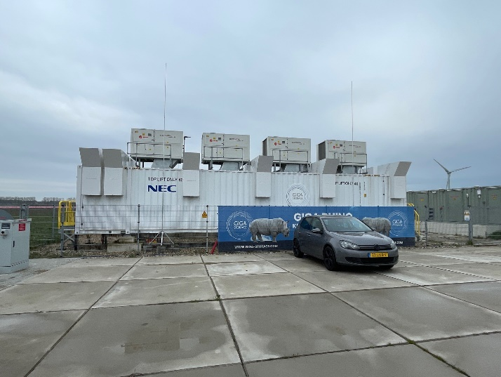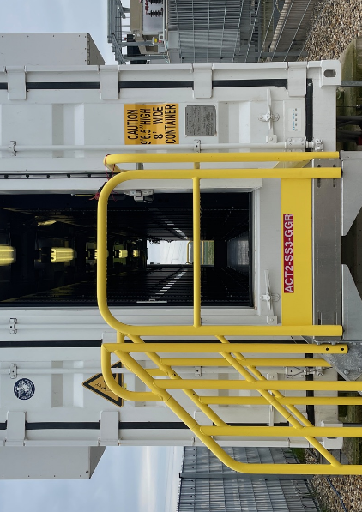

**Figure 1.** Image reproduced with permission of PNNL **Figure 2.** Image reproduced with the permission of PNNL  
  
More modern designs feature a cabinet design with access to the system being achieved through the provision of doors on the outside of the BESS unit (figure 3), thereby negating the need to enter the unit.

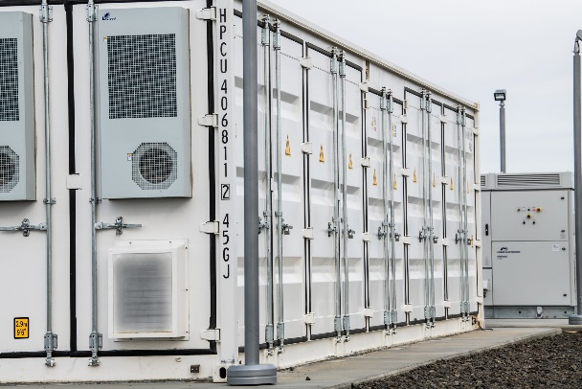

**Figure 3.** Image Reproduced with the permission of PNNL

FRSs should seek to obtain as much information as possible at the earliest opportunity from the applicant / developer / designer / manufacturer etc., to allow an initial appraisal of the BESS to be made. It is the responsibility of those above to provide this information to the FRS (via the local authority planners in the first instance), with appropriate evidence provided to support any claims made on performance and with appropriate standards cited for installation.

Such information should also be made available to FRSs for inclusion in SSRI records.

Areas for discussion that the FRS may wish to clarify with the site developer at the pre application / engagement phase include:

|  |  |
| --- | --- |
| Areas for discussion | Clarification questions |
| Thermal event / Deflagration | * How will the proposed BESS perform in the event of a thermal event / deflagration and what proactive / reactive systems are proposed to mitigate this? * How will the thermal event be contained to the BESS of origin without the radiant heat to others? * How has the performance of the BESS in a thermal runaway event influenced site design? |
| Site plans | * What are the assumptions about active firefighting, within the emergency response plan and what measures are in place to reduce the scale of an incident? * Are the incident assumptions realistic? What is the role of the FRS at an incident? Are they realistic? What is the expectation of the FRS in terms of the fire strategy at a thermal event? * What is the provision for firefighting access to, around and within the site? |
| Water supply / Suppression systems | * What is the type, purpose and effect of any fire suppression system installed? * What is the purpose of the water supply provision on site? Boundary cooling / defensive firefighting or active suppression? |
| BESS design | * What is the size, quantity and capacity of each BESS unit? * Is the BESS design appropriate for the weather at the proposed location i.e. prevention of water ingress and impact of temperature range on cooling systems? * Does the applicant / developer have relevant competence and experience in the field of BESS design and deployment on the scale of the proposed development? * What are the arrangements for ongoing monitoring of the BESS and what is the response time for onsite technical assistance in the event of an incident? |
| Annunciation | * What remote annunciation panels are available for monitoring an event from the site? * What data is available from these remote annunciation panels? |
| Environmental receptors | * Please refer to Section15 of this guidance. |

Responses to these questions will assist in shaping several areas of the emergency response plan.

Further, the Environment Agency has published [Fire Prevention Plans: Environmental Permits Guidance](https://www.gov.uk/government/publications/fire-prevention-plans-environmental-permits/fire-prevention-plans-environmental-permits#firefighting-techniques) detailing what should be included in a fire prevention plan, the fire prevention measures that must be put in place, a plan template and examples of alternative measures.

1. **Battery Chemistry**

Battery Chemistry is a very specialist area of materials science and as such NFCC are not an authoritative body to make comment other than to discuss the broad and generally accepted principles which were published as part of the Frazer Nash Report (Smart: Energy Storage & Flexibility Innovation. Health & Safety Guidance for Grid Scale EESS, Jan 2024). The text relating to battery chemistry is reproduced here with the permission of Department for Energy Security and Net Zero.

*There are a range of battery chemistries available which suit different use cases, have a different maturity and which present different risks and safety profiles that are at varying states of maturity.*

*Lithium-Ion batteries make up the majority of the current grid-scale BESS global market share, due to their ideal characteristics of high energy density, high energy efficiency and a long-life cycle.*

*There are multiple variants of Lithium-Ion batteries, with Lithium Nickel Manganese Cobalt Oxide (NMC) and Lithium Iron Phosphate (LFP) the two main chemistries that dominate stationary lithium-ion energy storage projects. There are multiple trade-offs when selecting battery cell types, including power and energy density, availability, cost and safety. From a safety perspective, it is noted that LFP batteries typically have better thermal stability (lowering the probability of thermal runaway) than NMC batteries, but not removing it.*

***Smart: Energy Storage & Flexibility Innovation. Health & Safety Guidance for Grid Scale EESS, January 2024***

Whilst there are different characteristics of lithium ion batteries (e.g. NMC, LFP and other chemistry types) involved in a fire, the overall risks they present to firefighters are similar. Specifically, they may all involve toxic, flammable and / or explosive vapour clouds. They may also result in intense flaming combustion.

In 2023,the Research Institute of Sweden (RI.SE) published a report: Guidelines for the fire protection of battery energy storage systems[3]. The report highlighted examples of cause scenarios and possible consequences related to BESS. These are listed below (in no particular order).

**Table 1. Summary of the cause scenarios and their associated possible consequences[4]**

|  |  |
| --- | --- |
| **Cause Scenarios** | **Possible Consequences** |
| Manufacturing or installation errors | High temperatures, fire, explosion, pressure build up, release of toxic gases, projectiles, electrical hazards, corrosive gases, chemical spill etc. |
| Damage to battery cells due to environmental effects (dust, humidity, salt water, lightning strikes etc.) |
| Electrical faults such as overcharging or deep discharge, electrical arcs |
| Ageing and lithium dendrite formation |
| Mechanical Impact e.g. collision, ice from wind turbines |
| External fire which spreads to the BESS |
| Over / Under Temperatures |
| Incidents caused by human factors during maintenance |
| Vandalism, Cyber attacks |

1. **Detection and monitoring**

An effective and appropriate method of early detection of a fault within the batteries should be in place, with immediate disconnection of the affected battery / batteries remotely. This may be achieved through the provision of an effective battery management system (BMS). Specific electrolyte vapour detection system are available and may be helpful, but should not be relied on in isolation as a pre cursor to a thermal event.

Detection systems should also be in place as part of the risk management process to alert the operator of an event at the site.

Appropriate automatic detection such as smoke, gas or radiant heat detectors, as well as continuous combustible gas monitoring within units should be provided in all ESS. Gas detectors should alarm at the presence of flammable gas, shut down the ESS, and cause the switch over to full exhaust of the ventilation system. Sensor locations should be appropriate for the response times, and type of gas detected e.g. hydrogen, carbon monoxide and other volatile organic compounds.

External audible and visual warning devices, as well as addressable identification at control and indicating equipment, should be linked to:

1. Battery management system (when a thermal runaway event is identified) 2. Detection and suppression system activation

This will enable first responders to understand what the warning is in relation to, aiding their decision-making and the formation of an incident plan.

1. **Suppression**

The type of suppression system should be dictated by the battery technology used within the BESS. For example, gas should not be used to compensate for the lack of availability and accessibility of water supplies at a particular site.

It is becoming increasingly common for BESS to be designed and manufactured without any suppression system and maybe specifically designed so that a fire can be contained within the BESS cabinet or enclosure. Even in cases where no water-based suppression system is installed, local water sources may be needed for exposure protection.

Where dry pipe or fire service inlets are provided for BESS enclosures, signage denoting their presence should be fixed in a prominent position for the FRS to use. It must also be acknowledged by all that where a dry pipe system is installed:

* FRS attendance is dependent on many factors, expectations on weight of attendance and times will vary between FRS, this should be discussed between the developer and the FRS in question.
* FRS inlets need to be positioned where operational crews are safe from the effects of a BESS event, failure to do so may lead to the system being unusable.
* There must be an appropriately sized water supply for the FRS to use in a location that promotes expediency of supplying water.

1. **Suppression systems**

The primary role of a fire suppression system in a BESS is to prevent a fire in the ancillary electrical equipment spreading to the battery modules. It may have a limited effect to protect the BESS from an external fire spreading to it. All claims of performance of suppression systems, need to be supported with appropriate evidence for that specific use case.

The suppression system, regardless of type, will have little effect on a thermal event within the battery cell. Any effectiveness they have will be in preventing cell to cell propagation, rather than fully extinguishing a fire in the cell.

Where the developer proposes that suppression systems are not required in the design, the FRS needs to be satisfied that alternative controls are in place to prevent a fire or other thermal event in the BESS of origin, from propagating to adjacent equipment.

**13.1 Inert Gaseous Suppression System**

Gaseous suppression systems have no cooling capability and given that thermal runaway will continue in the absence of oxygen, they will not suppress thermal runaway. Their use, however, has been effective in dealing with flaming combustion within enclosed spaces, which may be more appropriate for some ancillary electrical systems.

The design and selection of a gaseous suppression system should be specific to the use of the BESS in question and designed by a competent person. Whilst a suppression system may extinguish the flaming combustion within a BESS, it could create a further complexity for firefighters in the form of a developing vapour cloud, as occurred in the McMicken incident[5].

**13.2 Water based suppression system**

Whilst water has a high cooling capability and therefore may be able to prevent further cell to cell propagation and thermal runaway within a BESS, it is also conductive and has caused additional damage and increased incident duration in some cases.

Water based systems could be installed as either a wet pipe system with a dedicated water supply, or alternatively, as a dry pipe system with a standard instantaneous firefighting connection for the FRS to connect to from a distance.

Any calculations for sufficient water supply for an appropriate suppression system will need to be completed by a competent person considering the appropriate risk and duration of any fire.

1. **Explosion Control (Deflagration Protection)**

BESS containers should be fitted with explosion protection or deflagration venting appropriate to the hazard and battery technology deployed. Designs should be developed by competent persons, with design suitability able to be evidenced[6]. Exhaust systems designed to prevent deflagration should keep the environment below 25% of the lower explosive limit (LEL).

Flames and materials discharged as a result of any venting should be directed outside to a safe location and should not contribute to any further fire propagation beyond the unit involved or prevent further risk to persons. The likely path of any vented gasses or materials should be identified in emergency response plans to reduce the risk to responders.

Likewise, the position of any venting should take account of the likelihood of weather related ingress of water, so as to minimise the risk of water damage during the ordinary functioning of the BESS.

Consideration should also be given to leakage paths for explosive vapour via cable trunks and routes to other structures which could result in a secondary remote vapour cloud explosion[7].

Explosion / deflagration strategies should be built into the emergency response plan such that responders are aware of their presence and the impact of their actions on these strategies[8]. For example, opening the door to a unit may negate the potential effect of deflagration vents due to an alternative path of least resistance having been created[9].

Where emergency ventilation is used to mitigate an explosion hazard, the isolation/disconnect for the ventilation system should be clearly marked to notify personnel or first responders to not disconnect the power supply to the ventilation system during an evolving incident[10]. The remaining unaffected cells need to continue to be maintained within their operating temperature. The method of explosion control system utilised should be based on an explosion study performed by a qualified engineer.

1. **Site Location**

The choice of BESS site and the associated safety measures should account for the impact that an incident on the site could have on the local environment. A plan should be prepared to assist in discussions with developers and planners regarding the suitability of a site location highlighting all sensitive receptors within a 1km radius of the site to allow for appropriate emergency planning.

The [Fire Prevention Plans: Environmental Permits Guidance](https://www.gov.uk/government/publications/fire-prevention-plans-environmental-permits/fire-prevention-plans-environmental-permits#firefighting-techniques) provides examples of sensitive receptors that may include:

* Schools, hospitals, nursing and care homes, residential areas, workplaces.
* Protected habitats, watercourses, groundwater, boreholes, wells and springs supplying water for human consumption. Further habitat information can be found on the DEFRA [MAGiC map website](http://magic.defra.gov.uk/MagicMap.aspx).
* Roads, railways, bus stations, pylons (on or immediately adjacent to the site only), utilities, airports.

Any plans created should have a compass rose showing north and the prevailing wind direction.

Whilst incidents involving BESS are relatively rare at the time of publication, the impact of an incident could be protracted and may have an impact on business continuity in the area adjacent to the BESS. Given that all fire safety principles and design documents in the UK are predicated on the fact that an incident / fire will occur i.e., one fire at one time; an assessment of the impact of an incident on the surrounding area should be undertaken to consider the business continuity and neighbourhood disruption. The assessment should be inextricably linked to the battery technology type, the expected incident response from the FRS (controlled burn or active firefighting) and the proximity of any significant transport infrastructure, public buildings etc.

The assessment should identify that any incident may span a period of hours to days in terms of duration and the disruption to the local and / or national economy.

Developers may also wish to commission an analysis of fire gas plume modelling under different scenarios to help understand the impact on local communities from prevailing wind etc. Such modelling, if undertaken, should be completed by a competent person.

Local Resilience Forum (LRF) partners may wish to comment on the impact of the assessment on the surrounding area to establish whether the outcome is tolerable to the environment and the local economy including major transport infrastructure.

External factors also need to be considered including proximity of other BESS sites and the risk to the site from surface water flooding or spread from wildfire.

**16. Access**

**16.1 Site Access**

Suitable facilities for safely accessing and egressing the site should be provided. Designs should be developed in close liaison with the local FRS as specific requirements may apply due to variations in vehicles and equipment.

In achieving adequate access for the FRS, firefighters should not have to enter the BESS site and drive through a vapour / gas cloud to reach the scene of operation. It is therefore preferable to have an alternative access point taking account of the likely wind direction.

Whilst BESS progress for approval is via the planning route, there is an absence of guidance regarding adequate access for the FRS.

However, the principles contained within Approved Document B in support of B5 may assist in providing a proportionate and adequate provision of access and facilities for the FRS. It must, however, be acknowledged by all, the guidance referenced below is for ‘common building situations’ which BESS are clearly not, therefore it is cited only as potential broad principles.

Approved Document B[11], section 15 sets out a number of tables relating to access routes and hardstanding areas that consider the dimensions of fire service vehicles.

Table 15.2 below provides an overview of access routes and hardstanding areas which have given consideration to fire service vehicles dimensions.

**Table 15.2 from Approved Document B – Typical FRS vehicle access route specification**

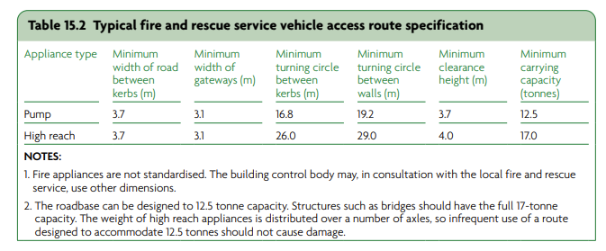

Diagram 15.3 from Approved Document B provides a schematic demonstrating a dead end situation.

**Diagram 15.3 Turning Facilities**

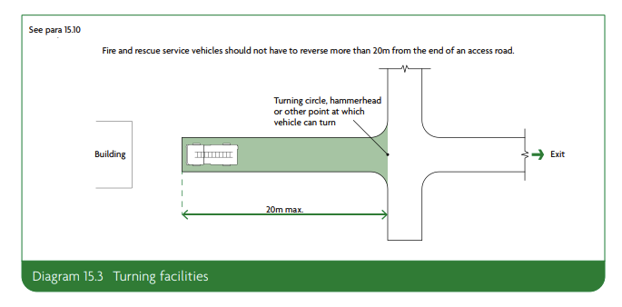

Fire Hydrants and connections to any dry pipe systems that are required to be installed on the BESS site should installed in accordance with BS 9990 (Non-automatic firefighting systems in buildings - Code of Practice) (current edition) and should be identified in accordance with BS 3251 Indicator Plates for Fire Hydrants (current edition).

1. **Spacing between BESS**

NFCC does not support the vertical stacking of containers or units on top of each other on the basis of the level of risk from the vertical fire spread between the BESS, the fire loading and the difficulty in gaining access.

The emergency response plan should be predicated on the scenario of the fire will not spread beyond the BESS container of origin. Fire and rescue operations should be limited to boundary cooling of surrounding BESS and monitoring the BESS involved in the thermal event.

This outcome can be achieved through a number of different routes including:

* Adequate separation between the BESS enclosures to ensure that the radiant heat from a thermal event in one BESS will not trigger a secondary event.
* Provision of fire resistant materials that will prevent direct flame impingement or radiated heat affecting adjacent BESS and allowing the incident to develop beyond BESS of origin.

The provision of a suppression system to the BESS is unlikely to provide a compensatory feature to allow reduced spacing between BESS.

In the event that the developer cannot demonstrate that a thermal event / fire can be contained to the BESS of origin, then the developer should be referred to guidance such as the separation distances within NFPA 855 (current edition - 2023). NFPA 855[12] states separation can be reduced to at least 3 feet or 0.914m between BESS if tests such as UL 9540A shows propagation does not occur.

* 1. **Spacing to other buildings beyond perimeter of site**

Individual site designs will mean that distances between BESS units and occupied buildings / site boundaries will vary. Proposed distances should take into account risks including the impact of any vapour cloud and also any mitigation factors that have been incorporated into the site design.

However, an initial minimum distance of 30m is proposed prior to any mitigation such as blast walls. This distance is based upon the 100ft distance cited in NFPA 855 for remote installations[13].

1. **Site Conditions**

In addition to the risk of an incident occurring within the BESS, the site needs to be maintained in order to prevent a fire spreading to the BESS or indeed fire loading, by providing a ‘bridge’ or path between BESS units to transmit flaming or radiant heat.

It is important that no combustible material is adjacent to BESS units and that clear access is maintained. Areas within 10 metres of BESS units should be kept clear of combustible vegetation and all other vegetation within the curtilage of the site should be kept in a condition such that it does not increase the risk of a fire on the site.

Areas with wildfire risk or vegetation that would result in a significant size fire should be factored into the assessment. Additional separation distances should be factored in to prevent a fire spreading to the BESS or increasing the ambient temperature within the BESS above the tolerances of the safe working temperature.

1. **Water Supplies**

Pumping fire appliances in the UK typically have a water storage capacity of approximately 1,800-2,000 litres of water which can be exhausted in under five minutes per appliance. Therefore, to supplement the supply of water, the site needs to be supplied with a water supply for FRS to utilise in the event of an emergency.

There must be enough water available for firefighting to take place and to manage a reasonable worst-case scenario. Depending on the site this could be water in storage tanks, lagoons on site, access to hydrants or mains water supply.

The amount of water required will vary and will be dependent on a number of factors including:

* The size of the incident to be dealt with e.g. 1 x BESS unit
* The principles of the emergency response plan and the expectation of the role of the FRS (firefighting strategy).
* Access and facilities for firefighters on site
* BESS location and proximity to infrastructure or areas of population.
* The requirement to supplement any on site firefighting facility such as a dry pipe sprinkler / deluge system.

Several manufacturers of BESS now advocate that should the BESS unit have a thermal event and progress to thermal runaway, the BESS unit should be allowed to consume itself i.e. burn itself out. Furthermore, an increasing number of manufacturers of BESS suggest that applying firefighting jets to the BESS will have limited affect and could prolong the duration of the thermal event unnecessarily. In these instances, water fog or spray pattern branches should only be directed to areas to ensure the incident does not spread to adjacent BESS.

If it can be confirmed that the recommended firefighting tactic for the BESS is to defensively fire fight and boundary cool whilst allowing the BESS to consume itself, this will reduce the water requirements, and thus the drainage / environmental protection requirements significantly.

IP ratings of units should be known so that risks associated with boundary cooling can be understood.

It is therefore imperative to enable the formation of the emergency response plan that the manufacturer’s instructions are followed to ensure that any incident is brought to a swift and safe conclusion with minimal damage to the environment and the local area.

Fire hydrants and connections to any dry pipe systems that are required to be installed on the BESS site should installed in accordance with BS 9990 Non-automatic firefighting systems in buildings code of practice (Current Edition) and should be identified in accordance with BS 3251 Indicator Plates for Fire Hydrants (Current Edition).

Fire Hydrants provided should achieve a flow rate of no less than 25 litres / second at any hydrant on the site[14]. This figure is based on guidance produced by Water UK and the Local Government Association. The flow rate for transportation has been selected as the comparative value for flow rates, rather than that of a domestic housing development or an industrial setting.

Where a flow of 25 litres / second cannot be achieved, it would be prudent to provide an equivalent static supply of water on site that will provide for the same flow rate for a duration of 120 minutes. This equates to approximately 180,000 litres of water. Consideration should be given, within the site design, to the management of water run-off (e.g. drainage systems, interceptors, bunded lagoons).

Water supplies for any onsite suppression system will require to be sized independently for the design fire size of the BESS by a competent fire engineer.

Any static water storage tanks designed to be used for firefighting must be located at least 10 metres away from any BESS container / cabinet to allow for safe access and usage. They must be clearly marked with appropriate signage. They must be easily accessible to FRS vehicles and their siting should be considered as part of a risk assessed approach that considers potential fire development / impacts. Outlets and connections should be agreed with the local FRS. Any outlets and hard suction points should be protected from mechanical damage (e.g. through use of bollards).

1. **Signage**

Signage should be installed in a suitable and visible location on the outside of BESS units identifying the presence of a BESS system. Safety signage should be installed in accordance with Health and Safety (Safety Signs and Signals) Regulations 1996. Signage should also include details of:

* Relevant hazards posed.
* The type of technology associated with the BESS.
* Any suppression system fitted.
* 24/7 Emergency contact information signs on the exterior of a building or enclosure should be sized such that at least one sign is legible at night at a distance of 30 metres or from the site boundary, whichever is closer[15].

Adherence to the Dangerous Substances (Notification and Marking of Sites) Regulations 1990 (NAMOS) should be considered where the total quantity of dangerous substances exceeds 25 tonnes.

1. **Emergency Response Plan**

To ensure the provision of risk information to the FRS, the site operator should develop and share an emergency response plan with the local FRS point of contact. There will be variance in the layout and design of each operator’s emergency response plan, but it should contain the following broad subject areas:

* How the FRS will be alerted.
* A facility description, including infrastructure details, operations, number of personnel and operating hours.
* A site plan depicting key infrastructure: site access points and internal roads, firefighting facilities (water tanks, pumps, booster systems, fire hydrants, fire hose reels etc), drainage, and neighbouring properties.
* Details of the emergency response co-ordinator including the subject matter expert for the site.
* Safe access to and within the facility for emergency vehicles and responders, including to key site infrastructure and fire protection systems.
* Details and explanation of warning systems and alarms on siteand locations of alarm annunciators with alarm details (smoke, gas, temperature).
* Hazards and potential risks at the facility and details of their proposed management.
* The role of the FRS at incidents involving a fire, thermal event or fire spreading to the site.
* Emergency shutoff or isolator locations.

1. **Site Plans and Maps**

In addition, site plans should be provided to the FRS that include:

* + The layout of buildings.
  + Any areas where hazardous and flammable materials are stored on site (location of gas cylinders, process areas, chemicals, piles of combustible wastes, oil and fuel tanks).
  + All permanent ignition sources on the site and show they are a minimum of 6m away from combustible and flammable waste.
  + Any areas where combustible waste is being treated or stored including non-waste material.
  + All separation distances.
  + Any areas where combustible liquid wastes are being stored.
  + Any area where depollution of ELVs takes place.
  + Any area where crushing, shredding, baling of metals or ELVs takes place.
  + Main access routes for fire engines and any alternative access.
  + Access points around the site perimeter to assist firefighting.
  + Hydrants and water supplies.
  + Areas of natural and unmade ground.
  + Drainage runs, pollution control features such as drain closure valves, and fire water containment systems such as bunded or kerbed areas (this may be easier to show on a separate drainage plan).
  + Storage areas with pile dimensions and fire walls (where applicable) – this includes wastes stored in a building, bunker, or containers – include indicative pile layouts and ensure it is geographically representative.
  + The location of fixed plant or storage location of mobile plants when not in use.
  + The location of spill kits.
  + The quarantine area.
  + Anything site specific considered needing to be added.

There must have plans showing all sensitive receptors within a 1km radius of the site that could be affected by a fire. Examples of sensitive receptors may include:

* Schools, hospitals, nursing and care homes, residential areas, workplaces.
* Protected habitats, watercourses, groundwater, boreholes, wells and springs supplying water for human consumption – further habitat information can be found on the Defra [MAGiC map website](http://magic.defra.gov.uk/MagicMap.aspx).
* Roads, railways, bus stations, pylons (on or immediately adjacent to the site only), utilities, airports

Plans must have a compass rose showing north and the prevailing wind direction.

1. **Environmental impacts**

Suitable environmental protection measures should be provided. This should include systems for containing and managing water runoff. System capability / capacity should be based on anticipated water application rates, including the impact of water based fixed suppression systems.

Sites located in flood zones should have details of flood protection or mitigation measures.

1. **Recovery**

The operator should develop a post-incident recovery plan that addresses the potential for re-ignition of ESS and de-energizing the system, as well as removal and disposal of damaged equipment.

1. **Bibliography**

1. BSI - Electrical installations. Protection against fire of battery energy storage systems for use in dwellings. Specification. 2024. PAS63100. [PAS 63100:2024 now available - Wiring and the Regulations BS 7671 - IET EngX - IET EngX (theiet.org)](https://engx.theiet.org/f/wiring-and-regulations/30482/pas-63100-2024-now-available?pifragment-2370=2)

2. Acts, UK Public General. Fire and Rescue Services Act 2004. <https://www.legislation.gov.uk/ukpga/2004/21/contents>.

4. CFA's Design Guidelines and Model Requirements for Renewable Energy Facilities v4 (2023). *CFA.* [Online] 4, 2023. <https://www.cfa.vic.gov.au/plan-prepare/building-planning-regulations/renewable-energy-fire-safety>.

5. Statistics, National. National Statistics: Engery Trends: December 2023. <https://assets.publishing.service.gov.uk/media/6582da2d23b70a0013234cef/Energy_Trends_December_2023.pdf>.

6. The Building Regulations 2010; Fire Safety Approved Document B. 2019. [Fire safety: Approved Document B - GOV.UK (www.gov.uk)](https://www.gov.uk/government/publications/fire-safety-approved-document-b)

7. Systems, Standard for the Installation of Stationary Energy Storage. *Energy Storage NFPA 855: Improving Energy Storage System Safety.* 2024. [NFPA855_Safety_240111.pdf (cleanpower.org)](https://cleanpower.org/wp-content/uploads/gateway/2024/01/NFPA855_Safety_240111.pdf)

8. UK, Local Government Association and Water. *National guidance document on the provision of water for fire fighting.* 2007 (Third Edition). pp. Appendix 5 (pages 37-38). [Microsoft Word - National guidance document on water for ffg FINAL.doc](https://www.water.org.uk/wp-content/uploads/2018/11/national-guidance-document-on-water-for-ffg-final.pdf)

9. Grönlund O, Quant M, Rasmussen M, Willstrand O, Hynynen J. Guidelines for the fire protection of battery energy storage systems. *RI.SE.* 2023. <https://urn.kb.se/resolve?urn=urn:nbn:se:ri:diva-68770>.

10. Electric, China. Institute of energy storage and novel electric technology. 2021.

11. Four Firefighters Injured in Lithium-Ion Battery Energy Storage System Explosion - Arizona. McKinnon, M B, DeCrane, S and Kerber, S. 2020, Firefighter Safety Research Institute.

12. Frazer Nash. *Smart: Energy Storage & Flexibility Innovation. Health and Safety Guidance for Grid Scale BESS* 2024. [Health and Safety Guidance for Grid Scale Electrical Energy Storage Systems (publishing.service.gov.uk)](https://assets.publishing.service.gov.uk/media/661feca73771f5b3ee757fac/grid-scale-storage-health-safety-guidance.pdf)

13. BSI. Flameless explosion venting devices . *Standard.* 2011. BS EN 16009:2011.

14. Explosion Suppression Systems. *Standard.* 2021. BS EN 14373:2021.

15. Explosion venting devices. 2007. BS EN 14797.

1. **Additional Resources**
2. NIPV Report EU Energy Storage Systems Safety Conference 2023. Hessels. December 2023. [20231218-NIPV-Report-EU-Energy-Storage-Systems-Safety-Conference-2023.pdf](https://nipv.nl/wp-content/uploads/2023/12/20231218-NIPV-Report-EU-Energy-Storage-Systems-Safety-Conference-2023.pdf)
3. American Clean Power Association Draft Emergency Response Plan. American Clean Power Association Draft Emergency Response Plan. [Energy Storage Emergency Response Template | ACP (cleanpower.org)](https://cleanpower.org/resources/energy-storage-emergency-response-template/)
4. FM Global (2017) Property Loss Prevention Data Sheets: Electrical Energy Storage Systems Data Sheet 5-33. [FM Global Loss Prevention Data Sheets – FM Global](https://www.fmglobal.com/research-and-resources/fm-global-data-sheets)

1. [Energy Trends December 2023 (publishing.service.gov.uk)](https://assets.publishing.service.gov.uk/media/6582da2d23b70a0013234cef/Energy_Trends_December_2023.pdf)
2. State of Victoria (County Fire Authority) (2022), Design Guidelines and Model Requirements: Renewable Energy Facilities, p.4
3. Gronland, Quant et al RISE Report 2023:117
4. Table 2 Page 15 Gronland, Quant et al RISE Report 2023:117
5. Surprise, Arizona 2019
6. BS EN 16009:2011 Flameless Explosive Venting Devices; BS EN 14373:2021 Explosion Suppression Systems; BS EN 14797:2007 Explosion venting Devices.
7. Dahongmen Incident, Beijing, 2021.
8. UL FSRI (2020) Four Firefighters injured in Lithium- Ion Battery Energy Storage System Explosion- Arizona pp 47-49
9. <https://www.pnnl.gov/news-media/pnnl-invention-reduces-risk-battery-explosions>
10. NFPA (2023) Standard for the Installation of Stationary Energy Storage Systems, para G.1.4.3.3
11. [Approved Document B (fire safety) volume 2: Buildings other than dwellings, 2019 edition incorporating 2020 and 2022 amendments (publishing.service.gov.uk)](https://assets.publishing.service.gov.uk/media/639ae876e90e0721839ea637/Approved_Document_B__fire_safety__volume_2_-_Buildings_other_than_dwellings__2019_edition_incorporating_2020_and_2022_amendments.pdf)
12. NFPA 855. Standard for the Installation of Stationary Energy Storage Systems. (2023)
13. NFPA 855. Standard for the Installation of Stationary Energy Storage Systems. (2023)
14. Appendix 5 Guidelines on flow requirements for firefighting. National Guidance document Jan 2007 3rd Edition [Microsoft Word - National guidance document on water for ffg FINAL.doc](https://www.water.org.uk/wp-content/uploads/2018/11/national-guidance-document-on-water-for-ffg-final.pdf)
15. NFPA 855. Standard for the Installation of Stationary Energy Storage Systems. (2023)