Risk Analysis
Who is the guidance for?
This guidance on Risk Analysis in the Community Risk Management Plans (CRMP) process is for those tasked with leading and managing and developing the CRMP for UK Fire and Rescue Services.

According to the CRMP Approved Fire Standard, fire and rescue services must:

Analyse risk, consider its risk appetite, determine the risk levels and prioritise risk accordingly

In 2020, the NFCC’s Community Risk Programme (CRP) through its Definition of Risk (DOR) project, delivered a national definition of risk, a glossary of risk-related terms and a conceptual risk framework for the UK Fire and Rescue Service, to help bring national and local consistency to community risk management planning.
It is important to note that the whole CRMP is underpinned by three key themes that should support, influence, and inform each individual component throughout the whole process:
- Data and Business Intelligence.
- Equality / People Impact Assessment (EqIA).
- Stakeholder and Public Engagement.

These themes should be utilised to ensure each component within the process has been developed using a broad range of community and organisational intelligence, and links are made throughout this guidance.
Individuals within a Fire Service who work to develop a CRMP may differ between fire services and may differ from one cycle of CRM planning work to the next. With these acknowledgements in mind, a series of competency frameworks have been developed which aim to clearly articulate the requisite competencies (behaviours, skills, knowledge, experience, and techniques) required to undertake CRM planning. Within the competency frameworks the requisites are outlined for strategic level staff members, as well as risk analysis and implementation level staff members.
Overview
The element of the CRMP process is where risk level of an identified hazard is determined.
The sources and causes of the hazardous events generated during hazard identification should be considered, their consequences, and the likelihood of those consequences occurring.
This involves developing an understanding of each hazardous event, including the effectiveness of current control. It will generate the ‘risk level’. This should be compared with the risk criteria defined as part of Scope, to identify whether additional controls are needed.
The risk assessment will inform priorities for improvements to, and/or adjustments to, control activities and the associated deployment of resources. Your decisions should take account of the Scope, and the actual and perceived consequences to external and internal stakeholders.
Your risk assessment should comprise an appreciation of:
- the sources and causes that lead to the hazardous events.
- the consequences that could occur (expressed in terms of your objectives), along with their nature and magnitude.
- the associated likelihood of those consequences occurring.
- the effectiveness of the control activities that you already have in place
- the risk level
- where further resources should be directed and for what effect
- uncertainty in any of the above.

“We encourage all practitioners involved in risk management to have a good awareness of the limitations of their risk management methodologies, as this will influence the relative validity of findings, and push FRSs to continue to improve their methodologies” (National Review of Community Risk Methodology across the UK Fire and Rescue Service)
Likelihood
Likelihood is defined as calculating the probability and/or frequency of a hazardous event occurring, this includes determining the influence of causal factors and existing organisational control measures will have on the overall likelihood.
Assessing risk also requires determining the likelihood of experiencing consequences. In the absence of complete data, likelihood might in part involve an expression of informed beliefs based on available data or other information.
The method of expressing likelihood should be consistent with the scope. This align with the Fire Service’s CRMP refresh cycle. Even if comparative terms (such as 'likely' or 'rare') are used to label bands of likelihood, these need to be defined in relation to a time period.
You can estimate likelihood by either using:
- historical data based on similar events that have occurred (note this can only be used if there is sufficient historical data for the analysis to be statistically valid)
- Informed Judgement of subject matter experts.

It helps to consider the factors that are associated with the likelihood of a hazardous event occurring. This needs to be informed by the Community Risk CRMP Equality Impact Assessment. For example, the image below produced as part of the DoR project outlines the factors that impact on the likelihood of dwelling fire:
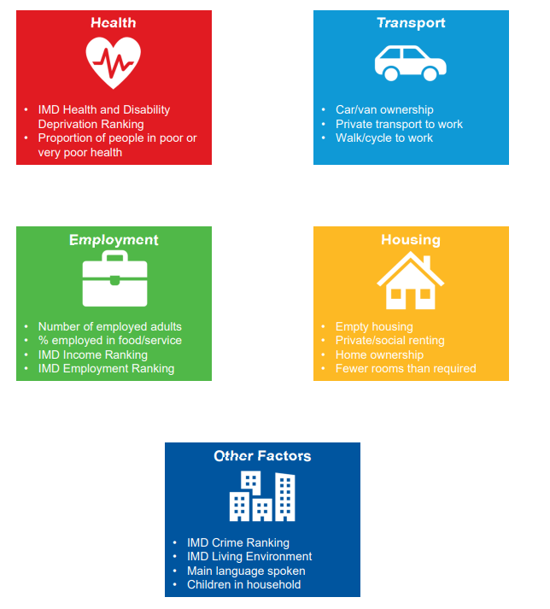
Consequences
What is the severity and extent of the harm caused by a hazardous event? This is determining the impact factors and existing organisational control measures will have on the overall consequences.
Hazardous events lead to either a specific consequence or range of consequences of different types and magnitude.
Determining the type and levels of magnitude of consequences requires collecting, collating and considering relevant available data. Techniques to determine the types and magnitude of consequences might include the following:
- Review of past events (bearing in mind the past might not be indicative of the full range of consequences that are possible)
- modelling, to determine the way in which consequences develop following an event
- considering both immediate consequences and secondary consequences, such as those affecting other objectives, associated systems, activities, equipment or people.
In general, it is harder to draw conclusions about consequence than it is likelihood. For example, while likelihood is assessing the relationship between potential factors and whether or not a dwelling fire occurred, for consequence some measure of the severity of the incident is required.

Determining consequences
Hazardous events lead to either a specific consequence or range of consequences of different types and magnitude.
Determining the type and levels of magnitude of consequences requires collecting, collating and considering relevant available data. Techniques to determine the types and magnitude of consequences might include the following:
- look into past events (bearing in mind the past might not be indicative of the full range of consequences that are possible)
- modelling, to determine the way in which consequences develop following an event
- considering both immediate consequences and secondary consequences, such as those affecting other objectives, associated systems, activities, equipment or people.

Risk Metrics
Process of measuring the level of risk to assist with prioritisation and weighting
As part of the DoR project.
A risk metric is a way of measuring the risk level. Risk is a multi-dimensional concept, so there are many different possible risk metrics. Risk metrics include many ways of combining the likelihood and consequence elements of risk:
- Event frequency – the number of events of a specific type (i.e. more than a specific consequence threshold) in a specific time period. For example, the fire frequency could be the average annual number of fire call-outs in a specific FRS.
- Expectation value – the event frequency multiplied by the event consequence. For example, a fire damage rate could be the average annual cost of damage from fires in the UK.
- Risk matrix – a plot showing the likelihood and consequence of different events, grouped by typically 3-5 likelihood and consequence categories.
- Probability distribution – a distribution showing the likelihood of different consequences of event. For example, the probabilities of different numbers of fatalities, given fires in the UK.
- Exceedance distribution – a distribution showing the likelihood of exceeding different consequences of event. For example, the frequency-fatality (FN) distribution showing the frequency exceeding different numbers of fatalities in fires in the UK.
- Risk contours – lines joining locations exposed to the same risk. For example, contours showing the probability of explosion damage around a chemical plant.

This diversity explains why the expectation value (Definition 4 above) is too specific to be a general definition of risk. Risk metrics should cover all relevant risk groups. For example, they may refer to:

- Injury or fatality risks for people
- Damage probabilities or costs for properties
- Business interruption costs
- Impacts on the environment
- Risk metrics may refer to:

Group risk – the total risk in a specific group. For example, the average number of injuries in a specific FRS or the annual cost of damage from fires in the UK are both types of group risk. National group risks are sometimes called “societal risks”.
- Individual risk – the average risk for individuals within a specific group. For example, the individual risk for a fire-fighter may be expressed as the number of deaths per fire attended, per person-year or per 100 million hours Risk metrics may be expressed as:
- Absolute risk - metrics that directly quantify the risk, comparable to accident statistics. For example, the annual probability of death.
- Relative risk – metrics that are proportionate to the risk but not comparable to accident statistics. For example, DCLG guidance on risk-based fire safety inspection26 uses a relative risk score, which reflects the fire risk in a building by a score between approximately 2 and 8.

In general, is it harder to draw conclusions about consequence that it is likelihood. While likelihood is assessing the relationship between potential factors that could lead to a hazardous event, for consequence some measure of the severity of the incident is required. As part of the DOR project, the NFCC propose an overall consequence score can be calculated by determining consequence score for both life and property:

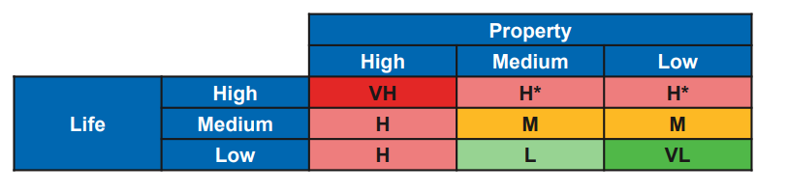

Risk Measure Example: Random Forest Modelling
Random Forest Models calculate a score by comparing historical incident demand and locations with any different combinations of base data variables.

Appendix 1 Domestic Dwelling Fires Risk Methodology
The following is the executive summary from the
This report provides two data-led approaches, one using LSOA data modelling and the other using UPRN data modelling to ensure that all services are able to apply the methodology locally whilst still achieving consistency nationally. Looking forward, we will be working with colleagues within the NFCC Digital and Data Programme to address the current shortfalls in data availability and capture
Some of the key factors linked to likelihood of dwelling fires include car or home ownership, (un)employment, deprivation, property type and tenure. Similar factors are associated with consequence; however, these differ for life and property consequences, and neither provide the robust predictions as for likelihood. Individually, the correlated factors that we have identified do not necessarily contribute to higher risk, however, when considered collectively, these factors can be used to identify areas that are statistically more likely to contain people who are higher risk (January 2022).
The approach involved collecting incident data from Incident Recording System (IRS) and national data on a wide range of potential influencing factors. ORH used data analysis and statistical modelling to assess these factors and develop a long list of associated factors. From this, the focus shifted to producing a framework methodology that any fire and rescue service (FRS) could apply in its local area
The key recommendation is that FRSs follows the Unique Property Reference Number (UPRN) model to evaluate likelihood and consequence. However, we recognise that some FRSs will be more comfortable working at the Lower Layer Super Output Area (LSOA) level, so this methodology is also provide.

