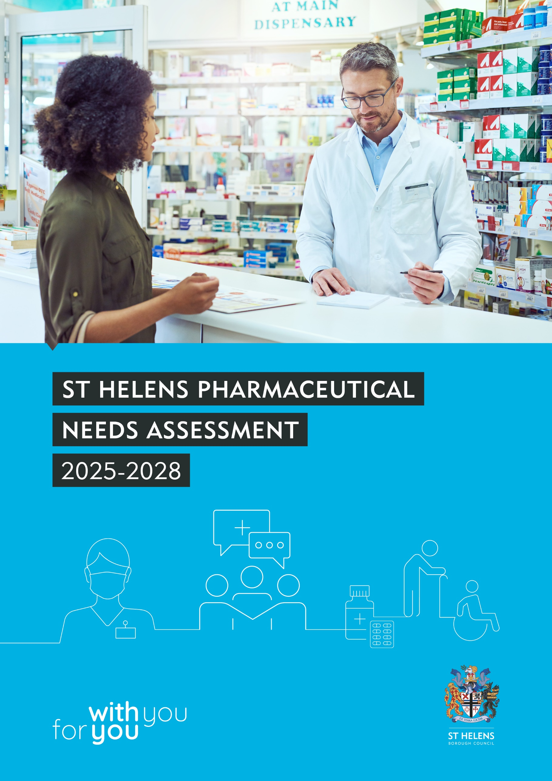

Foreword
Local pharmacies are a really valued local provision and makeup a key part of our local healthcare system, offering access to a wide range of medicines, treatment options and advice close to home. St Helens residents are supported by pharmacies as they provide many services such as advice on new medicines, blood pressure, contraception and many more services highlighted in this document.

This Pharmaceutical Needs Assessment (PNA) document provides an overview of pharmacies in the St Helens area, assessing if these services are adequate to meet the needs of our local residents and identifies any gaps in service provision.

As part of the needs assessment a public consultation was completed in two phases during 2024 and 2025, firstly to obtain views on local pharmacy services and then on the draft needs assessment document. We would like to express our thanks to everyone who took the time to take part offering comments. The comments, where applicable, have been integrated into the final version of the PNA.

The findings from this assessment will be used to inform future commissioning decisions on local pharmacy provision in the Borough.

The PNA is quite a lengthy and technical document and as such an ‘‘easier to read’’ version of this document which will be made available.
We are grateful for the support from the steering group and acknowledge the assistance from our partners in producing this final document.
  Councillor Sue Murphy MBE  Public Health Portfolio Holder,  St Helens Borough Council | 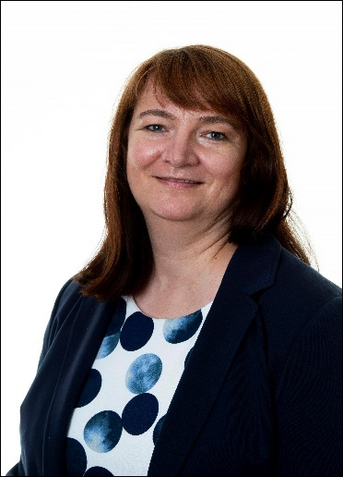  Ruth du Plessis  Director of Public Health,  St Helens Borough Council
Version Control
Main Authors: Diane Bolton-Maggs, Rachel Brown, Aylish MacKenzie
Editor: Diane Bolton-Maggs, Rachel Brown, Aylish MacKenzie
Issue Date: 1 October 2025
Review Date: Supplementary Statements as necessary with a formal review by 1 October 2028
Version | Summary of Changes | Date of Issue
2011 PNA | First formally approved PNA for Halton & St Helens PCT (Primary Care Trust) | 1 February 2011
2015 PNA | Published St Helens People’s Board first PNA | 1 April 2015
2018 PNA | Published St Helens People’s Board second PNA | 1 April 2018
2022 PNA | Published St Helens People’s Board third PNA | 1 April 2018
2025-2028 PNA | Draft for consultation presented to People’s Board | 20 March 2025
 | Completed version St Helens People’s Board | 1 September 2025
 | Published St Helens People’s Board fourth PNA | 1 October 2025

*PNA = Pharmaceutical Needs Assessment
PNA Working Group Members
- Ruth du Plessis: Director of Public Health, St Helens Borough Council
- Diane Bolton-Maggs: Public Health Consultant, St Helens Borough Council
- Rachel Brown: Public Health Intelligence Lead, St Helens Borough Council
- Aylish MacKenzie: Public Health Practitioner, St Helens Borough Council

Acknowledgements
- Cheshire & Merseyside colleagues for support throughout development of the PNA together with Cheshire & Merseyside ICB for arranging the sub-regional steering group.
- Pharmacies for completing the contractor survey.
- Helen Murphy, Chief Officer Community Pharmacy Halton, St Helens and Knowsley, for supporting the provision of information.
- Jackie Jasper, Primary Care Manager, Integrated Care Board (ICB) for advice and supporting the provision of information.
- Marketing and Engagement Team at St Helens Borough Council for supporting the public survey and the statutory consultation.
- Liverpool City Council for setting up and administering the public survey on behalf of Cheshire & Merseyside.
- Sara Manson, Principal Planning Officer, St Helens Borough Council for providing information and map of planned housing developments.
- Emma Beck, Public Health, St Helens Borough Council, for administration support.
- St Helens networks for distributing the public survey.
- The residents of St Helens for taking the time to give their views in the public survey.

Abbreviations Used in the PNA
ADHD | Attention Deficit Hyperactivity Disorder
AMR | Antimicrobial Resistance
AUR | Appliance Use Review
CATC | Care at the Chemist
CPCS | Community Pharmacist Consultation Service
DALP | Delivery and Allocations Local Plan
EHC | Emergency Hormonal Contraception
EVA | Economic Viability Assessment
GIRES | Gender Identity Research & Education Society
GP | General Practice / General Practitioner
HIV | Human Immunodeficiency Virus
HLE | Healthy life expectancy
HRT | Hormone Replacement Therapy
HWB | Health and Wellbeing Board
ICB | Integrated Care Board
IMD | Index of Multiple Deprivation
JSNA | Joint Strategic Needs Assessment
LA | Local Authority
LD | Learning disability(ies)
LE | Life expectancy
LGB(T)+ | Lesbian, Gay, Bisexual (Transgender)+
LMC | Local Medical Committee
LPC | Local Pharmaceutical Committee
LPS | Local Pharmaceutical Services
LSOA | Lower Super Output Area
NHS | National Health Service
MAR | Medicines Administration Record
MCA | Multi-compartment Compliance Aids
MEC | Minor Eye Conditions
MECC | Making Every Contact Count
MHCLG | Ministry for Housing & Local Government
MMR | Measles Mumps Rubella (vaccination)
NHS | National Health Service
NHS BSA | NHS Business Services Authority
NHSE | NHS England
NICE | National Institute for Health and Clinical Excellence
NMS | New Medicines Service
NRT | Nicotine Replacement Therapy
NSP | Needle & Syringe (exchange) Programme
OFT | Office of Fair Trading
OHID | Office for Health Improvement & Disparities
ONS | Office of National Statistics
PCN | Primary Care Network
PCT | Primary Care Trust
PHE | Public Health England
PNA | Pharmaceutical Needs Assessment
PSNC | Pharmaceutical Services Negotiating Committee
QOF | Quality Outcomes Framework
SHLAA | Strategic Housing Land Availability Assessment
SHMA | Strategic Housing Market Assessment
SMI | Severe Mental Illness
SPS | Specialist Pharmacy Service
UKHSA | UK Health Security Agency
UTC | Urgent Treatment Centres
VCFSE | Voluntary, Community, Faith, and Social Enterprise

Table of Contents
Foreword……………………………………………………………………..2
Executive Summary………………………………………………………………..10
Key Findings………………………………………………………………………...11
PNA Conclusions…………………………………………………………………..13
Part 1: Purpose, process, and explanation of pharmaceutical services……………………………………………………………………..17
1. Introduction………………………………………………………………………18
2. Statements from pharmaceutical regulations (2013)……………………..19
Regulatory Statements……………………………………………………………...19
Statement One: Necessary services: Current provision…………………………19
Statement two: Necessary services: Gaps in provision…………………………19
Statement three: Other relevant services: Current provision……………………19
Statement Four: Improvements and better access: Gaps in provision………...20
Statement five: Other NHS services……………………………………………….20
Statement Six: How the assessment was carried out……………………………20
Map of provision……………………………………………………………………..20
3. Scope and Methodology……………………………………………………….21
3.1. Scope of the PNA………………………………………………………………21
3.2 Geography used for Considering Pharmaceutical Services………………..21
3.3. Methodology and Data Analysis………………………………………………21
3.4 How Data and Other Information Has Been Used to Derive Conclusions..23
3.5 Consultation……………………………………………………………………...24
3.5. PNA Review Process…………………………………………………………..25
3.6. How to use the PNA……………………………………………………………26
Part 2: Health needs based on demography, localities and linked to JSNA…………………………………………………………………………27
4. Population Profile of St Helens……………………………………………….28
4.1. Location………………………………………………………………………….28
4.2. Population Structure and Projections 28
4.3. Future Planning: Housing Developments 32
4.4. Populations with Protected Characteristics 35
4.5. Deprivation and socio-economic factors 43
5. Health Profile of St Helens ………………………………………………………46
5.1 Summary of Health Issues 46
5.2. St Helens People’s Board Priorities 49
Part 3: Current service provision: access; prescribing; advanced and locally commissioned services (including public and contractor survey findings)………………………………………………50
6. Pharmacy Premises ………………………………………………………………51
6.1 Pharmacy Providers 51
6.2. Pharmacy locations and level of provision 54
6.3. Access to and provision of community pharmacy services in local authorities bordering St Helens 58
6.4. Getting to the pharmacy 59
6.5. Pharmacy opening hours, including 72–100-hour pharmacies and distance selling pharmacies. 63
6.6. Access for people with a disability and/or mobility problem 66
6.7. Access for clients whose first language is not English 67
6.8. Pharmacy consultations 68
7. Prescribing …………………………………………………………………………69
7.1. Prescribing volume 69
7.2. Medicines Shortages 71
7.3. Public Satisfaction with Dispensing of Prescriptions 74
7.4. Prescription Delivery Services 75
7.5. Reasonable Adjustments 75
8. Advanced, enhanced and locally commissioned service provision …….77
8.1. Pharmacy provision of advanced, enhanced and locally commissioned services…………………………………………………………………………………………77
8.2. How essential, advanced and locally commissioned pharmacy services support local priority health needs………………………………………………………….80
Appendix 1: Community Pharmacy addresses and opening hours (as of quarter 3 2024-25) …………………………………………………………..84
Appendix 2: Community Pharmacy services ………………………………….87
Appendix 3: Cross border Community Pharmacy service provision…………………………………………………………………….. 91
Appendix 4: Pharmacy Contractor Survey Questionnaire ………………….93
Appendix 5: Public Local Pharmacy Services Questionnaire ……………...97
Appendix 6: Public Survey Respondent Demographics…………………..109
Appendix 7: 60-day statutory Consultation Letter and Questionnaire………………………………………………………… …...110
Appendix 8: 60-day statutory Consultation Response …………………….117
References …………………………………………………………………………118

Table of Figures
Figure 1: PNA development process 22
Figure 2: St Helens resident population compared to England, mid-2023 estimated age and sex structure 29
Figure 3: Percentage of St Helens and England population, by broad ethnic group (2021) 30
Figure 4: St Helens population projections 2020 to 2043 31
Figure 5: Key indicators for pregnancy and maternity 38
Figure 6: St Helens population distribution by national deprivation decile, IMD 2019 and 2015 44
Figure 7: Key health statistics for St Helens, as of February 2025 48
Figure 8: Crude rate (per 100,000 population) of pharmacies in St Helens by ward, as at January 2025 57
Figure 9: Importance of pharmacy location, Q7 of public survey of community pharmacy services 57
Figure 10: Method used to get to the pharmacy, Q5 of public survey of community pharmacy services 59
Figure 11: Ease of access usual pharmacy, Q8 public survey of community pharmacy services 63
Figure 12: How many times recently have you needed to use your usual pharmacy (or the pharmacy closest to you) when it was closed, Q17 public survey of community pharmacy services 65
Figure 13: Consultations and satisfaction with privacy during them, Q29 and Q30 public survey of community pharmacy services 68
Figure 14: Prescribing trend, 2019-20 to 2023-24: Trend in average number of prescription items dispensed each month in St Helens and Cheshire and Merseyside 70
Figure 15: Reasons for visiting the pharmacy, Q3 public survey of community pharmacy services 71
Figure 16: When did you last use a pharmacy to get a prescription, buy medicines or to get advice? Q4 public survey of community pharmacy services 71
Figure 17: How important is the delivery of medicines to your home when choosing a pharmacy in terms of products and services? Q32 public survey of community pharmacy services 76
Figure 18: Type of advice or service received recently, Q28 public survey of community pharmacy services 80
Figure 19: How satisfied overall are you with the services and products available at your local pharmacy? Q34 public survey of community pharmacy services 80

Table of Maps
Map 1: Location of St Helens Borough 28
Map 2: Location of housing developments in St Helens 33
Map 3: Geographical distribution of deprivation in St Helens, IMD 2019 45
Map 4: Location of pharmacies in St Helens mapped against other health services 54
Map 5: Pharmacy locations in St Helens mapped against levels of local deprivation by LSOA 55
Map 6: Pharmacy locations in St Helens mapped against population density 56
Map 7: Pharmacies in other boroughs most likely to be used St Helens residents 58
Map 8: Drive times to community pharmacies during the day in St Helens 60
Map 9: Drive times to community pharmacies during rush hour in St Helens 60
Map 10: Walking times to community pharmacies in St Helens 61
Map 11: Travel time to pharmacies by public transport on a weekday morning in St Helens 62
Map 12: Travel time to pharmacies by cycle in St Helens 62

Executive Summary
The Pharmaceutical Needs Assessment (PNA) aims to identify the pharmaceutical needs of people living in St Helens.

The requirement to produce a Pharmaceutical Needs Assessment (PNA) is a statutory responsibility of the St Helens People’s Board (local Health and Wellbeing Board) by virtue of the National Health Service (NHS) Pharmaceutical and local Pharmaceutical services Regulations 2013, which came into force on 1st April 2013. The regulations outline the process which Integrated Care Boards (formerly NHS England) must comply with in dealing with applications for new pharmacies or changes to existing pharmacies. This process relies on the PNA which must be robust and fit for purpose.

Local partner organisations within St Helens have contributed to the development of this PNA. Data sources include the local Joint Strategic Needs Assessment (JSNA), census data, data from commissioners, local approach to health and wellbeing, pharmacy contractors’ survey and a resident’s survey. This information informed the draft PNA which then went out for the statutory (minimum) 60 days consultation.

The PNA presents a picture of community pharmacies, reviews services currently provided, and considers how these could be utilised further. Community pharmacies can support the health and wellbeing of the population of St Helens in partnership with other community services and GPs. Services should be directed towards addressing health inequalities and supporting self-care in areas of greatest need.

Key Findings
Taking into account information gathered for this PNA.
The provision of pharmacy services within St Helens in terms of location, opening hours and services provided is considered adequate to meet the needs of the population.

As such this PNA has not identified a current need for a new
NHS pharmaceutical service provider in St Helens at the point of PNA publication.

We are mindful of proposed housing developments in the borough, the largest of which will be situated in Sutton South East and Bold & Lea Green, however, building is set to commence later than 2029.
Whilst it is anticipated that capacity within existing services should support the overall pharmaceutical needs of future populations during the lifetime of the current PNA, any identified changes in the situation will need to be addressed through a supplementary statement and/or be addressed by the Integrated Care Board (ICB) commissioning or directing existing pharmacies to open for additional hours.

The assessment is based on the following observations:

- St Helens has a larger number of pharmacies in relation to its size of population (20.1 per 100,000) when compared to the England (12.8 per 100,000) and Cheshire & Merseyside (19.35 per 100,000). However, it has a lower rate than the North West which was 27.01 per 100,000 population.

- It is possible to compare prescribing volume by converting total items prescribed into a monthly prescribing rate per pharmacy per 1,000 population. St Helens ICB community pharmacy dispensing volume pattern has consistently been above the Cheshire & Merseyside ICB and North West average. In 2023/24 the St Helens prescribing volume per pharmacy was also higher than in England.

- In 2019/20 3,092,475 prescription items were prescribed in St Helens. By 2023/24 this had risen to 3,957,516 items. The average number of prescription items per month per 1,000 population was 1,620. This was below the Cheshire & Merseyside average of 1,806.5, but higher than the England average of 1,527.5

- There is adequate access to pharmacy services throughout the week, with provision in the evening and at weekends across St Helens. Members of the public commented however, that it is not always easy to access pharmacy services in the evening, i.e., after 7pm, and on weekends. Where any specific service gaps develop these will be addressed initially through dialogue with existing contractors. Our existing network provides a comprehensive essential pharmaceutical service to our population.

- There is adequate provision of locally commissioned services across our population. We will continue to work with our existing contractors to ensure that this provision continues to match the needs of our population and that any inequalities in activity which arise are addressed.

- St Helens population structure is predicted to change during this decade. All age groups aged under 70 are forecast to decrease proportionally between 2020 and 2043, particularly those aged 5-14. Conversely, the proportion of those aged 70 and over is predicted to increase from 15.6% of St Helens’ population to 19.1%. This is an increase of around 8,300 people. The working age population is forecast to shrink proportionally. This ‘ageing population’ is likely to put increased pressure on the NHS and social care as this age group makes up a disproportionately large percentage of GP consultations, hospital admissions and social service contacts. This is likely to have an impact on prescribing levels whereby we can expect an increase, and therefore also an increase on pharmacy workload, assuming that current prescribing patterns persist.

- The UK government as of December 2024 have set increased mandatory housing figures for local authorities. This will see St Helens’ new housing target go from 486 dwellings to 718 dwellings. This will require a review of the local plan; however, it is unlikely that any planned building will change within the next five years. Housing will be reviewed in the 2028 Pharmaceutical Needs Assessment.
- Feedback and information provided by patients, the public and other stakeholders consulted during the development of the PNA showed that people feel that the community pharmacies offer a valuable service, are convenient, and recognise that whilst staff are busy, they are also friendly and helpful.

- Most respondents to the public survey state that access to a local pharmacy was very easy (68%) or quite easy (24%), however, there are some areas of the borough where the nearest pharmacy is more than a 20-minute walk away.

- 70% of our community pharmacies offer a free home delivery service although 58.8% of respondents said they were either not aware of the service or had never used the service. This suggests a potential need for the promotion of this service.

PNA Conclusions

Provision of services and accessibility

Community pharmacy services for St Helens are provided across a range of reasonable geographical locations, with good accessibility and sufficient provision throughout the borough. St Helens has 41 community pharmacies serving a population of 203,547 (total GP registered population, as of January 2025), who provide a comprehensive service with a full range of essential services and some advanced services. This equates to approximately one pharmacy for every 4,965 St Helens GP patients compared to an England average of 5,168 patients per pharmacy (in the previous PNA St Helens had 46 community pharmacies, equating to approximately one pharmacy per 4,000 patients). Consequently, the population remains well served by pharmacy services.

In keeping with the national picture, services are predominantly situated in more densely populated areas of the borough. Thus, less densely populated areas of St Helens have fewer pharmacies per head of population. However, there is wide variation in the pharmacy–to-population ratio across wards, even taking town centre locations into account. Any decisions regarding new pharmacies need to take the population-to-pharmacy ratio in to account. Conversely, any closures need to be carefully monitored to determine the impact this will have on access, especially in those wards where the population-to-pharmacy ratio is already low.

St Helens has geographical borders with the borough of Knowsley, in the southwest, the district of West Lancashire in the north, the borough of Wigan in the northeast, and to the south the boroughs of Warrington and Halton. Members of the St Helens population will cross these borders for leisure and work purposes and also to access pharmacy services if it is more convenient for them and not due to there being a lack of service in St Helens.
The PNA has not identified a current need for new NHS pharmaceutical service providers in St Helens however, this should remain under review alongside the revision of the local plan. However, members of the public commented that it is not always easy to access pharmacy services in the evening, i.e., after 6pm, and weekends.

There is a great deal of satisfaction with pharmacy services from the public in St Helens. Overall, members of the public find them accessible, friendly, and helpful.

Despite the overall geographical differences, and those for availability of extended hour pharmacy provision, the need for ‘emergency prescriptions’ will almost always be centred on patients using ‘out of hours services.’ St Helens is currently covered by two GP Out of Hours providers. This service is provided by either Primary Care 24 or GP Rota depending on which GP practice the patient is registered with. There is also one Urgent Care Centre located at the Millenium Centre, Corporation Street. Pharmacy provision is available on-site or close to these sites with a range of extended hours or 72-100 hour contract pharmacies available to access.

Advanced and Enhanced Services

As part of the production of the PNA document, a review of community pharmacy services was undertaken in relation to population needs, services offered and local/national requirement(s). This allowed a series of conclusions to be made with recommendations as required for each of the services. Table 1 indicates and summarises what conclusions have been made from the completion of this review.

Table 1: Enhanced and Advance Services - Conclusions

Service or Priority | 2025 Conclusions
Pharmacy services | The current pharmacy services across the borough are adequate to meet the needs of St Helens residents.
New Medical Services | Coverage of New Medical Services is adequate to meet the needs of St Helens residents.
Hypertension Case Finding Services | Coverage of Hypertension Case Finding Services is adequate to meet the needs of St Helens residents.
Stop smoking services | Stop smoking behaviour change services can be accessed via specialist smoking cessation services across the borough and are supplemented using nicotine replacement therapy supplied by pharmacies.
Emergency Hormonal Contraception (EHC) | EHC can be accessed throughout the borough and activity is reported to be increasing. It will be essential that EHC providers continue to promote and encourage uptake of routine or long-acting contraceptive methods to those who access EHC.
Pharmacy Contraception Service | Opportunities to access routine contraception now include provision of the NHS Pharmacy Contraception Service, in which registered Pharmacies can initiate and/or supply repeat prescriptions for oral contraception. Due to this service being new in April 2023, we will continue to monitor uptake of this service.
Needle and Syringe Programme (NSP) and Supervised Consumption | Currently there is an adequate number and distribution of services providing NSP and Supervised Consumption based on local need. Supervised Consumption can be accessed via community pharmacy and specialist services across the borough.
Alcohol consumption | We will continue to work with pharmacies and ensure they are aware of services for signposting.
On-demand availability of palliative care | There is generally adequate provision of palliative care services throughout the borough.
Antimicrobial resistance (AMR) | Pharmacies have a role in increasing public awareness of AMR and providing information on how the public can help reduce antibiotic use. St Helens Place continue to meet and work towards our local AMR action plan.
Minor Eye Conditions (MEC) | The MEC medicines supply service is considered adequate for the level of need in St Helens, but this service is reviewed regularly.
Early long-term detection of cancers. | Public Health campaigns will support the early detection of cancers. Additional community events and campaigns are being carried out within the borough and pharmacies will be included where appropriate.
Mental Health | Pharmacies in St Helens support the promotion of the ‘Ok To Ask’ suicide prevention campaign.
Seasonal vaccinations | Influenza (flu) and COVID-19 vaccinations are available at an adequate number of pharmacies across the borough. The pharmacy vaccine programme supports the campaign against seasonal illnesses by offering influenza and COVID-19 vaccinations to those on the NHS eligibility criteria alongside some pharmacies offering private vaccinations.
Obesity | Currently, there are no plans to commission weight management services from pharmacies due to the lack of evidence for effectiveness.
Dementia | Further research needs to be undertaken to ascertain the effectiveness of dementia screening. Community pharmacists can take an active role in dementia by encouraging ‘Dementia Friends’ and by signing up to the Dementia Friendly Community Group.

In addition to essential services, there is adequate access to the full range of advanced services and locally commissioned public health and NHS services to meet local needs.
Based on the information available at the time of developing this PNA, no gaps have been identified in essential, advanced enhanced or locally commissioned services that if provided either now or in the future would secure improvements, or better access, to pharmaceutical services.

Developments which may precipitate the need for changes to pharmacy services

Any conclusions made from this PNA need to consider future developments, such as but not limited to, changes in population, changes in sources/numbers of prescriptions, may take place. This could influence the demand for pharmaceutical services. Hence this PNA is a ‘dynamic’ document.

Workload and demand in pharmacy is driven by two factors: changes to the population and changes to prescribing volume and introduction of additional, new services:

The combined effects of population change (proportion of those aged 70 and over is predicted to increase from 15.6% of St Helens population to 19.1%), and prescribing volume (1,620 per 1,000 population per month) have a compounding effect on the pharmacy workload. It is anticipated that growth in the future will continue at a similar rate. Prescription volumes and service provision needs to be monitored to identify where demand is likely to exceed supply. An ageing population is likely to have an impact on prescribing levels and therefore pharmacy workload, assuming current prescribing patterns persist.

There are also on-going housing developments planned within St Helens. It is anticipated that capacity within existing services should be able to support the pharmaceutical needs over the lifespan of this PNA, however there will be a need for regular review to ensure provision remains adequate in light of any future developments and population growth.

Pharmaceutical Needs Assessment

Part 1: Purpose, process, and explanation of pharmaceutical services

1. Introduction
A Pharmaceutical Needs Assessment (PNA) forms part of the commissioning function for pharmacy services. It relates the current provision of pharmaceutical services to the characteristics of the local population and Health & Wellbeing Board (HWB) priorities for improving health and wellbeing and reducing health inequalities in St Helens. In St Helens, this is the Peoples Board.

The PNA addresses the following broad questions:
- What is the provision of pharmacy service to our population and is this adequate?
- How is the pharmacy contract utilised for the benefit of the population of St Helens?
- How can community pharmacy through its nationally commissioned or locally commissioned services support us to deliver our priorities for health and wellbeing for the population of St Helens?

The effective commissioning of accessible primary care services is central to improving quality and implementing the vision for health and healthcare. Community pharmacy is one of the most accessible healthcare settings. Nationally 99% of the population, including those living in the most deprived areas, can get to a pharmacy within 20 minutes by car. And 96% of people living in the most deprived areas have access to a pharmacy either through walking or via public transport.

The PNA presents a picture of community pharmacies and other providers of pharmaceutical services, reviewing the services currently provided and how these could be utilised further. Community pharmacies can support the health and wellbeing of the population of St Helens in partnership with other community services and GP practices. Services can be directed towards addressing health inequalities and supporting self-care in areas of greatest need. Mapping of service provision and identifying gaps in demand are essential to afford commissioners with the market intelligence they need to take forward appropriate and cost-effective commissioning of services.

All national NHS pharmaceutical service providers must comply with the contractual framework that was introduced in April 2005. The national framework is set out below and can be found in greater detail on the Pharmaceutical Services Negotiating Committee (PSNC) website:
http://www.psnc.org.uk/pages/introduction.html
https://psnc.org.uk/contract-it/the-pharmacy-contract/

The pharmaceutical services contract consists of three different levels:
- Essential services
- National enhanced services: Covid-19 vaccination
- Advanced services

2. Statements from pharmaceutical regulations (2013)

Regulatory Statements
The National Health Service (NHS) Pharmaceutical and local Pharmaceutical Services Regulations (2013) set out the legislative basis for developing and updating PNAs and can be found at: http://www.dh.gov.uk/health/2013/02/pharmaceutical-services-regulations/. Schedule 1 of the regulations sets out the minimum information that is to be contained within the PNA and detailed below are the six statements included in schedule 1, and the necessity for a local PNA map of service providers.

Statement One: Necessary services: Current provision
Provide a statement of the pharmaceutical services that the Health and Wellbeing Board (HWB) has identified as services that are provided:
- In the area of the HWB and which are necessary to meet the need for pharmaceutical services in its area; and
- outside the area of the HWB but which nevertheless contribute towards meeting the need for pharmaceutical services in its area (if the HWB has identified such services).

Statement two: Necessary services: Gaps in provision
Provide a statement of the pharmaceutical services that the HWB has identified (if it has) as services that are not provided in the area of the HWB but which the HWB is satisfied:
- need to be provided (whether or not they are located in the area of the HWB) in order to meet a current need for pharmaceutical services, or pharmaceutical services of a specified type, in its area.
- will, in specified future circumstances, need to be provided (whether or not they are located in the area of the HWB) in order to meet a future need for pharmaceutical services, or pharmaceutical services of a specified type, in its area.

Statement three: Other relevant services: Current provision
Provide a statement of the pharmaceutical services that the HWB has identified (if it has) as services that are provided:
- in the area of the HWB and which, although they are not necessary to meet the need for pharmaceutical services in its area, nevertheless have secured improvements, or better access to pharmaceutical services in its area.
- outside the area of the HWB and which, although they do not contribute towards meeting the need for pharmaceutical services in its area, nevertheless have secured improvements, or better access, to pharmaceutical services in its area.
- in or outside the area of the HWB and, whilst not being services of the types described in sub-paragraph (A) or (B), or paragraph one, of the 2013 regulations, they nevertheless affect the assessment by the HWB of the need for pharmaceutical services in its area.

Statement Four: Improvements and better access: Gaps in provision
Provide a statement of the pharmaceutical services that the HWB has identified (if it has) as services that are not provided in the area of the HWB but which the HWB is satisfied:
- would, if they were provided (whether or not they were located in the area of the HWB), secure improvements, or better access to pharmaceutical services, or pharmaceutical services of a specific type, in its area.
- would, if in specified future circumstances they were provided (whether or not they were located in the area of the HWB), secure future improvements, or better access, to pharmaceutical services, or pharmaceutical services or a specified type, in its area.

Statement five: Other NHS services
Provide a statement of any NHS services provided or arranged by the St Helens HWB, NHS England, NHS St Helens Place Integrated Care Board, any NHS trusts or any NHS foundation trust to which the HWB has had regard in its assessment, which affect:
- the need for pharmaceutical services, or pharmaceutical services of a specified type, in its area or
- whether further provision of pharmaceutical services in its area would secure improvements, or better access to pharmaceutical services, or pharmaceutical services of a specific type in its area.

Statement Six: How the assessment was carried out
Provide an explanation of how the assessment has been carried out, in particular:
- how it has determined what are the localities in its area.
- how it has taken into account (where applicable)
- the different needs of different localities in its area, and
- the different needs of people in its area who share a protected characteristic and
- a report on the consultation that it has undertaken.

Map of provision
A map that identifies the premises at which pharmaceutical services are provided in the area of the HWB.
A map of provision of pharmaceutical services, Map 4, page 55, shows the geographical distribution of both community pharmacies and distance selling pharmacies together with key health services.
There are twelve other maps within the PNA that demonstrate good access to pharmaceutical services in areas with highest population density and highest deprivation as well as most of the population being within 20 minutes walking and public transport distance from a pharmacy and the whole population being covered by a 20 minute drive time even in rush-hour times. Finally, the map of pharmacies outside the St Helens area shows that there is choice of pharmaceutical services within a 2-mile radius in Knowsley, Halton, Knowsley, Warrington, Wigan and West Lancashire

3. Scope and Methodology

3.1. Scope of the PNA
The scope of the assessment of need must address the following principles:
- The safe and efficient supply of medicines.
- Pharmaceutical care that provides quality healthcare and public health information and advice to all members of the population.
- High quality pharmacy premises that increase capacity and improve access to primary care services and medicines.
- Local enhanced services which increase access, choice and support self-care.
- Locally commissioned enhanced pharmaceutical services that have the potential to reduce avoidable hospital admissions and reduce bed-days.
- High quality pharmaceutical support to prescribers for clinical and cost-effective use of resources.

3.2 Geography used for Considering Pharmaceutical Services
St Helens borough is split into 18 electoral wards and these have been used where possible within the analysis. Spatial mapping of service provision has been included in the document to draw conclusions about access to pharmacies and advanced services.

3.3. Methodology and Data Analysis
Key principles of the PNA are:
- It is an iterative process involving patients, the public and key stake holders.
- It is a developing, live document to be refreshed regularly.
- It continues to focus on identifying health needs which can be supported by pharmaceutical services and makes recommendations for the commissioning of those services.
- It is developed through a multidisciplinary PNA Steering Group.

Figure 1: PNA development process
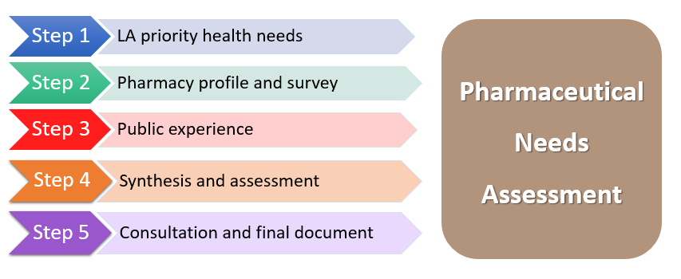

Development of the St Helens Health and Wellbeing Board’s PNA has been initiated and overseen by St Helens Public Health Directorate and a multi-professional working group. The working group consists of:
- St Helens Borough Council Public Health
- Primary Care Manager – Pharmacy, Cheshire & Merseyside Integrated Care Board (ICB)
- Local Pharmaceutical Committee representative
- St Helens Borough Council elected member, Portfolio holder for Public Health

The content of the document is closely linked to the local JSNA and has been produced by means of a structured analysis and distillation of complex and comprehensive data sources to identify the following:
- the health and pharmaceutical needs of the population.
- current local provision of pharmaceutical services, and subsequently.
- gaps in provision of pharmaceutical services.

The following information sources have been used for the development of this PNA:
- Joint Strategic Needs Assessment
- Joint Health & Wellbeing Strategy
- Office for Health Improvement and Disparities’ (formerly PHE) Fingertips tool for additional data on health and wellbeing
- Public Health England’s SHAPE tool for travel time maps
- Data on socio-economic circumstances of the local area
- Community pharmacy providers questionnaire
- NHS Business Services Authority
- Public pharmacy services questionnaire
- St Helens Borough Local Plan

3.3.1 Community Pharmacy Contractors Survey
A short contractors survey was conducting during June-August 2024 to gather data from contractors for information not available from routine sources including NHS BSA (NHS Business Services Authority) and local commissioners. This included a range of questions on external and internal accessibility of premises and reasonable adjustments available.

3.3.2 Public Survey
A survey was conducted between 28th October 2025 and 25th November 2025. It aimed to gather views of people’s experience using their usual pharmacy – how often they used it, whether they had any issues accessing their usual pharmacy/pharmacy services, including prescriptions, when and the impact this had.

3.4 How Data and Other Information Has Been Used to Derive Conclusions
Pharmaceutical need is a broad term which is hard to define precisely. There is not a fixed formula to determine need and whether it has been met or not as there are so many variables that come into play that need factoring in and people live their lives differently in different places. Some factors that are suggested a HWB should consider are:

• When prescriptions are generated and the opening hours. This asks about the generation of the demand; however, the timing of demand will of course vary between acute prescribing and chronic prescribing.

• The distance between pharmacies, access, parking arrangements and walking distance / public transport links for members of the public also must be taken into account. This will naturally be contextually different as you move between urban and rural areas and dispensing doctor practices will also contribute to meeting the provision against need in the truly rural areas. The importance of distance has also changed over time with more and more GP work now performed remotely by video or telephone, many areas are seeing high utilisation of the Electronic Prescription Service and delivery is available to all patients via the provisions within the regulations around Distance Selling Pharmacies.

• Capacity of current pharmacies to meet demand. This is important as the number of premises is not the only context to consider, as an efficiently run pharmacy with the right premises, workforce access and equipment can deal with a high volume of items and patients. This is one reason why, within the Cheshire & Merseyside Contractors Survey, we asked the question "if your business need expanded, how could you cope?" and this will continue to change as contractors bring modern solutions such as use of robotics, more efficient pharmacy computer systems, more efficient ordering routines and off-site assembly. How this could vary and how broad a variation is described in the bullets below:
- Looking at 3 pharmacies at different scales - in 1 month. Pharmacy A (a big Distance Selling Pharmacy) dispensed 1.5 million items, Pharmacy B (city centre destination) did 65k, Pharmacy C (a Health centre) did 11k.
- Pharmacy D (A high street pharmacy with closures nearby) has roughly doubled their capacity in a decade from 11.8k in April 2014 to 21k in December 2023.
- Variation between areas within a place can be really helpful to appraise but must take into account the capacity to deliver described above.

3.5 Consultation
Regulation 8 requires health and wellbeing boards to consult a specified range of organisations on a draft of the pharmaceutical needs assessment at least once during the process of drafting the document. This must be for a minimum period of 60 days.

A draft PNA was published 12:00pm 28 March 2025 inviting comments to be made prior to closing 12:00pm 30 May 2025.

The draft document was distributed as follows: -

Community and Hospital Providers, All Local Pharmacies, Professional Bodies, NHS Bodies and Staff
- All 30 General Practices in St Helens
- All 41 Pharmacies in St Helens
- Bridgewater Community Healthcare NHS Foundation Trust
- Halton, St Helens and Knowsley Local Pharmaceutical Committee (LPC)
- Mersey Care NHS Foundation Trust
- Mersey and West Lancashire Teaching Hospitals NHS Trust
- Mid Mersey Local Medical Committee (LMC)
- Neighbouring Local Authority Health and Wellbeing Boards (or equivalent): St Helens, Warrington, Liverpool, Knowsley, Cheshire East, Cheshire West & Chester
- Neighbouring LPCs of Cheshire & Wirral and Liverpool
- NHS Cheshire and Merseyside
- NHS England
- St Helens Sexual Health Service

Patients and Public
- St Helens Healthwatch
- Voluntary Sector Groups via Halton and St Helens Voluntary and Community Action

Full documentation was published on St Helens Borough Council’s website with an online facility to help readers make comments on the PNA. Respondents were offered paper copies of the PNA if required and they could also complete the survey using a copy of the questions supplied with the invitation letter. Written comments could therefore be made online, completion of the questionnaire electronically or print version sent back to the Public Health team. The PNA was available in English language only.

The 60-day statutory consultation letter and questionnaire can be found in Appendix 7. Responses received during the consultation period can be found in Appendix 8. This includes how the steering group responded to each submission and any amends to the PNA made as a result.

3.5. PNA Review Process
The PNA will be reviewed as an integrated part of the annual commissioning cycle as well as when any changes to the pharmacy contractor list occurs. This action will be overseen by St Helens People’s Board with input from the NHSE Pharmacy Contracts Group. The task is delegated to the Public Health Intelligence Team and the multi-professional steering group who have developed the PNA.

Examples of changes that might dictate a new or diminished pharmaceutical need are:
- New pharmacy contracts.
- Pharmacy closures.
- Changes to pharmacy locations.
- Pharmacy opening hours.
- Local intelligence and significant issues relating to pharmacy enhanced service provision.
- Appliance provision changes.
- Significant changes in health need, housing developments or primary care service developments that may impact either complimentary or adversely on pharmacy-based services.
- Significant changes in workforce due to movement of local businesses/employers.
Typically, this would be in the form of issuing a Supplementary Statement, unless the changes were significant enough that a new PNA was warranted and did not form a disproportionate response to the level of change identified. The PNA must have a complete review every 3 years.

Successful applications for ‘consolidations and mergers’ as part of the revised pharmacy regulations would also necessitate the development of a supplementary statement. Details can be found on the Community Pharmacy England website concerning consolidation and mergers https://cpe.org.uk/quality-and-regulations/market-entry/pharmacy-mergers-consolidations/.

3.6. How to use the PNA
The PNA should be utilised as a service development tool in conjunction with the Joint Strategic Needs Assessment (JSNA) and the strategic plans from local commissioners. Mapping out current services and gaining a sense of future service needs will pinpoint the areas where the development of local pharmaceutical services may be necessary.

The PNA can be used by patients, current service providers, future service providers and commissioners alike in the following way:

- Maps and tables detailing specific services will mean patients can see where they can access a particular service.

- Current service providers will be better able to understand the unmet needs of patients in their area and take steps to address this need.

- Future service providers will be able to tailor their applications to be added to the pharmaceutical list to make sure that they provide the services most needed by the local community.

- Commissioners will be able to move away from the ‘one-size fits all approach’ to make sure that pharmaceutical services are delivered in a targeted way.

- NHSE will be in a better position to judge new applications to join the pharmaceutical list to make sure that patients receive quality services and adequate access without plurality of supply.

Pharmaceutical Needs Assessment

Part 2: Health needs based on demography, localities and linked to JSNA

4. Population Profile of St Helens

4.1. Location
St Helens is situated in Merseyside and is part of the Liverpool City Region (map 1). It covers an area of 136 square kilometres and is home to over 185,000 people with 4,800 businesses based in the borough. It is a place with a strong identity and cultural history, rooted in our world-famous industrial heritage.
Map 1: Location of St Helens Borough
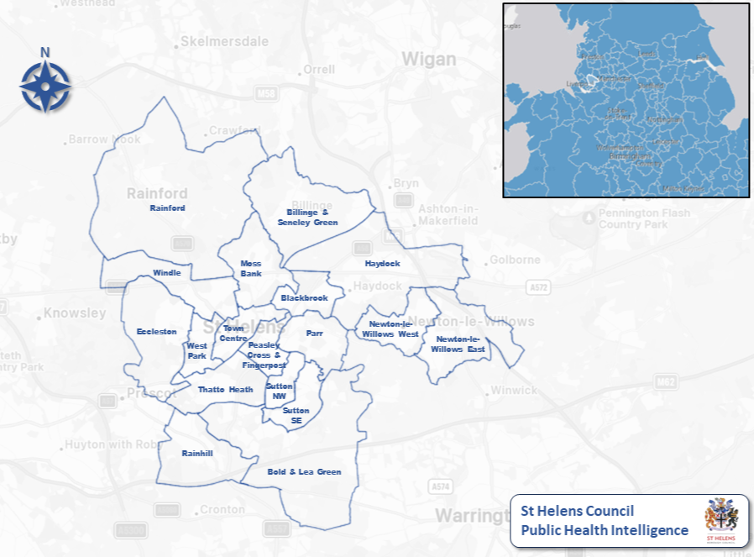

4.2. Population Structure and Projections
The estimated resident population of an area includes all people who usually live there, whatever their nationality. Members of UK and non-UK armed forces stationed in the UK are included whilst UK forces stationed outside the UK are excluded. Students are taken to be resident at their term time address.

4.2.1. Resident population
Population estimates are estimates of what the resident population make-up should look like at that time, and are based on previous years’ births, deaths, and net migration. Office for National Statistics (ONS) mid-2023 population estimates:

- 185,982 people live in St Helens
- 49% of these are male and 51% female (91,397 and 94,585 respectively)

The population age structure is detailed in Figure 2. Compared to the England average the resident population of St Helens has a slightly different structure in the following ages:

- Age bands covering 0-49 years: smaller proportion than England.
- Age bands covering 45–89-year-olds: larger proportion than England.
- Age 90+ years: smaller proportion than England.
Figure 2: St Helens resident population compared to England, mid-2023 estimated age and sex structure

Source: Office for National Statistics

4.2.2. GP Registered Population
The majority of people who reside in St Helens are registered with a St Helens GP for their primary healthcare. However, there is not a 100% match. People who move into and out of the borough may prefer to stay with their original GP. This means that some people residing in our neighbouring boroughs are registered with St Helens GPs and some St Helens residents will be on a GP register outside of the borough. There are more people registered with a St Helens GP than there are residents. 203,547 are registered with a St Helens GP practice (as of January 2025) compared to 185,982 St Helens residents (2023 mid-year estimate).

4.2.3. Ethnicity
In terms of ethnic breakdown of the population, data have only routinely been available from each Census. Census data, published by the ONS, is the gold standard for ethnicity recording in England and Wales.

The most recent Census was carried out in 2021 and data show that St Helens has a larger white population than England as a whole at 96.5% compared to 81.0% in England (figure 3).
Figure 3: Percentage of St Helens and England population, by broad ethnic group (2021)

Source: Office for National Statistics, Census 2021

4.2.4. Resident Population Forecasts
St Helens population structure is predicted to shift over the twenty years. Figure 4 shows all age groups between 5 and 19 years, 25 and 49 years, and 50 and 69 years, are forecast to decrease proportionally between 2020 and 2043.

Conversely, the proportion of those aged 70 and over is predicted to increase from 15.6% of St Helen’s population to 19.1%. This is an increase of around 8,300 people. The working age population, i.e., those aged 16-64 years, is forecast to shrink slightly. This ‘ageing population’ is likely to place increased pressure on the NHS and social care services, as this age group makes up a disproportionately large percentage of GP consultations, hospital admissions and social service contacts. This is also likely to have an impact on prescribing levels and therefore pharmacy workload, assuming current prescribing patterns persist.
Figure 4: St Helens population projections 2020 to 2043

Source: Office for National Statistics, based on 2018 populations

The projections form a "baseline" view of what the population dynamics would be in the given areas if recent demographic trends were to continue. It is important to note that these projections are consistent across England as a whole.
- In the short term (2023 - 2028) St Helens’ population is projected to grow by 1.2% from 183,762 to 186,536.
- In the medium term (2023 - 2033) St Helens’ population is projected to grow by 2.8% from 183,762 to 188,867.
- In the long term (2023 - 2043) St Helens’ population is projected to grow by 5.6% from 183,762 to 194,118. This is lower than the North West region which is projected to grow by almost 9% and nationally, which is projected to grow by 7.5%.
- Younger people (0 - 15-year-olds) - population projected to be smaller, both in total numbers and as a proportion of the total population (2020 - 2043) – this is the case for St Helens, the North West and England.
- Working age (20 - 64 years) - population projected to be similar in terms of total numbers, whilst shrinking very slightly as a proportion of the total population (from 56.9% in 2020 to 54.7% in 2043) – this is also the case in the North West and England.
- Older people (75+) - population projected to grow by 51% from 17,074 in 2020 to 25,791 in 2043. A large increase is also forecast in the North West (60%) and England (67%).
4.2.5 GP registered population changes 2021 to 2025

St Helens has traditionally had a higher GP registered population then resident population. Between January 2021 and January 2025 the GP practice population increased by 2.3% from 198,975 to 203,547.

4.2.6 Births
- In 2023 there were 1,766 live births in St Helens, giving a crude birth rate of 9.5. This is lower than the crude birth rates in England and the North West at 9.8 and 9.7 respectively.
- The crude birth rate in St Helens has decreased from 10.1 in 2022 to 9.5 in 2023. A decrease was also observed nationally and regionally.

4.3. Future Planning: Housing Developments
Over the Local Plan period (2022 – 2037), the Council must deliver a minimum of 486 dwellings a year, this accounts for a target of 7,290 in total. However, due to a change in the National Planning Policy Framework (NPPF), this target will increase, and we should expect our Local Plan to be reviewed prior to 2037 to meet new housing targets.

Table 2 outlines the number of dwellings allocated to be built in each ward within St Helens between 2024 and 2034. Map 2 shows the geographical location of the allocated housing sites in the Local Plan alongside Safeguarded Sites for future development after the plan period. However, we expect these Safeguarded Sites will have to be used sooner than 2037 following the recent changes to the NPPF.

It is important to note that site 4HA has been allocated a total of 2,988 dwellings, with building expected to commence between April 2029 and March 2030, with most of the dwellings being built after 2034. Future pharmaceutical needs will therefore need to be taken into consideration in any future needs assessments and during the planning process for site 4HA. Another large site will be 6HA Moss Bank with a planned 1,100 dwellings with 112 planned between 2024-2029. This site looks to have sufficient pharmacy provision due to being close to the town centre however, we will consider this site in future pharmaceutical needs assessments.

Table 2: Number of dwellings allocated to be built in St Helens by ward

Code | Ward | Number of dwellings allocated 2024-2029 | Number of dwellings allocated 2024-2034
1HA | Billinge & Seneley Green | 112 | 216
2HA | Blackbrook (96%) Haydock (4%) | 112 | 337
4HA | Sutton South East / Bold & Lea Green | 0 | 270
5HA | Bold & Lea Green | 112 | 337
6HA | Moss Bank | 112 | 337
7HA | Newton-le-Willows | 112 | 140
8HA | Rainford | 112 | 259
9HA | Thatto Heath | 112 | 164
10HA | Sutton North West | 112 | 337

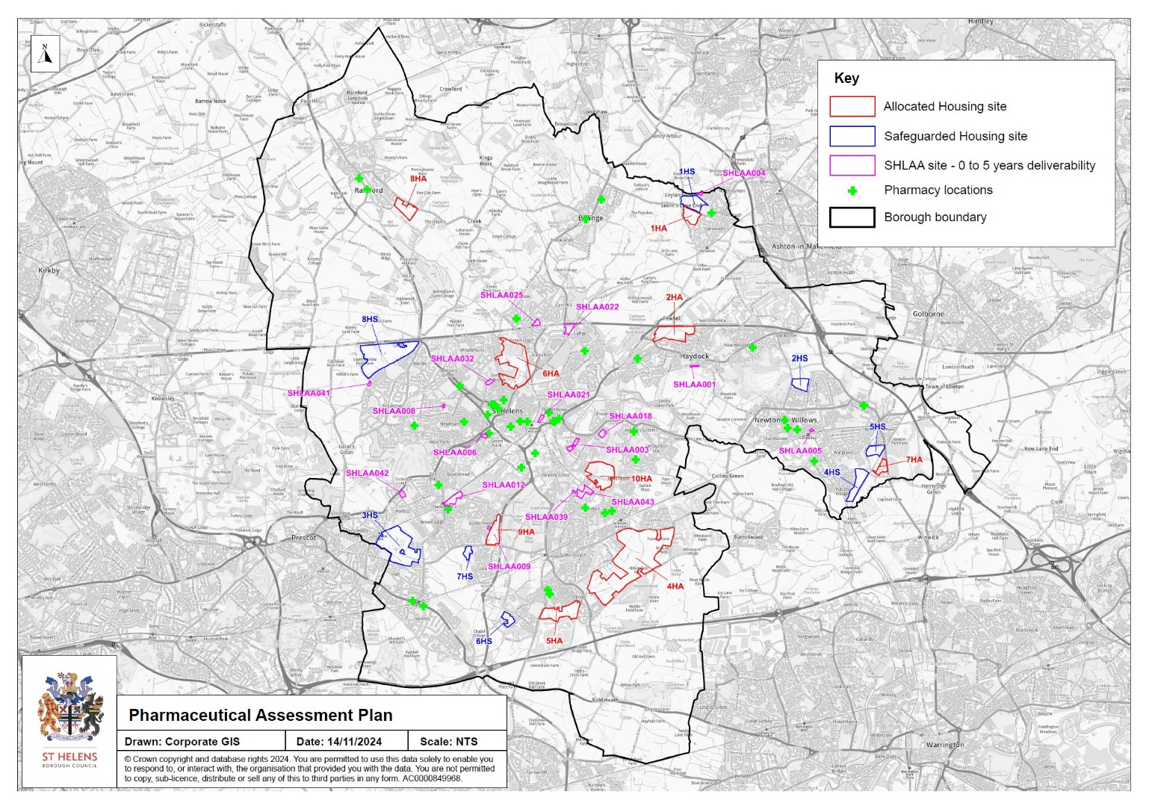
Map 2: Location of housing developments in St Helens

The supply of new houses will come from various sources including:
- Sites listed on the Strategic Housing Land Availability Assessment (SHLAA) – 7,933 dwellings.
- Local Plan Allocated sites – 6,948 dwellings.
- Windfall site – 93 dwellings (per year).

Between the period 2024 – 2029 the expected supply equates to a total of 3,048 dwellings, comprising of:
- Sites with Planning Permission – Not Started. This includes SHLAA sites that have planning permission but not started: 572 dwellings.
- Sites with Planning Permission - Under Construction. This includes SHLAA sites with planning permission and are under construction: 914 dwellings.
- SHLAA sites: 313 dwellings.
- Local Plan Allocations: 784 dwellings.
- Small windfall sites: 465 dwellings.

In the period beyond the initial 5 years, (2029-30 to 2033-34) the Local Plan projects potential for an additional 2,761 dwellings, from the following supply:
- Sites with Planning Permission - Not Started. This includes SHLAA sites that have planning permission but have not been started: 48 dwellings.
- Sites with Planning Permission - Under Construction. This includes SHLAA sites with planning permission and are under construction: 26 dwellings.
- SHLAA sites: 773 dwellings.
- Local Plan Allocations: 1,449 dwellings.
- Small windfall sites: 465 dwellings.

Affordable Housing
The St Helens Strategic Housing Market Assessment (SHMA) Update 2018 identifies that there is a need for 1,987 affordable housing units to be delivered in the Borough between 2016 and 2033 at an average of 117 units per year. It was considered reasonable at this stage to extend this assessment of annual need up until the end of the plan period (2037). Of the overall housing provision of 7,290 dwellings, it is therefore anticipated that about 1,755 (24%) should be affordable.
The Economic Viability Assessment 2018 (EVA) also demonstrated that there are geographical disparities in viability for residential development across the Borough, based on three separate affordable housing zones. These are outlined in Table 3.

Table 3: Affordable Housing Zone Requirements
Zone | Locations (Borough Wards)
1 | Parr, Peasley Cross & Fingerpost, Sutton North West (northern section), Sutton South East (northern section), St Helens Town Centre | No affordable housing requirement due to viability constraints
2 | Billinge & Seneley Green, Blackbrook, Bold & Lea Green, Haydock, Moss Bank, Newton-le-Willows East, Newton-le-Willows West, Sutton North West (southern section), Sutton South East (southern section), Thatto Heath, West Park, Windle (southern section) | ● 30% requirement on greenfield sites  ● 0% requirement on brownfield sites
3 | Eccleston, Rainford, Rainhill, Thatto Heath (western section), Windle (northern section) | ● 30% requirement on greenfield sites  ● 10% requirement on brownfield sites

St Helens has for many years had an identified need for further provision of social and affordable rented housing. This is confirmed in the St Helens SHMA update 2018. The Local Plan requires that where affordable housing is to be required (or contributed towards) as part of a wider scheme – at least 10% of the overall housing provision resulting from the proposals should be for affordable home ownership.

The UK government as of December 2024 have set increased mandatory housing figures for local authorities. This will see St Helens’ new housing target go from 486 dwellings to 718 dwellings. This will require a review of the local plan however, it is unlikely that any planned building will change within the next five years. Housing will be reviewed in the 2028 Pharmaceutical Needs Assessment.

4.4. Populations with Protected Characteristics
There is widespread evidence to demonstrate that some communities, such as people from ethnic minority groups and people from lesbian, gay, bisexual, and transgender (LGBT+) communities, can experience worse health outcomes. Other groups, such as refugees and asylum seekers and disabled people may face barriers to accessing health and social care services as well as support services to move into good employment. This can have an impact on their health and wellbeing.

Under the Equality Act 2010 there are 9 ‘Protected Characteristic’ groups. The numbers and main health issues facing each are detailed in this section. Whilst some of these groups are referred to in other parts of the PNA, this section focusses on their particular health issues.
4.4.1. Age
Population
See section 5.2 for detailed breakdown.
- Under age 18: 37,107 (20.0% of total population)
- 18-64: 110,461 (59.4% of total population)
- 65-74: 19,566 (10.5% of total population)
- 75+: 18,848 (10.1% of total population)
- Total population 185,982 (ONS 2023 mid-year population estimate)

Health issues
Health issues tend to be greater amongst the very young and the very old.

For children:
- Breast feeding is well evidenced to provide health benefits for both mother and baby and to promote attachment. Young mothers are among the groups least likely to breast feed.
- More than eight out of 10 adults who have ever smoked regularly started before the age of 19.
- Eight out of 10 obese teenagers go on to become obese adults.
- Nationally the diagnosis of sexually transmitted infections in young people, such as Chlamydia, has increased by 25% over the past ten years. Young people’s sexual behaviour may also lead to unplanned pregnancy which has significant health risks and damages the longer-term health and life chances of both mothers and babies.
- Alcohol misuse is contributing to increased pressure on a wide range of agencies including health, housing, social care, police, and the voluntary sector.

For older people (65+):
- They are less likely to smoke or drink alcohol to riskier levels. They are less likely to take drugs although the age of people in alcohol & substance misuse services is increasing.
- A high proportion of people aged 65+ live alone and this percentage increases with age. This can lead to loneliness and social isolation.
- The proportion of the population with long-term conditions increases with age.

4.4.2. Sex
Population
See section 5.2 for detailed breakdown
- Women 94,585 (50.9%)
- Men 91,397 (49.1%)
Health issues
- Overall life expectancy (LE), healthy life expectancy (HLE) and life expectancy at 65 are lower for St Helens residents than the England average.
- Male LE for all these measures is lower than females.
- There are significant variations in male and female LE within St Helens at ward level (2019-2023). With Town Centre and Peasley Cross and Fingerpost having the lowest life expectancy and Eccleston having the highest life expectancy.
- Men tend to use health services less than women and present later with diseases than women do. Consumer research by the Department of Health and Social Care into the use of pharmacies in 2009 showed men aged 16 to 55 to be ‘avoiders’ i.e., they actively avoid going to pharmacies, feel uncomfortable in the pharmacy environment as it currently stands due to perceptions of the environment as feminised/for older people/lacking privacy and of customer service being indiscreet.
- The mortality rate for coronary heart disease is much higher in men and men are more likely to die from coronary heart disease prematurely. Men are also more likely to die during a sudden cardiac event. Women’s risk of cardiovascular disease in general increases later in life and women are more likely to die from stroke.
- The proportion of men and women who are obese is roughly the same although men are markedly more likely to be overweight than women. Present trends suggest that weight-related health problems will increase among men in particular. Women are more likely than men to become morbidly obese.
- Women are more likely to report, consult for and be diagnosed with depression and anxiety. It is possible that depression and anxiety are under-diagnosed in men. Suicide is more common in men, as are all forms of substance abuse.
- Alcohol disorders are twice as common in men although binge drinking is increasing at a faster rate among young women. Among older people the gap between men and women is less marked.
- Morbidity and mortality are consistently higher in men for virtually all cancers that are not sex-specific. At the same time cancer morbidity and mortality rates are reducing more quickly for men than women.
- Victims of domestic violence are at high risk of serious injury or death. The majority of victims are female.
4.4.3. Disability
The definition of disability is consistent with the core definition of disability under the Equality Act 2010. A person is considered to have a disability if they have a long-standing illness, disability or impairment which causes substantial difficulty with day-to-day activities. Some people classified as disabled and having rights under the Equality Act 2010 are not captured by this definition, that is people with a long-standing illness or disability which is not currently affecting their day-to-day activities.

Population
The 2021 Census indicates 40,829 people in St Helens have a disability or illness that affects their day-to-day activities; this constitutes 22% of St Helens population, higher than the North West (19.8%) and England (17.7%).

The 2022-23 GP Quality Outcomes Framework (QOF) register shows there were 1,138 people in St Helens with learning disability (LD) known to their general practice. This is a prevalence rate of 0.57%, compared to 0.58% in Cheshire & Merseyside and 0.56% England.

Data from the 2024 GP Patient survey suggests that 84% (pertains to 2,940) of St Helens patients surveyed had a long-term physical or mental health condition. Of those, 12% said it affected their daily life a lot and a further 19% said it affected them a little. 17% said it did not affect ability to carry out their day-to-day activities at all. This is based on a representative sample.

Health issues
- There is a strong relationship between physical and mental ill health. Being physically disabled can increase a person’s chances of poor mental health.
- Co-morbidity of disabling conditions can occur.
- People with LD are living longer and as a result the number of older people with a LD is increasing. Despite the fact that people with LD are 58 times more likely to die before the age of 50 than the rest of the population, life expectancy for people with LD has increased over the last 70 years. Older people with LD need more to remain active and healthy for as long as possible.
- Despite this data from NHS Digital suggests people with learning disabilities still have a 4-5 times higher mortality rate than those without LD.
- Recent data by Office of Health Improvement and Disparities (OHID) suggests those with severe mental illness (SMI) have 2-3 times higher premature (under age 75 years) mortality rates compared to those without SMI. This is driven by higher mortality from cardiovascular disease, cancers and respiratory disease. One other feature is lower cancer screening uptake rates amongst people with SMI.
- Research by the Disability Rights Commission in 2006 found that people with a learning disability are two and a half times more likely to have health problems than the rest of the community.
4.4.4. Pregnancy and maternity
Population
Data from ONS via OHID Fingertips tool shows that St Helens has statistically a similar general fertility rate to that seen nationally. However, the under 18 ‘teenage’ birth rate in St Helens is statistically significantly higher and ranked as 3rd highest in the North West and 17th highest in England. There were 1,858 births in 2022.

Figure 5: Key indicators for pregnancy and maternity
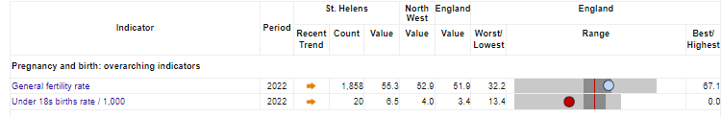

Health issues
There are many common health problems that are associated with pregnancy. Some of the more common ones are backache, deep vein thrombosis, high blood pressure and pre-eclampsia, haemorrhoids (piles), tiredness, headaches, pelvic pain, indigestion, vaginal discharge or bleeding, varicose veins, morning sickness and nausea, amongst others.

4.4.5. Race
Population
See section 4.2.3 for data.

Traveller and gypsy communities
Travellers are a group considered to face some of the highest levels of health deprivation, with significantly lower life expectancy, higher infant mortality, and higher maternal mortality alongside mental health issues, substance, misuse, and diabetes. These issues are representative of various lifestyle factors alongside issues of poor education, lack of integration with mainstream support services and a lack of trust in such institutions.

Refugees and asylum seekers
Asylum seekers are one of the most vulnerable groups within society often with complex health and social care needs. Within this group are individuals more vulnerable still including pregnant women, unaccompanied children, and people with significant mental ill health. Whilst many asylum seekers arrive in relatively good physical health, some asylum seekers can have increased health needs relative to other migrants due to the situation they have left behind them, their journey to the UK and the impact of arriving in a new country without a support network.

The latest data from the Home Office and Ministry for Housing, Communities and Local Government (year ending 30 September 2024) shows that 800 asylum seekers are being supported in St Helens, including 127 Homes for Ukraine arrivals. 574 in dispersed accommodation, and 52 in Contingency Accommodation.

Irregular or undocumented migrants such as those who have failed to leave the UK once their asylum claim has been refused, or those who have been illegally trafficked, also have significant health needs and are largely hidden from health services. Some asylum seekers will have been subjected to torture as well as witnessing the consequences of societal breakdown of their home country – with consequences for their mental health. Culturally, mental illness may not be expressed or may manifest as physical complaints. Stigma may also be attached to mental ill health. Furthermore, Western psychological concepts are not universally applicable to asylum seekers. Mental health problems such as depression and anxiety are common, but post-traumatic stress disorder is greatly underestimated and underdiagnosed and may be contested by healthcare professionals. Children are particularly neglected in this area.

Health issues
- Although ethnic minority groups broadly experience the same range of illnesses and diseases as others, there is a tendency of some within ethnic minority groups to report worse health than the general population and there is evidence of increased prevalence of some specific life-threatening illnesses.
- Ethnic differences in health are most marked in the areas of mental wellbeing, cancer, heart disease, Human Immunodeficiency Virus (HIV), tuberculosis and diabetes.
- An increase in the number of older people from ethnic minority groups is likely to lead to a greater need for provision of culturally sensitive social care and palliative care.
- Ethnic minority groups may face discrimination and harassment and may be possible targets for hate crime.
4.4.6. Religion and belief
Population
Data from the 2021 Census for St Helens residents showed:
- Christian 62.32%
- Buddhist 0.27%
- Hindu 0.32%
- Jewish 0.04%
- Muslim 0.73%
- Sikh 0.03%
- Other religion 0.35%
- No religion 31.21%
- Religion not stated 4.72%

Health issues
- Possible link with ‘honour-based violence’ which is a type of domestic violence motivated by the notion of honour and occurs in those communities where the honour concept is linked to the expected behaviours of families and individuals.
- Female genital mutilation is related to cultural, religious, and social factors within families and communities although there is no direct link to any religion or faith. It is a practice that raises serious health related concerns.
- There is a possibility of hate crime related to religion and belief.
4.4.7. Marital status
Population
Data from the 2021 Census for St Helens showed:
- Single (never married or never registered a same-sex civil partnership): 37.5%
- Married or in a civil partnership: 43.3%
- Separated (but still legally married or still legally in a civil partnership): 2.4%
- Divorced or formerly in a civil partnership which is now legally dissolved: 9.5%
- Widowed or surviving partner from a civil partnership: 7.3%

Health issues
- Literature on health and mortality by marital status has consistently identified that unmarried individuals generally report poorer health and have a higher mortality risk than their married counterparts, with men being particularly affected in this respect.
- A large body of research suggests that the formalisation of opposite-sex relationships is associated with favourable mental health outcomes, particularly among males. Recent analysis of wave 8 (2016-18) of Understanding Society: the UK Household Longitudinal Study suggests this is also the case for females in same-sex civil partnership.
4.4.8. Sexual orientation
Population
Data from the 2021 Census for St Helens showed:
- Straight or Heterosexual: 91.84%
- Gay or Lesbian: 1.60%
- Bisexual: 0.89%
- Pansexual: 0.08%
- Asexual: 0.05%
- Queer: 0.09%
- All other sexual orientations: 0.09%
- Not answered: 5.46%
Health issues
Attitudes toward the community may have an impact on some of their key health concerns around sexual and particularly mental health. A Stonewall survey (2018) found:
- Half of LGBT people (52%) said they’ve experienced depression in the last year.
- One in eight LGBT people aged 18-24 (13%) said they’ve attempted to take their own life in the last year.
- Almost half of trans people (46%) have thought about taking their own life in the last year, 31% of LGB people who aren’t trans said the same.
- 41% of non-binary people said they harmed themselves in the last year compared to 20% of LGBT women and 12% of GBT men.
- One in six LGBT people (16%) said they drank alcohol almost every day over the last year.
- One in eight LGBT people aged 18-24 (13%) took drugs at least once a month.
- One in eight LGBT people (13%) have experienced some form of unequal treatment from healthcare staff because they’re LGBT.
- Almost one in four LGBT people (23%) have witnessed discriminatory or negative remarks against LGBT people by healthcare staff. In the last year alone, six per cent of LGBT people – including 20% of trans people – have witnessed these remarks.
- One in twenty LGBT people (5%) have been pressured to access services to question or change their sexual orientation when accessing healthcare services.
- One in five LGBT people (19%) aren’t out to any healthcare professional about their sexual orientation when seeking general medical care. This number rises to 40% of bi men and 29% of bi women.
- One in seven LGBT people (14%) have avoided treatment for fear of discrimination because they're LGBT.

4.4.9. Gender identity
Population
Data from the 2021 Census for St Helens showed:
- Gender identity the same as sex registered at birth: 95.48%
- Gender identity different from sex registered at birth but no specific identity given: 0.17%
- Trans woman: 0.06%
- Trans man: 0.08%
- Non-binary: 0.03%
- All other gender identities: 0.02%
- Not answered: 4.15%
Health issues
Research from Stonewall (2018) shows:
- Drugs and alcohol are processed by the liver as are cross-sex hormones. Heavy use of alcohol and/or drugs whilst taking hormones may increase the risk of liver toxicity and liver damage.
- Alcohol, drugs and tobacco and the use of hormone therapy can all increase cardiovascular risk. Taken together, they can also increase the risk already posed by hormone therapy.
- Smoking can affect oestrogen levels, increasing the risk of osteoporosis and reducing the feminising effects of oestrogen medication.
- Many transgender people struggle with body image and as a result can be reluctant to engage in physical activity.
- Being transgender, non-binary or non-gender and any discomfort a person may feel with their body, with the mismatch between their gender identity and the sex originally registered on their birth certificate, their place in society, or with their family and social relationships is not a mental illness. Gender dysphoria is the medical term used to describe this discomfort. Transgender people are likely to suffer from mental ill health as a reaction to the discomfort they feel. This is primarily driven by a sense of difference and not being accepted by society. If a transgender person wishes to transition and live in the gender role they identify with, they may also worry about damaging their relationships, losing their job, being a victim of hate crime and being discriminated against. The fear of such prejudice and discrimination, which can be real or imagined, can cause significant psychological distress.

4.5. Deprivation and socio-economic factors
The English Indices of Deprivation provide data on relative deprivation for small areas in Halton and nationally.

The Indices of Deprivation 2019 (ID 2019) are the primary measure of deprivation for small areas or Lower layer Super Output Areas (LSOAs) in England. The indices were published by the Ministry of Housing, Communities & Local Government (MHCLG) in September 2019 and replaced the 2015 indices.

Each LSOA in England is ranked in order of deprivation, and then grouped into ten percentage groups knows as deciles. LSOAs in decile 1 are in the 10% most deprived in the country, and LSOAs in decile 10 are in the 10% least deprived in the country. St Helens has 121 LSOAs.

The main output of the Indices of Deprivation is the Index of Multiple Deprivation (IMD) which combines measures across seven distinct domains of deprivation: income, employment, education, health, crime, barriers to housing and services, and living environment. The IMD is the most widely used output of the indices, but each domain provides insight into a particular area of deprivation.

More of St Helens population are living in areas classified as the 10% most deprived nationally: 25%, an increase from 23.4% in 2015. This is almost 4,524 more people, a total of 46,107 St Helens residents. Figure 6 shows the distribution of St Helens population by national deprivation decile, both in 2019 and 2015.

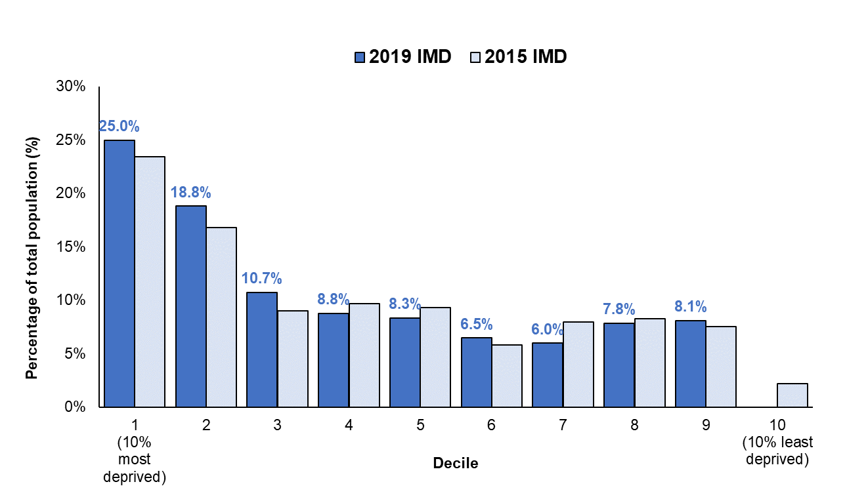
Figure 6: St Helens population distribution by national deprivation decile, IMD 2019 and 2015
Source: ONS Mid Year Populations and Indices of Multiple Deprivation
The proportion of people living in the most deprived 20% nationally increased between 2015 and 2019: 43.8% up from 40.2%. Map 3 shows the levels of deprivation (IMD 2019) across the borough, by lower super output area or LSOA (statistical geographical areas of approximately 1,500 population), using national quintiles.

St Helens is ranked as the 26th most deprived local authority in England (out of 317 local authorities) putting it in the most deprived 10% nationally. In 2015 we were the 36th most deprived local authority, which means that St Helens is now relatively more deprived. As illustrated in Map 3 that Town Centre and Parr are the most deprived areas, but there are borough wide pockets of deprivation. Some areas of Eccleston, Rainford, Rainhill, Billinge & Seneley Green and Newton are less deprived.

When we consider the ‘Health Deprivation and Disability’ domain of the IMD, St Helens ranks as the 8th most deprived local authority in England, with 42% of LSOAs falling within the most deprived 10% of all LSOAs nationally, and 33% falling within the most deprived 5% nationally. In 2015 we were 12th most deprived local authority. Levels of health deprivation are widespread, with the highest relative levels found in the Town Centre, Parr, Bold, West Park and Thatto Heath.

Map 3: Geographical distribution of deprivation in St Helens, IMD 2019

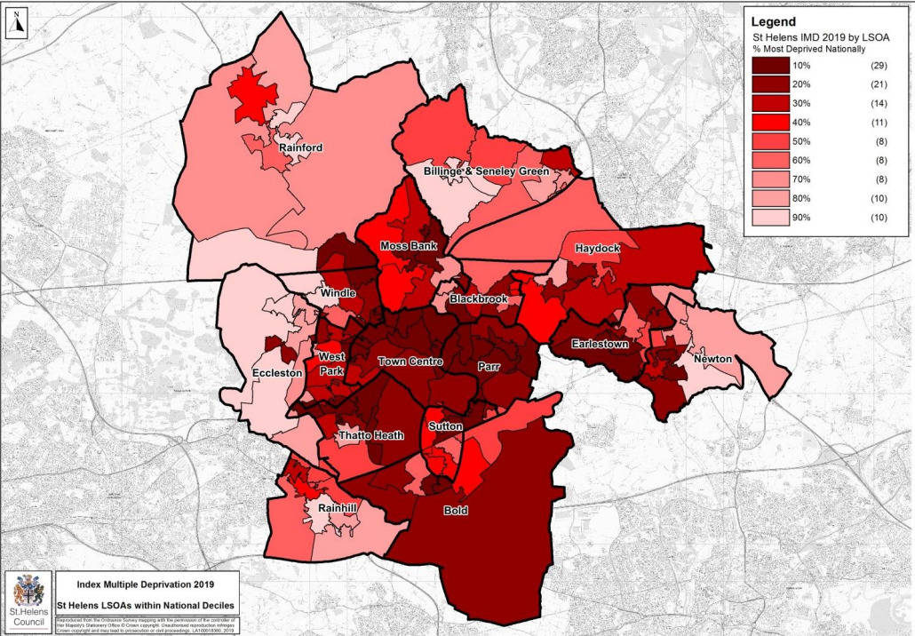

Source: Indices of Multiple Deprivation (2019)

5. Health Profile of St Helens

5.1 Summary of Health Issues
Despite the continuing challenges the borough faces there are some health indicators which show some improvement, particularly in relation to child health indicators. So, whilst the borough’s health continues to be, generally, worse than the England average, these improvements show that in some areas we are moving in the right direction – we are doing the right things for the right people, who are then able to engage with services, making the most of them to bring about positive changes for themselves, their families, and their communities.
Some highlights include:
- Child immunisations and flu vaccination uptake continue to perform well in St Helens. For example, uptake of MMR (measles, mumps, rubella vaccination) is higher compared to the North West and England and uptake of flu vaccination amongst those aged 65 and over is similar to the North West and England.
- Children meeting the expected level of development at age 2-2.5 years is statistically significantly higher than nationally and breastfeeding prevalence at 6-8 weeks is improving, and smoking at the time of delivery is decreasing.
- Smoking prevalence amongst adults continues to fall and is now below the regional average. Inequalities continue e.g., between those in routine & manual occupations and amongst those with mental illness compared to the overall prevalence.
- Smoking at the time of delivery continues to fall.
- There has been a fall in the employment gap between those with a long-term condition and the overall employment rate and is now also below the England value.
- Unemployment levels in St Helens are similar to the North West and England rates.

However, some areas do remain difficult to improve and others have worsened since the previous reporting period:
- Both male and female life expectancy, at birth and at age 65, have worsened and remain statistically worse than England. The most recent life expectancy for 2021-23 is 76.8 years for men and 80.3 years for women.
- Internal differences in both male and female life expectancy remain across the borough.
- There has been an increase in the levels of children living in poverty. The percentage of children living in relative and absolute low-income families has increased.
- The under 18 conception rate is statistically higher than the England average.
- Levels of childhood obesity have increased and are statistically worse than the North West and England averages.
- Hospital admissions amongst young people due to self-harm and due to alcohol are both worse than the North West and England averages.
- The rate of suicide in the borough has increased.
- The rate of working age people economically inactive due to long-term sickness is higher than the North West and England rates.
- Older people being admitted to hospital due to injuries from falls remains a challenge locally with rates above the North West and England averages.
- The uptake of NHS Health Checks has decreased since 2021-22 and is significantly lower than the England average.

Figure 7: Key health statistics for St Helens, as of February 2025
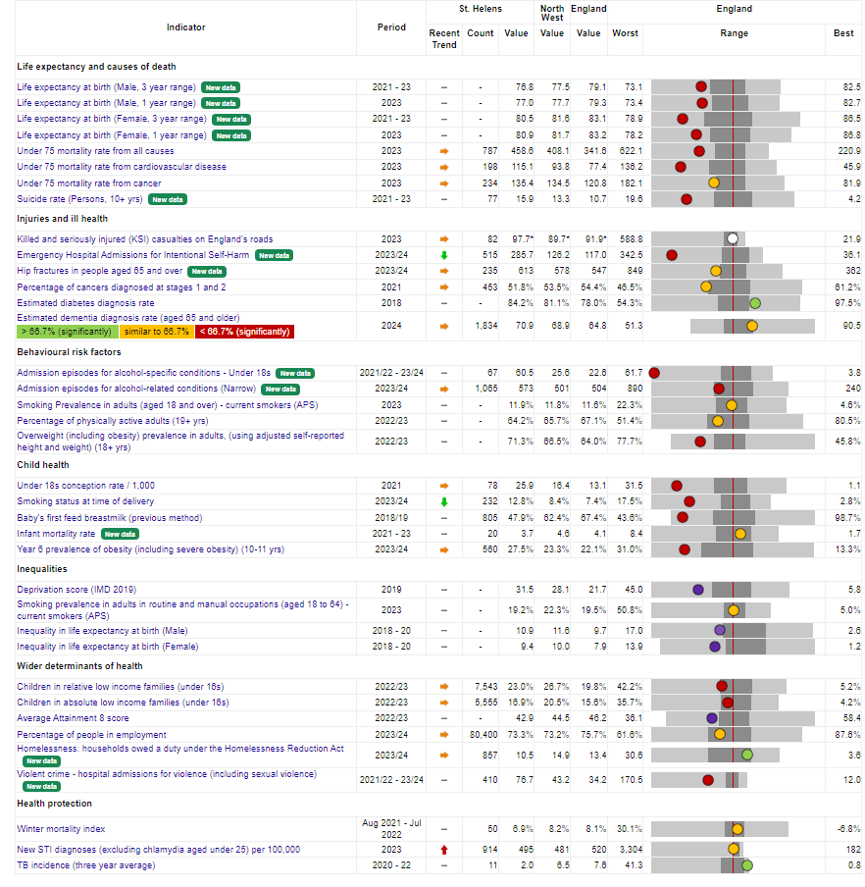
Source: OHID Fingertips tool, Local Authority Health Profiles (accessed 04 February 2025)

5.2. St Helens People’s Board Priorities
The Joint Strategic Needs Assessment (JSNA) has been used to inform leaders and commissioning decisions about the health and wellbeing needs of the borough, as well as the wider determinants that impact on these issues. Following an extensive engagement and prioritisation process, St Helens People’s Board agreed a core set of priorities for its 2024 - 2027 health and wellbeing strategy titled: St Helens People’s Plan.

Our All Age Partner Priorities are:

- Mental Wellbeing
  - Support people who are at risk of self-harm.
  - Reduce social isolation and loneliness in the borough.
  - Improve the emotional wellbeing and mental health of children and young people.
  - Improve the capacity and capability for the VCFSE.

- Healthy Weight
  - Support healthy eating choices in the Borough.
  - Encourage residents to lead a more active lifestyle.
  - Reduce the prevalence of diabetes.

- Care Communities
  - Rolled out Care Communities across four primary care networks.
  - Developed metrics to evaluate the impact of Care Communities.

- Inequalities
  - Improve our standing in Merseyside across a range of Marmot indicators.
  - Raise the aspirations of children and young people in St Helens.
  - Continue to influence partners to reduce inequalities.

The community pharmacy services that can support these priorities are detailed in Part 3, section 8.2.

Pharmaceutical Needs Assessment

Part 3: Current service provision: access; prescribing; advanced and locally commissioned services (including public and contractor survey findings)

6. Pharmacy Premises

6.1 Pharmacy Providers

6.1.1 Community Pharmacy Contractors
Community pharmacy contractors can be individuals who independently own one or two pharmacies or large multinational companies e.g., Lloyds, Boots, Sainsbury’s etc. who may own many hundreds of pharmacies UK wide.

St Helens has 41 community pharmacy contractors, and this is a reduction from the previous PNA where there were 46 community pharmacies.

Every pharmacy premise must have a qualified pharmacist available throughout all of its contractual hours, to ensure services are available to patients. In general pharmacy services are provided free of charge, without an appointment, on a “walk–in” basis. Pharmacists dispense medicines and appliances as requested by “prescribers” via both NHS and private prescriptions.

In terms of the type of community pharmacies in our area there are:

35 - delivering a minimum of 40 hours service per week
6 - delivering a minimum of 72-100 hours service per week

In the previous PNA, St Helens had 6 community pharmacies that were contracted to open 100 hours per week, this has now reduced to 2 pharmacies.

Further details of community pharmacies operating in St Helens can be found in Chapter 6.2 of this PNA, as well as in Appendix 1 and 2.

6.1.2. Dispensing Doctors
Dispensing doctors’ services consist mainly of dispensing for those patients on their “dispensing list” who live in more remote rural areas. There are strict regulations which stipulate when and to whom doctors can dispense. St Helens has no dispensing doctor practices.

6.1.3. Appliance Contractors
These cannot supply medicines but are able to supply products such as dressings, stoma bags, catheters etc. Currently St Helens does not have an appliance contractor physically located within its area, but patients can access services from appliance contractors registered in other areas.

6.1.4. Local Pharmaceutical Services (LPS)
This is an option that allows commissioners to contract locally for the provision of pharmaceutical and other services, including services not traditionally associated with pharmacy, within a single contract. Given different local priorities, LPS provides commissioners with the flexibility to commission services that address specific local needs which may include services not covered by the community pharmacy contractual framework. There are currently no LPS contracts in St Helens.

6.1.5. Acute Hospital Pharmacy Services
There is one Acute Hospital Trust within the St Helens catchment area: Mersey and West Lancashire Teaching Hospital NHS Trust, formerly St Helens and Knowsley Teaching Hospitals Trust. Many St Helens residents will attend the hospital within the borough, however some residents may also choose to attend a different hospital trust. For example, some residents in the north of the borough may attend hospitals in Wigan under the Wrightington, Wigan and Leigh NHS Foundation Trust. Hospital Trusts have pharmacy departments whose main responsibility is to dispense medications for use on the hospital wards for in-patients and during the out-patient clinics.

6.1.6. Mental Health Pharmacy Services
The population of St Helens is served by the Mersey Care NHS Foundation Trust. As of 1 June 2021, Mersey Care NHS Foundation Trust completed the acquisition of North West Boroughs Healthcare NHS Foundation Trust to provide an enlarged range of mental health and community health services across Merseyside, Cheshire and the North West region. They employ pharmacists to provide clinical advice within their specialist areas and they provide an inhouse pharmacy service to dispense the necessary medications for their patients at the various services across the patch.

6.1.7. GP Out of Hours Services and Urgent Care Centres
There are currently two GP Out of Hours providers in St Helens. This service is provided by either Primary Care 24 or GP Rota depending on which GP practice the patient is registered with. All patients received into the service are triaged by a clinician over the phone prior to a decision being made regarding the medical care they may require. This consultation may result in a face-to-face consultation or a home visit from one of their GPs. During normal pharmacy opening hours, patients who subsequently require a medicine are provided with a prescription that is usually sent electronically to a local community pharmacy. During evenings and part of the weekends, when pharmacy services may be more limited, patients may be provided with pre-packaged short courses of medication directly or a prescription may need to be sent to a pharmacy outside of the local area. By default, this service operates a limited formulary and tends to provide medications needed for immediate, acute use.

There is one Urgent Treatment Centre (UTC) in St Helens that can see patients for urgent injuries or illnesses and will provide access to any medication deemed necessary as a result. This will depend on the nature of the problem and the medication required. The St Helens UTC is located at the Millenium Centre, Corporation Street. A GP is available on-site Monday to Friday, 11.00am to 8.00pm, in addition to the nursing staff.

Consideration is given to the availability of pharmacy services in the out of hours period, at weekends and bank holidays to ensure patients do not experience undue delay in accessing urgent treatment.

6.1.8. Bordering Services / Neighbouring Providers
The population of St Helens can access services from pharmaceutical providers not located within the local authority’s own boundary. When hearing pharmacy contract applications or making local service commissioning decisions, the accessibility of services close to the borders will need to be considered. For further information on such services please refer to the relevant neighbouring Health and Wellbeing Boards’ own PNA.

6.1.9 Quality Standards for Pharmaceutical Service Providers: Community Pharmacy Assurance Framework
The ICB area team requires all pharmaceutical service providers to meet the high standards expected by patients and the public. All Pharmacies providing NHS services are included within a programme of assurance framework monitoring visits. The delivery of any locally commissioned services is scrutinised by the commissioner of each of the services under separate arrangements. As stated within the NHS review 2008, high quality care should be as safe and effective as possible, with patients treated with compassion, dignity, and respect. This statement is as meaningful to pharmacies as to other NHS service providers and is the principle that the NHS England area team adopts when carrying out the Community Pharmacy Assurance Framework Monitoring visits for essential and advanced services.

The Community Pharmacy Assurance Framework process follows a structured sequence of events including:
- Self-assessment declarations.
- A rolling programme of pre-arranged visits to pharmacies for observation of processes and procedures and a detailed interview with the pharmacist in charge and support staff.
- Scrutiny of internal processes for confidential data management.
- Recommendations for service development or improvement.
- Structured action plan with set timescales for completion.
In addition to the structured process outlined above, the NHS England team will also consider findings from the annual community pharmacy patient questionnaire that is undertaken by the pharmacy contractor as well as any patient complaints relevant to pharmacy services. In cases where the professional standard of an individual pharmacist is found to fall below the expected level, the NHS England area team will work with the relevant professional regulatory body, such as the General Pharmaceutical Council, to ensure appropriate steps are taken to protect the public.

6.2. Pharmacy locations and level of provision
As of January 2025 there are 41 community pharmacies across St Helens which is reduction from 46 pharmacies in the previous PNA (see Map 4 and Appendix 1 for full list of community pharmacies).
Nationally there has been a reduction in the number of community pharmacies in England which now stands at 7,838 for a GP registered population of 63,330,210 (as of 1 May 2024), giving an average of approximately one community pharmacy for every 8,080 members of the population. A reduction in the number of pharmacies has also been seen in St Helens with 6 less compared to the 2022-2025 PNA.
Omitting the 1 distance selling pharmacy, St Helens has one community pharmacy for every 4,965 people (based on GP registered population of 203,547). This is lower compared to a Cheshire and Merseyside ICB average of 5,168, and higher than the North West average of 3,702. Whilst this is a very crude analysis, it does show that despite a reduction in the number of pharmacies, St Helens still has a lower average number of patients per pharmacy than in Cheshire and Merseyside and nationally.

Map 4: Location of pharmacies in St Helens mapped against other health services
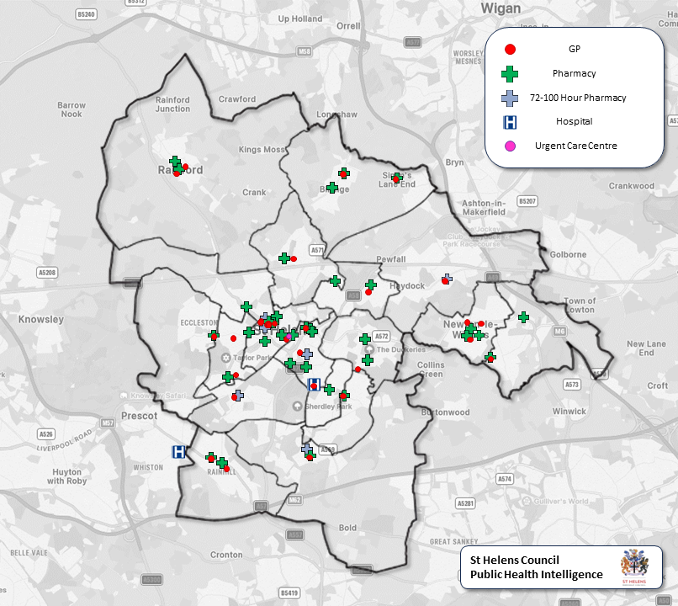
Map 5 shows that generally there is a good provision of pharmacies in the most deprived areas of St Helens. The lower super output areas (LSOA) in the most deprived quintile without a pharmacy have at least one nearby. As shown in Map 8, these areas are within a 5-minute drive of a pharmacy. For residents who do not have access to a car, the travel time would be around a 20-minute walk or trip on public transport (see Maps 9 and 10 for further details on walking and public transport travel times).

Map 5: Pharmacy locations in St Helens mapped against levels of local deprivation by LSOA
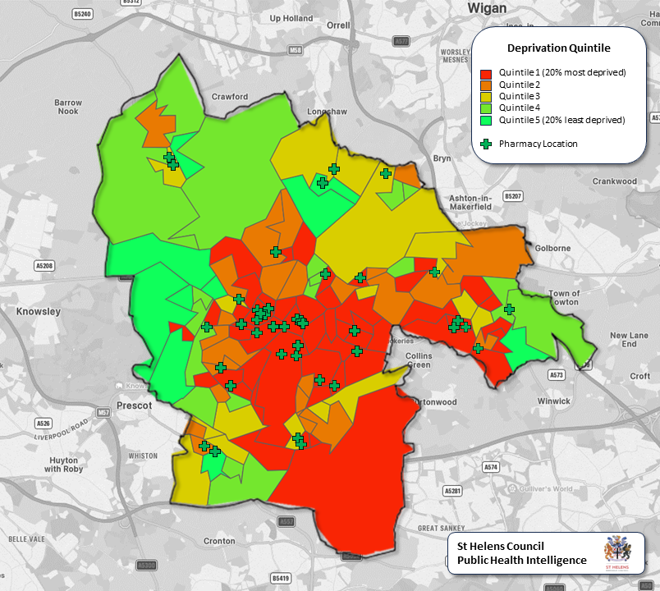

Map 6 shows that in all areas of high population density there is adequate pharmacy provision. In terms of the location of the proposed housing development of 2,988 dwellings in the Bold are, as illustrated this is located in an area with lower population density.

Map 6: Pharmacy locations in St Helens mapped against population density
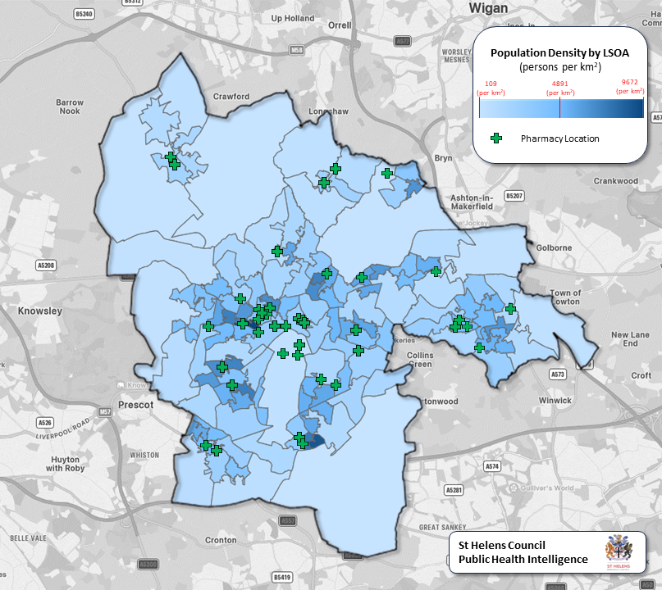

Based on the number of community pharmacies (as at April 2024) as a rate per 100,000 GP registered population (as at 1 May 2024), St Helens has a larger number of pharmacies in relation to its size of population (20.1 per 100,000) when compared to the England (12.8 per 100,000) and Cheshire & Merseyside (19.35 per 100,000). However, it has a lower rate than the North West which was 27.01 per 100,000 population.

Figure 8 shows this value ranges widely across the borough when analysed in terms of pharmacies per 100,000 population at electoral ward level. For example, the ward of Peasley Cross and Fingerpost has 6 pharmacies and therefore gives a crude rate of 179 pharmacies per 100,000 resident population, in Town Centre the rate is 89 per 100,000, whilst Thatto Heath has a rate of 8 pharmacies per 100,000 resident population. Although Map 6 shows a lack of pharmacies in the south of the borough, this is mostly rural land with a low population density. There are also pharmacies available in neighbouring wards and boroughs to currently support residents in this rea. However, it is previously mentioned that there are future plans for this area to see an increase of 2998 dwellings and therefore pharmacy provision will need to be reviewed.
Figure 8: Crude rate (per 100,000 population) of pharmacies in St Helens by ward, as at January 2025

Source: NHSBA and ONS population estimates

In the public survey of community pharmacy services 68% stated the most important reason for choosing the pharmacy they regularly use was that it was close to their home, with 31% saying because it was easy to park nearby and 30% because it was close to their doctor’s surgery (figure 9). Note, respondents had the option to tick all that applied to them, therefore the total percentage adds up to more than 100%.

Figure 9: Importance of pharmacy location, Q7 of public survey of community pharmacy services

Source: Public Survey, 2024

6.3. Access to and provision of community pharmacy services in local authorities bordering St Helens
The framework for this PNA has been based largely on the 2022-2025 PNA, which was a collaborative process across Cheshire & Merseyside. This approach facilitated the identification of pharmaceutical services along the borders of neighbouring boroughs that the St Helens population may access. For example, a pharmacy in a neighbouring borough may be closer to a resident’s home or place of work, even though they are registered for NHS Services with a GP practice in St Helens. St Helens has geographic borders with several local authorities, namely, Knowsley, Halton, Warrington, Wigan and West Lancashire. Map 7 shows the locations of these cross-border pharmacies. Analysis of the information supplied, identified that there is adequate service provision on the borders of Knowsley, Halton, Warrington, Wigan and West Lancashire. A list of the pharmacies is available in Appendix 3.

Map 7: Pharmacies in other boroughs most likely to be used St Helens residents
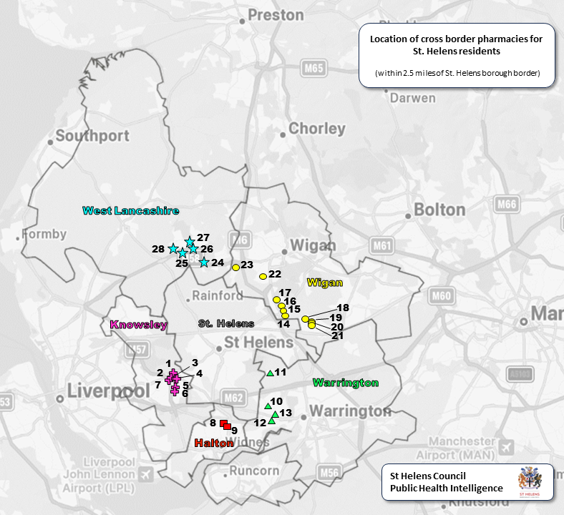
Source: NHS Business Services Authority

6.4. Getting to the pharmacy
In order to demonstrate accessibility, it is helpful to produce some local maps using pharmacy locations for drive and walk times which demonstrate travel accessibility for the local population. To assess this a series of travel time maps from the OHID’s SHAPE Atlas have been accessed considering both travel by car, walking, as well as public transport and cycling.

The public survey showed the majority of respondents get to their usual pharmacy by car (68%), with 39% walking (figure 10). Data from the Census shows households in St Helens without a car has declined from 26.7% in the 2011 Census to 23.2% in the 2021 Census.
Figure 10: Method used to get to the pharmacy, Q5 of public survey of community pharmacy services

Source: Public Survey 2024

Mapping drive times during the day and during rush hour shows that no location in St Helens is more than a 15-minute drive from a pharmacy during the day (map 8) and 20 mins away during rush hour (map 9)

Map 8: Drive times to community pharmacies during the day in St Helens
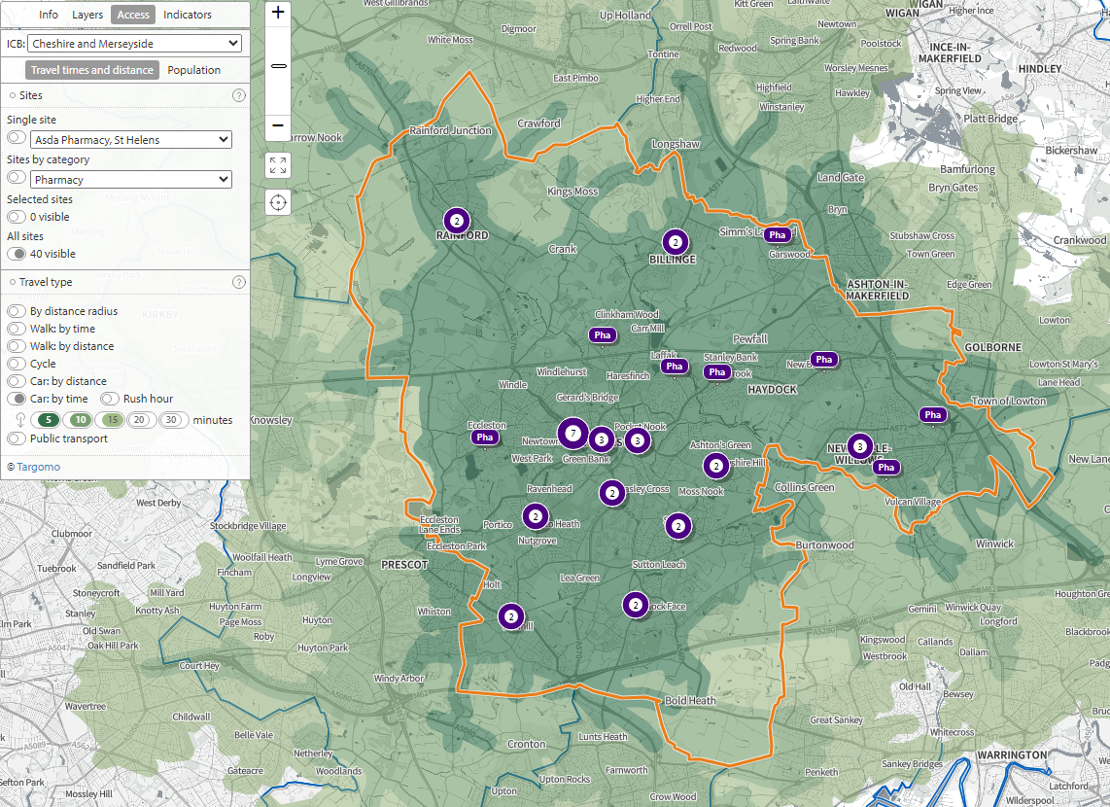

Source: PHE SHAPE tool (accessed January 2025)
Map 9: Drive times to community pharmacies during rush hour in St Helens
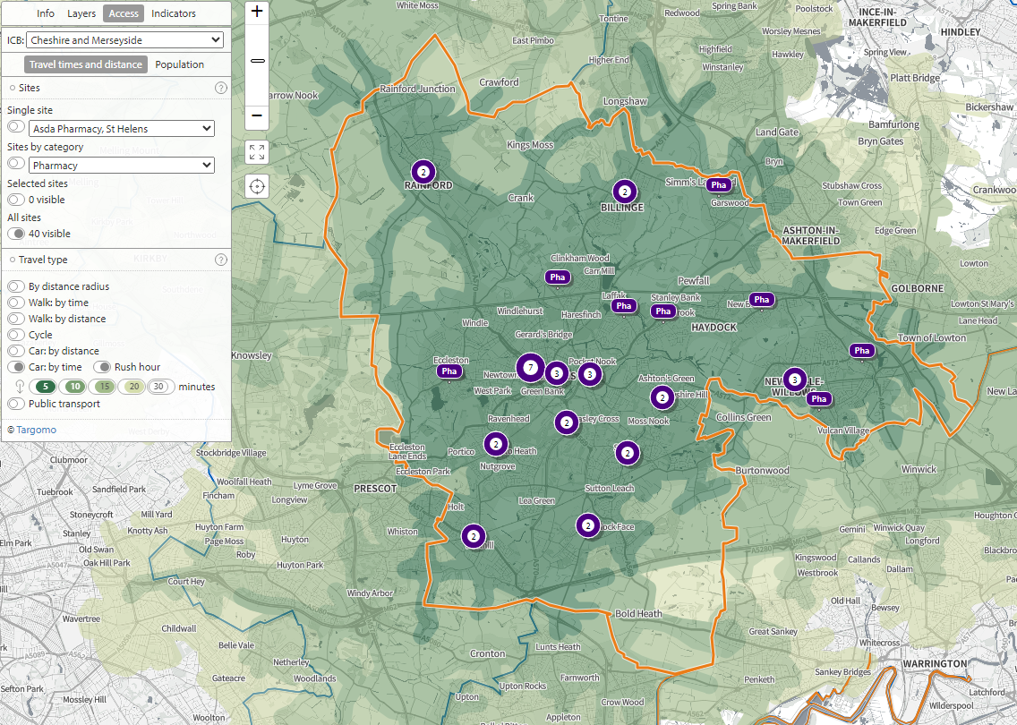

Source: PHE SHAPE tool (accessed January 2025)
For those choosing to walk (39% of respondents to the public survey indicated they use this mode of transport), accessibility is slightly more limited. As shown in Map 10 access to a pharmacy on foot is easier in the centre of the Borough, but there are some areas where the nearest pharmacy is more than a 20-minute walk away (note these are predominantly areas without GP practices also). However, as illustrated in Map 9, these areas are no more than a 15–20-minute drive away even in rush hour times.
Map 10: Walking times to community pharmacies in St Helens
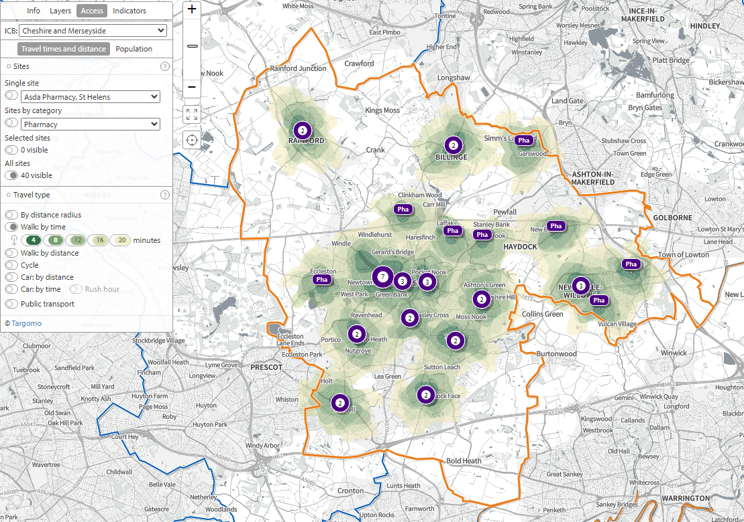

Source: PHE SHAPE tool (accessed January 2025)

The majority of St Helens is within 30 minutes travel time via public transport to a pharmacy on an average weekday morning (see Map 11). And for many the nearest pharmacy is within 15 minutes travel time via bicycle (see Map 12).

Map 11: Travel time to pharmacies by public transport on a weekday morning in St Helens
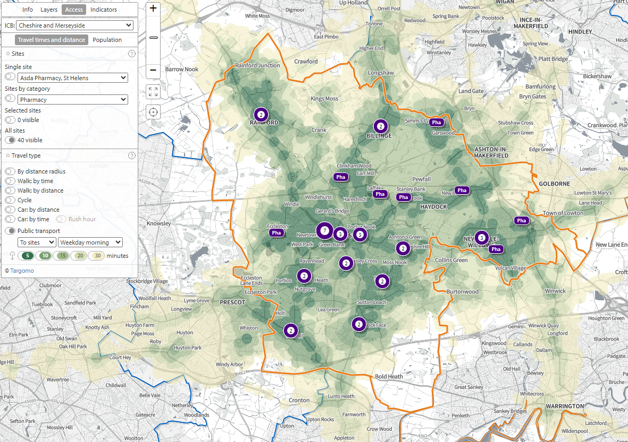
Source: PHE SHAPE tool (accessed January 2025)
Map 12: Travel time to pharmacies by cycle in St Helens
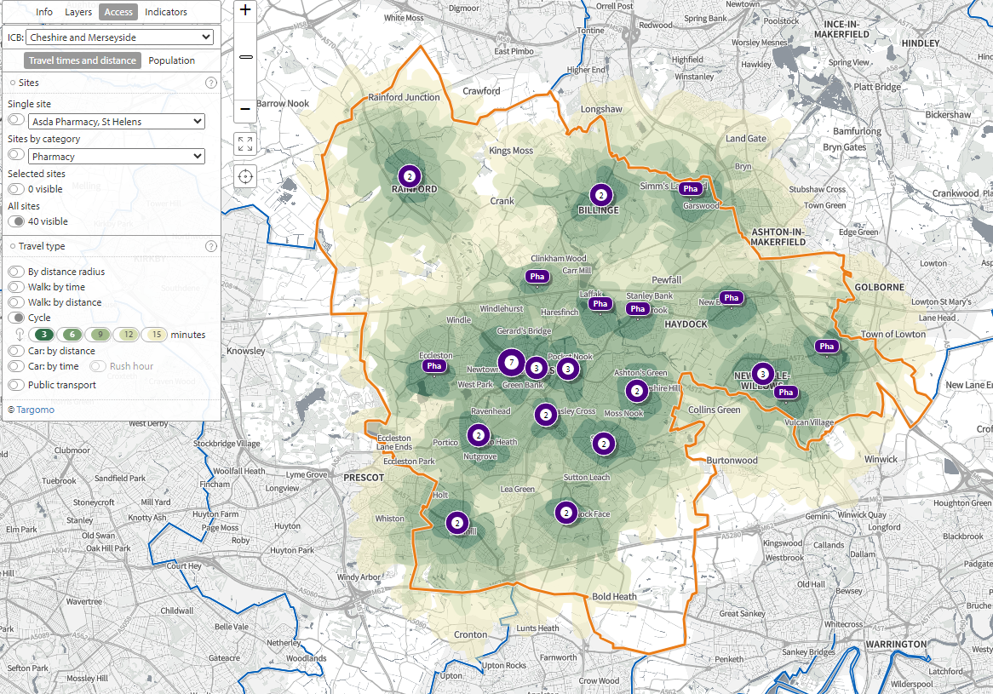
Source: PHE SHAPE tool (accessed January 2025)

It is not surprising therefore that most respondents to the public survey stated that it was very easy (68%) or quite easy (24%) to get to a pharmacy (figure 11).

Figure 11: Ease of access usual pharmacy, Q8 public survey of community pharmacy services

Source: Public Survey 2024

6.5. Pharmacy opening hours, including 72–100-hour pharmacies and distance selling pharmacies.
Under the contract, community pharmacies must be open for a minimum of 40 hours each week, but they are free to set their own hours of opening as long as this minimum is provided. From 25 May 2023, contractors who had been opening 100-hour can apply to reduce the total weekly core opening hours from 100-hour pharmacies to not less than 72. Data from quarter 3 2024-25 from NHS Business Services Authority (NHSBSA) shows:
- 29 out of 41 community pharmacies in St Helens are open between 40 and less than 50 hours per week.
- 10 pharmacies are open for 50 hours or more per week but less than 100 hours. The pharmacies that have extended opening hours are in areas with good transport links.
- There are 2 100-hour pharmacies which are open to the public for essential services.
Full details of each pharmacy opening can be found in Appendix 1. They highlight the following:

Table 4: Number of percentage (%) of community pharmacies in St Helens according to opening hours (as of quarter 3 2024-25)

Opening Hours | Number | Percentage (%)
Before 8am | 2 | 5
After 6pm | 13 | 32
After 8pm | 6 | 15
After 10pm | 2 | 5
Saturday | 22 | 54
Saturday afternoon (after 1pm) | 11 | 27
Sunday | 6 | 15

- From Monday to Friday, all 41 community pharmacies are open between at least 9am to 5pm, with 12 closing over the lunchtime period for between ½ and 1 hour each day, between the hours of 12:30pm to 2pm.
- Cover is also available throughout the week at the extreme hours from 6:00am and up to 11:59pm. 13 pharmacies are open after 6pm with the latest opening being 11:59pm;
- On Saturday, 22 of the 41 community pharmacies are open in the morning and 10 of these remain so into the afternoon (with 7 remaining open after 5pm).
- Sundays sees less pharmacies being open, with 6 out of 41 open. One of these is a 100 hour pharmacy. Provision is between 9am and 9pm.
- Beyond this time, cover continues via 72-100 hour pharmacies across the Borough.
The location of 72-100-hour pharmacies are shown in Map 4.

From the public survey, 56% of respondents said they were very satisfied with the opening hours of their pharmacy, and 27% said they were somewhat satisfied with the opening hours of their pharmacy (this was in line with the 2022-2025 PNA survey response).

This question also elicited over 60 free text responses. Several themes emerged from these:
- Many people stated that they were indeed satisfied with their usual pharmacy.
- The most common issue was that around opening times, most frequently that the pharmacy was not open late enough in the evenings or on the weekend, which was difficult for those working during daytime hours.
- Others mentioned that their pharmacy was closed at lunchtime, again making it difficult for those who are working.
- Some respondents stated that their pharmacy have reduced their opening hours and that these did not correspond to advertised times online.
59% hadn’t needed to use their usual pharmacy when it was closed but 40% said they had (figure 12).
Figure 12: How many times recently have you needed to use your usual pharmacy (or the pharmacy closest to you) when it was closed, Q17 public survey of community pharmacy services

Source: Public Survey 2024

In 23% of cases where people had found their usual pharmacy closed, this was between Monday and Friday, but the majority of time it was a Saturday (45%) or Sunday (17%), with the remaining not being able to remember (14%). Afternoon or late evenings were the most cited times of day.

Of the people who said that they found their pharmacy closed between Monday and Friday 68% said the time of day was after 5pm which suggests a need for more pharmacies to be open until at least 6pm to better cater for working people. Of the people who found their pharmacy closed on a Saturday, 31% said this was in a morning and 31% said it was in the afternoon, 14% said it was after 5pm and 8% said it was at lunchtime (between 12pm and 2pm).

53% of people experiencing a closed pharmacy waited until it was open with 37% going to another pharmacy and 6% using another NHS service.

In the public survey, when asked about what was most important in choosing a pharmacy, many people cited ‘opening hours’ as being important.

Bank and public holiday opening
NHS England is required to ensure that the population within any given Health & Wellbeing Board area can access pharmaceutical services on every day of the year. Under the terms of their contract, pharmacies and dispensing appliance contractors are not required to open on bank holidays or Easter Sunday. In order to provide adequate provision, contractors must confirm to NHS England their opening hour intentions for each of the days. Where a gap in provision is identified, NHS England will then direct a contractor to open part or all of the day.

72-100 hour pharmacy provision
There are six 72 - 100-hour pharmacies, and these are identified on map 4 by a light blue marker, and are situated in the following wards:
- Bold and Lea Green
- Haydock
- Peasley Cross and Fingerpost
- Thatto Heath
- Town Centre
- Windle
Further details of opening hours and locations of 72-100 hour pharmacies can be found in Appendix 1.

6.6. Access for people with a disability and/or mobility problem
The majority of pharmacies have wheelchair access or are able to make provision for consultations for anyone in a wheelchair. 36 of the 41 community pharmacies stated (via the 2024 contractor survey) that their entrance was suitable for wheelchair access unassisted, and 4 stated this was not the case.

In respect to parking for people with mobility problems, 39 of the 41 community pharmacies have parking provision within 50 metres of the pharmacy, with only 1 stating that this was not the case. 25 out of the 41 pharmacies also have disabled parking available.

Several questions in the public survey covered issues of access for those with a disability and/or mobility problem or other access needs:
- ‘Do you have a disability, a health condition and/or other access needs that could affect how easily you access your chosen pharmacy?’ 25% said yes, and 72% said no
- ‘If you have a disability, a health condition and/or other access needs, can you access your chosen pharmacy?’ 98% said yes, and 2% said no.
- ‘If you have mobility issues, are you able to park your vehicle close enough to your pharmacy?’ 32.5% said yes, with 6.4% saying no.
Additionally, AccessAble, the UK leading source of information on access, has independently assessed 1 of St Helens community pharmacies (Tesco, St Helens Linkway). Information is gathered by sending a surveyor to pharmacy venues and every venue on their website is contacted each year to find out if their access has changed. A venue owner or customer can contact them at any time to inform of changes to venues. They use a wide range of criteria which have been designed in consultation with disabled people and represent important information that disabled people want to know about public venues.[]
The accessibility symbols for Tesco, St Helens Linkway are as follows:
- Level Access and Automatic Doors.
- Ramped/Sloped Access, and/or Manual Doors.
- Mobility Impaired Walker.
- On-site Parking.
- Blue Badge/Accessible Parking Bays.
- Designated Drop-Off Point.
- Ambulant Toilet.
- Step Free Standard Toilet.
- Baby Changing Facility.
- Seat(s) Available.
- Assistive Listening.
In relation to other facilities for disabled people a range of services were identified by pharmacies via the Pharmacy contractor survey:
- 5 said they provide large print labels.
- 12 said they provide large print leaflets.
- 8 have a bell at the front door.
- 4 could provide toilet facilities suitable for wheelchair access.
- 11 have automatic door assistance.
- 17 have hearing loop.
- 9 have wheelchair ramp access.
- 1 has sign language available.

6.7. Access for clients whose first language is not English
NHS England commission Language Line which is available to all pharmacies. From the Pharmacy contractor survey, July 2024, 9 out of the 40 pharmacies (23%) advised that they had a pharmacist or other member of staff who could speak at least one language in addition to English. The languages listed were Punjabi, Hindi, Urdu, Polish, Spanish, Arabic, Gujrati, and Portuguese. Some pharmacies have more than one non-English language spoken.

6.8. Pharmacy consultations
Being able to walk into a pharmacy to seek advice and/or treatment, usually without an appointment, is one of the key features of community pharmacy provision. Advice may be given at the counter or in a private consultation room. All pharmacies must have a private consultation room. 31 out of the 40 community pharmacies have handwashing facilities in the consulting room or close to it, and three have toilet facilities.

In relation to a client being able to seek advice from someone of the same sex as them:
- 19 pharmacies judged that this would be available at all times.
- 11 pharmacies thought this would be available by arrangement.
- 6 did not think they could provide this.
50.5% of respondents to the public survey had a recent consultation with their pharmacist. As shown in figure 13, 55.3% of consultations were taken in a separate room and 34.0% of consultations were carried out at the pharmacy counter. 81.6% of people who had a consultation with a pharmacist found privacy levels excellent, very good or good, whilst 17.5% of people rated privacy levels between fair, poor, or very poor.
Figure 13: Consultations and satisfaction with privacy during them, Q29 and Q30 public survey of community pharmacy services

Source: Public Survey, 2024

7. Prescribing

7.1. Prescribing volume
Data in this section was provided by Cheshire & Merseyside ICB business intelligence team using NHS BSA epact2 data. It analyses St Helens PCN against the England, North West and Cheshire & Merseyside averages.

Figure 14 shows that St Helens ICB community pharmacy dispensing volume pattern has consistently been above the Cheshire & Merseyside ICB and North West average. In 2023/24 the St Helens prescribing volume per pharmacy was also higher than in England.

The average number of prescription items per month per 1,000 population was 1,620. This was below the Cheshire & Merseyside average of 1,806.5), but higher than the England average of 1,527.5.
Figure 14: Prescribing trend, 2019-20 to 2023-24: Trend in average number of prescription items dispensed each month in St Helens and Cheshire and Merseyside

The majority of people surveyed, visit a pharmacy to get a prescription for themselves, with 71.6% using their pharmacy within the month prior to completing the survey for this reason (see figures 15 and 16).

Figure 15: Reasons for visiting the pharmacy, Q3 public survey of community pharmacy services

Source: Public Survey, 2024

Figure 16: When did you last use a pharmacy to get a prescription, buy medicines or to get advice? Q4 public survey of community pharmacy services

Source: Public Survey, 2024

7.2. Medicines Shortages
Since 2021 there have been reports of increasing supply problems affecting medicines. Recent media coverage has highlighted shortages of medicines used to treat diabetes, attention deficit hyperactivity disorder (ADHD) and epilepsy, as well as hormone replacement therapy (HRT) and others.
A House of Commons Library research briefingprovides information on the causes and consequences of medicines shortages in the UK and internationally, and the UK Government’s approach to address supply problems.

Causes and consequences of medicines shortages
Supply chains for medicines are long and complex and shortages can be caused by multiple factors. These include manufacturing or distribution problems and increased demand for medicines. Commentators have also drawn attention to the effects of wider geopolitical factors, including the conflict in Ukraine, the Covid-19 pandemic and Brexit.
This is not just a UK issue, with what is happening in the UK needing to be seen context of global problems with supply chains and the availability of key ingredients. A report by the Nuffield Trust found that the past two years have seen constantly elevated medicines shortages, in a "new normal" of frequent disruption to crucial products.
Pharmacists and patient organisations have drawn attention to the impact of medicines shortages on patients, who may struggle to access medicines and sometimes have to switch to alternative drugs. Community Pharmacy England, which represents community pharmacies, has also reported that medicines supply and pricing issues are “severe” financial pressures on pharmacy staff and businesses.

Government response to medicines shortages
The government has described medicines shortages as “an ongoing issue that the Department [of Health and Social Care] has been managing for many years”.
The Department of Health and Social Care and NHS England have published guidance on the management of medicines supply and shortages, which outlines the processes followed and options available to the government to address supply disruption. These include:
- issuing serious shortage protocols, which enable pharmacists to provide specific alternatives to scarce medicines
- taking regulatory action to approve new medicines or, in exceptional circumstances, extend medicine expiry dates
- restricting medicines exports
- offering pharmacies price concessions, to help pharmacies to cover the cost of NHS prescriptions.

Potential reforms to manage medicines shortages
Organisations representing pharmacists have called for reforms to the systems used to manage medicines shortages. Community Pharmacy England has called for “a strategic Government review of medicine supply and pricing” that focuses on supply chain functioning.
Appeals for reform centre on calls for pharmacists to be able to amend prescriptions to provide alternatives to patients when medicines are out of stock, and on changes to current medicines pricing systems.
This has led the Cheshire & Merseyside ICB to issue its own Medicines Shortage Statement: Guidance during periods of sustained medicines shortages in April 2024 in which they stated:
Medicines supply shortages can have significant negative impacts on patients, community pharmacies, general practice, and the wider NHS. It is imperative that all stakeholders work together in the best interest of the patient.
Where a local shortage of a formulary medicine has been identified, prescribers may need to consider alternatives for the duration of the shortage taking into consideration safety and cost effectiveness. For national shortages, see national guidance where applicable. Formulary alternatives should be considered first, however there may be circumstances where prescribing of non-formulary medicines is the most appropriate option following the key principles outlined below. It is recommended that healthcare professionals register for free with the Specialist Pharmacy Service (SPS) Medicines Supply Tool and subscribe to SPS email notifications to obtain details of medicines supply shortages, further information on alternatives and when shortages have resolved https://www.sps.nhs.uk/home/tools/medicines-supply-tool/

Key principles
- Effective communication between healthcare professionals in all sectors is paramount. – Specialists should communicate the rationale for any non-formulary recommendations and state whether the formulary choice medication can be reinstated once the supply issue has resolved.
- Primary care clinicians should seek specialist advice where appropriate.
- Prescribers in all sectors should seek guidance from their local Medicines Optimisation/Medicines Management teams as required.
- Patient safety is paramount, and patients must be kept informed of any changes to their medication and the potential differences with an alternative medication.
- When choosing an alternative medicine, prescribers should always consider the cost-effectiveness of any non-formulary choice.
- Any prescribing of alternative medicines due to a shortage should only be for the duration of the shortage and it is the prescriber’s responsibility to ensure that patients are prescribed the most appropriate and cost-effective medicine once the supply issue has resolved.

7.3. Public Satisfaction with Dispensing of Prescriptions
Of those that had a prescription filled last time they used a pharmacy, 79.1% of respondents got all the medicines they needed on that occasion without waiting. However, 20.9% of respondents said they did not or that they could not remember. 51.3% were informed of how long it would take to have their prescription filled, 41.0% were not told and would have like to have been, and 5.1% were not told but stated they did not mind this, and 2.6% could not remember.

When asked if they had to wait for all their prescription to be filled was reasonable, 33.3% said they felt the time taken was reasonable, whilst 53.8% did not.

74.4% of people stated that the reason for not receiving their entire prescription was because ‘the pharmacy had run out of my medicine’. Of the remainder, the most common responses were some other reasons, with 7.7% saying the prescription had not arrived at the pharmacy.

As most people received their medication without delay the following calculations need to be interpreted with caution. When people had not received all the items prescribed, only 5.1% got them later the same day and 28.2% of people received their medicines the day after. However, 12.8% had waited over a week and 7.7% stated they never got it. Unfortunately, there is no way to determine the impact of these longer waiting periods on the patient, or whether this was measured at the pharmacy and alternative arrangements discussed.

Whilst many people who responded to the public survey had a great deal of satisfaction with their pharmacy, several negative themes did also emerge:
- Busy, long processing times, and having to wait a long time (usually standing).
- Lack of essential medications and/or having to wait a long time for regular, repeat medications.
- Concerns around patient confidentiality with having to disclose information in public.
Positive themes include:
- Friendly staff and a recognition that staff are doing the best they can.
- Reliability and efficiency when collecting prescriptions.
- Being contacted when prescriptions were ready.
Despite the public concern about increasing waiting times, closures and stock issues, the majority if the 41 community pharmacy contractors, in the July 2024 contractor survey, said they had capacity to manage an increase in demand:
- We have sufficient capacity within our existing premises and staffing levels to manage an increase in demand in our area: 37
- We don’t have sufficient premises and staffing capacity at present but could make adjustments to manage an increase in demand in our area: 2
- We don’t have sufficient premises and staffing capacity and would have difficulty in managing an increase in demand: 2

7.4. Prescription Delivery Services
Although community pharmacies are not contracted to do so, 28 out of 40 offer a home delivery service free of charge. 12 do not offer a free delivery service. Of these 12, eight do offer delivery service at a charge whilst 4 do not offer any delivery service. This service improves access to medicines for a wide range of people.

In the public survey, 35.3% of respondents said that the pharmacy they use offers a delivery service, 5.4% said they did not have this service, but 58.8% were either not aware of the service or had never used it. When asked about what was important to them when choosing a pharmacy in terms of products and services, 21% said that deliver of medications to their home was important (figure 17).
Figure 17: How important is the delivery of medicines to your home when choosing a pharmacy in terms of products and services? Q32 public survey of community pharmacy services

Source: Public Survey, 2024

7.5. Reasonable Adjustments
Community pharmacies are required to support patients in taking dispensed medications by making reasonable adjustments for patients with identified needs as per the Equality Act 2010. The requirement of the community pharmacy is to ensure that an appropriate assessment is undertaken of the patient to establish their needs and ascertain what type of reasonable adjustment would be required. There is no exhaustive list of what a reasonable adjustment could be, and community pharmacies are not required to provide a multi-compartment compliance aid (MCA).

Community pharmacies are encouraged to work collaboratively with prescribers, other health professionals and social care to support patient needs. Community pharmacies are not required to dispense medications into MCAs because it has been directed by another health professional or social care. Health professionals and social care should highlight patients who may require support with medicines to enable the community pharmacy to carry out an assessment to determine appropriate medicines support.

St Helens community pharmacies provide a wide range of reasonable adjustments with the majority providing multiple different tools and aids to help patients take their medication safely. As such the numbers below add up to more than the 41 community pharmacies in the borough:
- Eye drop aid provided by 12 community pharmacies.
- Large print labels provided by 39 community pharmacies.
- Easyhaler device provided by 19 community pharmacies.
- MAR charts provided by 39 community pharmacies.
- Multi-compartment device (blister pack) provided by 32 community pharmacies.
- Blister popping device provided by 24 community pharmacies.
- Tablet cutter/crusher provided by 24 community pharmacies.
- Non click-lock caps provided by 26 community pharmacies.
- Reminder charts provided by 27 community pharmacies.
- Lid gripping device provided by 9 community pharmacies.
- Magnifying glass provided by 4 community pharmacies.
- Audio label provided by 1 community pharmacy.

8. Advanced, enhanced and locally commissioned service provision
Community Pharmacy England provides a full service description of all elements of the NHS commissioned pharmacy services. In addition to these essential, advanced and national enhanced services locally commissioned community pharmacy services can be contracted via a number of different routes and by both local authority or ICB teams.

8.1. Pharmacy provision of advanced, enhanced and locally commissioned services
In addition to the essential services all pharmacies must provide they have the option to provide a range of other commissioned services. Some are more specialist than others. As such, provision varies, service by service, from 100% community pharmacies providing to just a handful required to meet need.

Full details of which service each pharmacy provides are outlined in Appendix 2. Table 5 provides a summary of each service provision level and whether this is assessed as adequate. Unless specified this assessment is based on the number of pharmacies registered to provide each service not on activity data. This is an important distinction as some services rely on referrals from other services which may or may not happen despite the pharmacy having the necessary training, equipment and capacity to deliver.

Also to note, community pharmacies may be the sole provider of some services but one of many providers for others.
Table 5: Summary of advanced, enhanced and locally commissioned service provision
Type of Service | Service Name | Number of pharmacies providing each service out of 41 community pharmacies | Is provision of this service adequate?
Advanced | New Medicines Service | 37 | Yes
 | NHS Influenza Vaccination Programme | 41 | Yes
 | Lateral Flow Device Service | 31 | Yes
 | Pharmacy Contraception Services | 26 | Yes, this supplements other opportunities to access routine contraception.
 | Pharmacy First service | 39 | Yes
 | Hypertension Case Finding Service | 38 | Yes
 | Smoking Cessation Service | 38 | Yes
National Enhanced | Covid-19 vaccination service | 27 | Yes, this supplements other opportunities to access COVID-19 vaccinations.
Locally Commissioned NHS | Care at the Chemist | 38 | Yes
 | Palliative Care Scheme | 9 | Yes, this is a specialist service.
 | Minor Eye Conditions Pharmacy Service | 12 | Yes, provision is adequate for patient need but this is reviewed regularly.
Locally Commissioned Public health | Vitamin D vouchers | 9 | Yes. Provision has increased from 4 since the previous year and provision is adequate for the number of vouchers redeemed.
 | Nicotine Replacement Therapy | 36 | Yes
 | Supervised consumption of methadone | 32 | Yes
 | Supervised consumption of buprenorphine | 31 | Yes
 | Needle – Syringe Exchange | 23 | Yes, this is a specialist service.
 | Emergency Hormonal Contraception | 32 | Yes

When asked ‘what is important to you when choosing a pharmacy in terms of products and services? 65.7% of people said ‘the range of services available’ was important, with 25.5% stating it was neither important nor unimportant.
The types of services people have used varies with advice on minor health issues being the most commonly used, together with medicine advice (figure 18).
Figure 18: Type of advice or service received recently, Q28 public survey of community pharmacy services

Source: Public Survey, 2024

87.7% were either very satisfied or fairly satisfied overall with the range of services and products provided at their local pharmacy. There were 5.4% who were either fairly or very dissatisfied (figure 19).
Figure 19: How satisfied overall are you with the services and products available at your local pharmacy? Q34 public survey of community pharmacy services

Source: Public Survey, 2024

8.2. How essential, advanced, and locally commissioned pharmacy services support local priority health needs

In England there are an estimated 1.2 million visits to a pharmacy every day for health-related issues, and these provide a valuable opportunity to support behaviour change through making every one of these contacts count. Making healthy choices such as stopping smoking, improving diet and nutrition, increasing physical activity, losing weight, and reducing alcohol consumption could make a significant contribution to reducing the risk of disease, improving health outcomes for those with long-term conditions, reducing premature death and improving mental wellbeing. Pharmacies are ideally placed to encourage and support people to make these healthy choices as part of the provision of pharmaceutical services and services commissioned locally by St Helens Borough Council Public Health team and the NHS. As can be seen from this section, it is important that NHS England, the ICB and the Public Health Team work together to maximise the local impact of public health communications, messages, and opportunities. Promoting the services that pharmacies provide was highlighted in some of the responses to the patient and public engagement questionnaire. This can be undertaken in a number of ways including pharmacies ensuring that their NHS Choices profile is up-to-date.

Community pharmacy services can support the St Helens’ People’s Plan priorities in a number of ways.

8.2.1 Mental Wellbeing
Pharmacies can contribute to our mental wellbeing priority as a key community service available to our residents. Pharmacists are often considered trusted sources of health information that have the opportunity to engage with the public. It is therefore important that pharmacists are able to signpost to relevant services within the borough. Pharmacies in St Helens have promoted public health resources such as the ‘OK to Ask’ suicide prevention campaign.

There are a range of services available to support individuals who would like to stop smoking as it is beneficial to have a holistic approach. Nicotine Replacement Therapy is available via our pharmacies to complement our behaviour change smoking cessation service. With this we aim for our residents to feel supported as we appreciate the challenge of facing an addiction.

For future consideration, St Helens’ Public Health team would like to provide some wellbeing resources to accompany first-time prescriptions of anti-depressants. This would be an opportunity to engage with people that are at higher risk of social isolation.
8.2.2 Healthy Weight
Healthy weight and obesity is a complex condition that can be an indication of multiple risks or long-term conditions. This priority therefore benefits from a range of services that our pharmacies provide.

Pharmacies are required to participate in up to six public health campaigns each calendar year by promoting public health messages to users. The topics for these campaigns are selected by NHS England. Public health campaigns could include raising awareness about the risks of alcohol consumption, cancer awareness and/or screening, self-management of long-term conditions and minor ailments by displaying posters, distributing leaflets and other relevant materials.

Where a person presents a prescription, and they appear to have diabetes, be at risk of coronary heart disease (especially those with high blood pressure), smoke or are overweight, the pharmacy is required to give appropriate advice with the aim of increasing that person’s knowledge and understanding of the health issues which are relevant to their circumstances. Pharmacists should also provide healthy living advice during consultations and take a MECC (Make Every Contact Count) approach to other health issues discussed for example alcohol dependency.

8.2.3. Care Communities
The St Helens People’s Plan includes priority action aimed specifically at supporting resilient communities by supporting our residents to live independently.

Services available can promote independence to community members as people can acquire information and advice without solely replying on their GP. These services include blood pressure checks, emergency hormonal contraception (EHC) and smoking cessation tools such as nicotine replacement therapy (NRT).

Pharmacists are also sources of advice and signposting. Through services such as the New Medicines Service (NMS) and Community Pharmacist Consultation Service (CPCS) there is another opportunity for polypharmacy to be identified which can contribute to issues such as poor circulation or an increased risk of falls.

Vaccination programmes can support building resilient communities as people are better protected against seasonal illnesses. As well as reducing the disruption caused by being ill, we recognise that vaccinations have many mental wellbeing and social benefits such as increased confidence in attending social engagements.

8.2.4. Inequalities
There is good provision of pharmacies in the most deprived areas of St Helens. The lower super output areas (LSOA) in the most deprived quintile are without a pharmacy although have at least one nearby.

Pharmacies contribute to the key clinical areas of health inequalities as highlighted by the NHS Core20+5 approach. This approach focuses on the 20% most deprived population in addition to protected characteristics with particular priority on five health conditions. 46% of pharmacies provide Easyhalers as a reasonable adjustment which is considered one of the most convenient inhalers for daily use. Asthma is one of the five clinical areas of focus for Integrated Care Partnerships and the availability of Easyhalers could contribute to the aim of decreasing the number of asthma attacks.

“Community pharmacies must make ‘reasonable adjustments’ to ensure persons with disabilities can access pharmacy services. A person with a disability must not be put at a substantial disadvantage1 when compared to persons with no disabilities in accessing services that are provided by the pharmacy,” . Reasonable adjustments in pharmacies include large print labels, eye drop aids, and tablet crusher and cutter which are summarised in section 7.5. These adjustments contribute to equitable access to health.

Pharmaceutical Needs Assessment

Part 4: Appendices

Appendix 1: Community Pharmacy addresses and opening hours (as of quarter 3 2024-25)
Name | Address 1 | Postcode | Monday | Tuesday | Wednesday | Thursday | Friday | Saturday | Sunday | 100 Hour Pharmacy
Asda Pharmacy | Kirkland Street | WA10 2EF | 09:00 - 12:30  13:00 - 16:30  17:00 - 21:00 | 09:00 - 12:30  13:00 - 16:30  17:00 - 21:00 | 09:00 - 12:30  13:00 - 16:30  17:00 - 21:00 | 09:00 - 12:30  13:00 - 16:30  17:00 - 21:00 | 09:00 - 12:30  13:00 - 16:30  17:00 - 21:00 | 09:00 - 12:30  13:00 - 16:30  17:00 - 21:00 | 10:30 - 16:30
Ashcroft Chemist | 97 Greenfield Road | WA10 6SL | 09:00 - 13:00  14:00 - 18:00 | 09:00 - 13:00  14:00 - 18:00 | 09:00 - 13:00  14:00 - 18:00 | 09:00 - 13:00 | 09:00 - 13:00  14:00 - 18:00 | 09:00 - 13:00 | Closed
Ashtons Pharmacy | 13 Ashtons Green Drive, Parr | WA9 2AP | 09:00 - 13:00  14:00 - 17:30 | 09:00 - 13:00  14:00 - 17:30 | 09:00 - 13:00  14:00 - 17:30 | 09:00 - 13:00  14:00 - 17:30 | 09:00 - 13:00  14:00 - 17:30 | 09:00 - 12:00 | Closed
Atlas Pharmacy | Fingerpost Park Health Centre, Atlas Street | WA9 1LN | 09:00 - 18:00 | 09:00 - 18:00 | 09:00 - 18:00 | 09:00 - 18:00 | 09:00 - 18:00 | Closed | Closed
Boggiano's Pharmacy | Millfields, Eccleston | WA10 5NS | 09:00 - 13:00  14:00 – 18:00 | 09:00 - 13:00  14:00 – 18:00 | 09:00 - 13:00  14:00 – 18:00 | 09:00 - 13:00  14:00 – 18:00 | 09:00 - 13:00  14:00 – 18:00 | 09:00 - 13:00 | Closed
Boots | 8 Church Street, 24 La Grange Arcade | WA10 1BD | 09:30 - 17:30 | 09:30 - 17:30 | 09:30 - 17:30 | 09:30 - 17:30 | 09:30 - 17:30 | 09:30 - 17:30 | Closed
Boots | Unit 3 Ravenhead Park, Milverney Way | WA9 1JF | 09:00 - 20:00 | 09:00 - 20:00 | 09:00 - 20:00 | 09:00 - 20:00 | 09:00 - 20:00 | 09:00 - 18:00 | 10:30 - 16:30
Boots | 32 Market Street, Earlestown | WA12 9AN | 09:00 - 17:30 | 09:00 - 17:30 | 09:00 - 17:30 | 09:00 - 17:30 | 09:00 - 17:30 | 09:00 - 17:00 | Closed
Bradlegh Road Pharmacy | Newton Community Hospital, Bradlegh Road | WA12 8RB | 09:00 - 18:00 | 09:00 - 18:00 | 09:00 - 18:00 | 09:00 - 18:00 | 09:00 - 18:00 | Closed | Closed
Brian H Donlon Pharmacy | Woodside Healthcare Centre, Woodside Road | WA11 0NA | 08:00 - 21:00 | 08:00 - 21:00 | 08:00 - 21:00 | 08:00 - 21:00 | 08:00 - 21:00 | 09:00 - 21:00 | 09:00 - 21:00
Chain Lane Pharmacy | Unit 9,The Shopping Centre, Chain Lane | WA11 9HB | 09:00 - 18:00 | 09:00 - 18:00 | 09:00 - 18:00 | 09:00 - 18:00 | 09:00 - 18:00 | 09:00 - 13:00 | Closed
Clarks Pharmacy | 196 Robins Lane, Sutton | WA9 3PB | 09:00 - 17:00 | 09:00 - 17:00 | 09:00 - 17:00 | 09:00 - 17:00 | 09:00 - 17:00 | Closed | Closed
Farleys Chemist | 59 Higher Parr Street | WA9 1AD | 09:00 - 18:00 | 09:00 - 18:00 | 09:00 - 18:00 | 09:00 - 18:00 | 09:00 - 18:00 | Closed | Closed
Fingerpost Pharmacy | 80-82 Higher Parr Street | WA9 1AF | 09:00 - 18:00 | 09:00 - 18:00 | 09:00 - 18:00 | 09:00 - 18:00 | 09:00 - 18:00 | 09:00 - 13:00 | Closed
Four Acre Chemist | 1&2 Four Acre Lane, Four Acre Precinct | WA9 4BZ | 06:00 - 23:59 | 06:00 - 23:59 | 06:00 - 22:40 | 06:00 - 22:40 | 06:00 - 22:40 | 06:00 - 20:00 | Closed | Y
Four Acre Pharmacy | Four Acre Health Centre, Burnage Avenue | WA9 4QB | 09:00 - 13:00  14:00 - 18:00 | 09:00 - 13:00  14:00 - 18:00 | 09:00 - 13:00  14:00 - 18:00 | 09:00 - 13:00  14:00 - 18:00 | 09:00 - 13:00  14:00 - 18:00 | Closed | Closed
Garswood Pharmacy | Garswood Health Centre, Billinge Road | WN4 0XD | 09:00 - 18:00 | 09:00 - 18:00 | 09:00 - 18:00 | 09:00 - 18:00 | 09:00 - 18:00 | Closed | Closed
Heath Pharmacy | 18 Elephant Lane, Thatto Heath | WA9 5QW | 09:00 - 21:00 | 09:00 - 21:00 | 09:00 - 21:00 | 09:00 - 21:00 | 09:00 - 21:00 | 09:00 - 12:00  17:00 – 21:00 | 10:00 - 16:00
Heaton's Pharmacy | 23 Bassenthwaite Avenue | WA11 7AB | 09:00 - 13:00  14:00 - 18:00 | 09:00 - 13:00  14:00 - 18:00 | 09:00 - 13:00  14:00 - 18:00 | 09:00 - 13:00  14:00 - 18:00 | 09:00 - 13:00  14:00 - 18:00 | 09:00 - 13:00 | Closed
IPharm | 2 Roundwood Drive | WA9 5JD | 09:00 – 17:00 | 09:00 – 17:00 | 09:00 – 17:00 | 09:00 – 17:00 | 09:00 – 17:00 | Closed | Closed
Jacksons Pharmacy | 181 Cambridge Road | WA10 4HA | 09:00 - 17:30 | 09:00 - 17:30 | 09:00 - 17:30 | 09:00 - 17:30 | 09:00 - 17:30 | Closed | Closed
Jolley's Chemist | 77 High Street, Newton-Le-Willows | WA12 9SL | 09:00 - 13:00  14:00 - 18:00 | 09:00 - 13:00  14:00 - 18:00 | 09:00 - 13:00  14:00 - 18:00 | 09:00 - 13:00  14:00 - 18:00 | 09:00 - 13:00  14:00 - 18:00 | Closed | Closed
Legh Street Pharmacy | Legh Street, Earlstown | WA12 9NF | 08:30 - 18:30 | 08:30 - 18:30 | 08:30 - 18:30 | 08:30 - 18:30 | 08:30 - 18:30 | Closed | Closed
Leslie Road Pharmacy | 1 Leslie Road | WA10 3EQ | 09:00 - 13:00  14:00 - 18:00 | 09:00 - 13:00  14:00 - 18:00 | 09:00 - 13:00  14:00 - 18:00 | 09:00 - 13:00  14:00 - 18:00 | 09:00 - 13:00  14:00 - 18:00 | Closed | Closed
Liverpool Road Pharmacy | 79 Liverpool Road | WA10 1PQ | 09:00 - 17:00 | 09:00 - 17:30 | 09:00 - 17:30 | 09:00 - 17:30 | 09:00 - 17:30 | Closed | Closed
Longsters Pharmacy | 578 Warrington Road | L35 4LZ | 09:00 - 17:30 | 09:00 - 17:30 | 09:00 - 17:30 | 09:00 - 17:30 | 09:00 - 17:30 | 09:00 - 13:00 | Closed
Millennium Pharmacy | 29-31 Shaw St | WA10 1DG | 09:00 - 13:00  14:00 - 18:00 | 09:00 - 13:00  14:00 - 18:00 | 09:00 - 13:00  14:00 - 18:00 | 09:00 - 13:00  14:00 - 18:00 | 09:00 - 13:00  14:00 - 18:00 | 09:00 - 12:30 | Closed
PA White Chemist | 56-58 North Road | WA10 2TR | 09:00 - 18:30 | 09:00 - 18:30 | 09:00 - 18:30 | 09:00 - 18:30 | 09:00 - 18:30 | Closed | Closed
Peak Pharmacy | 5-6 Concourse Way, Parr | WA9 3QW | 08:45 - 13:00  13:30 - 18:00 | 08:45 - 13:00  13:30 - 18:00 | 08:45 - 13:00  13:30 - 18:00 | 08:45 - 13:00  13:30 - 18:00 | 08:45 - 13:00  13:30 - 18:00 | 09:00 - 12:00 | Closed
Rainbow Pharmacy | 335 Robins Lane, Sutton | WA9 3PN | 09:00 - 17:30 | 09:00 - 17:30 | 09:00 - 17:30 | 09:00 - 17:30 | 09:00 - 17:30 | Closed | Closed
Rainhill Pharmacy | 473 Warrington Road, Rainhill | L35 4LL | 09:00 - 18:00 | 09:00 - 18:00 | 09:00 - 18:00 | 09:00 - 18:00 | 09:00 - 18:00 | 09:00 - 13:00 | Closed
Rowlands Pharmacy | 65 Market Street, Earlestown | WA12 9BS | 09:00 - 13:00  14:00 - 18:00 | 09:00 - 13:00  14:00 - 18:00 | 09:00 - 13:00  14:00 - 18:00 | 09:00 - 13:00  14:00 - 18:00 | 09:00 - 13:00  14:00 - 18:00 | 09:00 - 12:00 | Closed
St Helens Pharmacy | 130 Duke Street | WA10 2JL | 08:00 - 17:00 | 08:00 - 17:00 | 08:00 - 17:00 | 08:00 - 17:00 | 08:00 - 17:00 | Closed | Closed
Taylor's Pharmacy | 210 West End Road, Haydock | WA11 0AN | 09:00 - 19:00 | 09:00 - 19:00 | 09:00 - 19:00 | 09:00 - 19:00 | 09:00 - 19:00 | 09:00 - 16:00 | 10:00 – 16:00
Tesco Instore Pharmacy | St Helens Linkway | WA9 3AL | 08:00 - 22:30 | 06:30 - 22:30 | 06:30 - 22:30 | 06:30 - 22:30 | 06:30 - 22:30 | 06:30 - 22:00 | 11:00 - 17:00 | Y
Well | 18 Church Road, Rainford | WA11 8HE | 09:00 - 17:30 | 09:00 - 17:30 | 09:00 - 17:30 | 09:00 - 17:30 | 09:00 - 17:30 | 09:00 - 13:00 | Closed
Well | 36 Church Road, Rainford | WA11 8HD | 08:45 - 12:30  13:30 - 18:15 | 08:45 - 12:30  13:30 - 18:15 | 08:45 - 12:30  13:30 - 18:15 | 08:45 - 12:30  13:30 - 18:15 | 08:45 - 12:30  13:30 - 18:15 | Closed | Closed
Well | Lowe House HC, 103 Crab Street | WA10 2DJ | 08:00 - 18:30 | 08:00 - 18:30 | 08:00 - 18:30 | 08:00 - 18:30 | 08:00 - 18:30 | Closed | Closed
Well | Mill Street Medical Centre, 2 Mill Street | WA10 2BD | 08:30 - 18:30 | 08:30 - 18:30 | 08:30 - 18:30 | 08:30 - 18:30 | 08:30 - 18:30 | Closed | Closed
Well | 11 Rainford Road, Billinge | WN5 7PF | 09:00 - 18:00 | 09:00 - 18:00 | 09:00 - 18:00 | 09:00 - 18:00 | 09:00 - 18:00 | 09:00 - 13:00 | Closed
Well | The Pharmacy, Recreation Drive | WN5 7LY | 08:30 - 18:00 | 08:30 - 19:00 | 08:30 - 19:00 | 08:30 - 14:00 | 08:30 - 19:00 | Closed | Closed

Appendix 2: Community Pharmacy services
Commissioned by | Key
NHSE | NMS | New Medical Service
 | Flu | NHS Influenza Vaccination (all adults at risk)
 | LFD | Lateral Flow Device Service
 | PhCont | Pharmacy Contraception Service
 | PhFirst | Pharmacy First
 | HypT | Hypertension Register
 | Smok | Smoking Cessation
Enhanced | COVID-19 | COVID-19 Vaccination
LA PH | VitD | Vitamin D
 | NRT | Nicotine Replacement Therapy Vouchers
 | SC-M | Supervised Consumption – Methadone
 | SC-B | Supervised Consumption - Bupranorphine
 | NS-Ex | Needle & Syring Exchange Service
 | EHC | Emergency Hormonal Contraception
NHS | CATC | Care at the Chemist (minor ailments)
 | PALL | Palliative Care Medicines Service
 | MECPS | Minor Eye Conditions Pharmacy Service

Pharmacy details |  | Advanced Services |  |  |  |  |  |  | Enhanced Services | Locally Commissioned: Public Health |  |  |  |  |  | Locally Commissioned NHS
Pharmacy | Post Code | NMS | Flu | LFD | PhCont | PhFirst | HypT | Smok | COVID-19 | VitD | NRT | SC-M | SC-B | NS-Ex | EHC | CATC | PALL | MECPS
Asda (Branch: 4995 - St Helens) | WA10 2EF | Yes | Yes | Yes | Yes | Yes | Yes | Yes |  |  | Yes | Yes | Yes |  | Yes | Yes
Ashcroft Chemist | WA10 6SL |  | Yes
Ashtons Pharmacy | WA9 2AP | Yes | Yes |  |  | Yes | Yes | Yes | Yes |  | Yes | Yes | Yes |  | Yes | Yes |  | Yes
Atlas Pharmacy | WA9 1LN | Yes | Yes |  |  | Yes | Yes | Yes | Yes |  | Yes | Yes | Yes |  | Yes | Yes |  | Yes
Boggiano’s Pharmacy | WA10 5NS | Yes | Yes | Yes | Yes | Yes | Yes | Yes | Yes | Yes | Yes | Yes | Yes | Yes | Yes | Yes |  | Yes
Boots (Branch: 1179 - St Helens Church St) | WA10 1BD | Yes | Yes | Yes | Yes | Yes | Yes | Yes |  |  | Yes | Yes | Yes | Yes | Yes | Yes
Boots (Branch: 1194 - Newton Le Willows Market) | WA12 9AN | Yes | Yes | Yes | Yes | Yes | Yes | Yes |  |  | Yes | Yes | Yes |  | Yes | Yes
Boots (Branch: 6549 - St Helens Ravenhead Park) | WA9 1JF | Yes | Yes | Yes | Yes | Yes | Yes | Yes |  |  | Yes | Yes | Yes |  | Yes | Yes | Yes
Bradlegh Road Pharmacy | WA12 8RB | Yes | Yes | Yes | Yes | Yes | Yes | Yes | Yes | Yes | Yes | Yes | Yes | Yes | Yes | Yes
Brian H Donlon Pharmacy Ltd | WA11 0NA | Yes | Yes |  |  | Yes | Yes | Yes |  |  |  |  |  |  |  | Yes | Yes | Yes
Chain Lane Pharmacy | WA11 9HB | Yes | Yes | Yes | Yes | Yes | Yes | Yes | Yes |  | Yes | Yes | Yes | Yes | Yes | Yes |  | Yes
Clarks Pharmacy | WA9 3PB | Yes | Yes | Yes |  | Yes | Yes | Yes | Yes |  | Yes |  |  |  |  | Yes
Farleys Chemist | WA9 1AD | Yes | Yes |  |  | Yes | Yes | Yes | Yes |  | Yes | Yes | Yes | Yes | Yes | Yes |  | Yes
Fingerpost Pharmacy | WA9 1AF | Yes | Yes | Yes |  | Yes | Yes | Yes | Yes |  | Yes | Yes | Yes | Yes | Yes | Yes |  | Yes
Four Acre Chemist | WA9 4BZ | Yes | Yes | Yes |  | Yes | Yes | Yes |  |  | Yes | Yes | Yes | Yes | Yes | Yes | Yes
Four Acre Pharmacy | WA9 4QB |  | Yes |  |  | Yes | Yes | Yes | Yes |  | Yes | Yes | Yes |  | Yes | Yes
Garswood Pharmacy | WN4 0XD | Yes | Yes | Yes | Yes | Yes | Yes | Yes | Yes | Yes | Yes | Yes |  | Yes |  | Yes
Heath Pharmacy (Branch: 01744818826) | WA9 5QW | Yes | Yes | Yes |  | Yes | Yes | Yes |  |  | Yes | Yes | Yes | Yes | Yes | Yes | Yes
Heatons Chemist | WA11 7AB | Yes | Yes | Yes | Yes | Yes | Yes | Yes | Yes | Yes | Yes | Yes | Yes | Yes | Yes | Yes
iPharm | Online WA9 5JD | Yes | Yes | Yes | Yes | Yes | Yes | Yes | Yes
Jacksons Pharmacy | WA10 4HA | Yes | Yes | Yes | Yes | Yes | Yes | Yes |  |  |  |  |  |  |  | Yes
Jolleys Chemist | WA12 9SL | Yes | Yes | Yes |  | Yes | Yes | Yes | Yes | Yes | Yes |  |  |  | Yes | Yes
Legh Street Pharmacy | WA12 9NF | Yes | Yes |  | Yes | Yes | Yes | Yes | Yes |  | Yes | Yes | Yes | Yes | Yes | Yes
Leslie Road Pharmacy | WA10 3EQ |  | Yes | Yes | Yes | Yes | Yes | Yes | Yes |  | Yes | Yes | Yes | Yes | Yes | Yes | Yes | Yes
Liverpool Road Pharmacy (Liverpool Rd) | WA10 1PQ | Yes | Yes | Yes | Yes | Yes | Yes | Yes | Yes |  | Yes | Yes | Yes | Yes | Yes | Yes
Longsters Pharmacy | L35 4LZ | Yes | Yes | Yes | Yes | Yes | Yes | Yes |  |  | Yes | Yes | Yes | Yes | Yes | Yes |  | Yes
Millennium Pharmacy | WA10 1DG | Yes | Yes | Yes | Yes | Yes | Yes | Yes | Yes | Yes | Yes | Yes | Yes | Yes | Yes | Yes | Yes | Yes
PA White Chemist | WA10 2TR | Yes | Yes |  |  | Yes |  |  |  | Yes | Yes | Yes | Yes |  |  | Yes
Peak Pharmacy (PARR) | WA9 3QW | Yes | Yes | Yes |  | Yes | Yes | Yes |  |  | Yes |  |  | Yes | Yes | Yes | Yes | Yes
Rainbow Pharmacy | WA9 3PN | Yes | Yes | Yes |  | Yes | Yes | Yes | Yes |  | Yes | Yes | Yes | Yes | Yes | Yes
Rainhill Pharmacy | L35 4LL | Yes | Yes |  | Yes | Yes | Yes | Yes | Yes |  | Yes | Yes | Yes |  | Yes | Yes
Rowlands Pharmacy (Branch: 1345 - Newton Le Willows (Branch 1345)) | WA12 9BS | Yes | Yes | Yes | Yes | Yes | Yes | Yes | Yes | Yes | Yes | Yes | Yes | Yes |  | Yes |  | Yes
ST HELENS PHARMACY (Branch: 000) | WA10 2JL |  | Yes |  |  |  |  |  | Yes |  | Yes | Yes | Yes | Yes | Yes | Yes
Taylors Pharmacy | WA11 0AN | Yes | Yes | Yes | Yes | Yes | Yes | Yes | Yes | Yes | Yes | Yes | Yes | Yes | Yes | Yes | Yes
Tesco Instore Pharmacy (Branch: 6504 - St Helens) | WA9 3AL | Yes | Yes | Yes | Yes | Yes | Yes | Yes |  |  | Yes | Yes | Yes |  | Yes
Well (Rainford) | WA11 8HE | Yes | Yes | Yes | Yes | Yes | Yes | Yes |  |  | Yes | Yes | Yes |  | Yes | Yes | Yes
Well (Rainford) | WA11 8HD | Yes | Yes | Yes | Yes | Yes | Yes | Yes | Yes |  | Yes |  |  | Yes | Yes | Yes
Well (Crab Street) | WA10 2DJ | Yes | Yes | Yes | Yes | Yes | Yes | Yes | Yes |  | Yes | Yes | Yes | Yes | Yes | Yes
Well (Mill Street) | WA10 2BD | Yes | Yes | Yes | Yes | Yes | Yes | Yes | Yes |  |  |  |  |  | Yes | Yes
Well (Billinge) | WN5 7PF | Yes | Yes | Yes | Yes | Yes | Yes | Yes | Yes |  | Yes | Yes | Yes | Yes | Yes | Yes
Well (Recreation Drive) | WN5 7LY | Yes | Yes | Yes | Yes | Yes | Yes | Yes | Yes |  | Yes | Yes | Yes |  |  | Yes

Appendix 3: Cross border Community Pharmacy service provision
Number on map | Pharmacy Name | Address | Postcode
KNOWSLEY
1 | Rowlands Pharmacy | 42 Eccleston Street, Prescot | L34 5QJ
2 | The Dispensing Hub | 60 – 66 Sewell Street, Prescot | L34 1ND
3 | Tesco Instore Pharmacy | Steeley Way, Prescot | L34 5NQ
4 | Boots Pharmacy | Unit D, Block 4, Cables Retail Park, Prescot | L34 5NQ
5 | Neil’s Pharmacy | 32 Molyneux Drive, Prescot | L35 5DY
6 | Boots Pharmacy | Old Colliery Road, Whiston | L35 3SX
7 | Prescriptions Pharmacy | The Kiosk, Manchester Road, Prescot | L34 1LT
HALTON
8 | Farnworth Village Pharmacy | 11 Farnworth Street, Widnes | WA8 9LH
9 | Widnes Late Night Pharmacy | Peel House Lane, Widnes | WA8 6TE
WARRINGTON
10 | Click Chemist | Pharmacy Unit, Barrow Hall Lane | WA5 3AA
11 | Ryedale Pharmacy | 16 Chapel Lane, Burtonwood | WA5 4HF
12 | Penketh Pharmacy | Honiton Way, Penketh | WA5 2EY
13 | Aston Pharmacy | 2 Station Road, Great Sankey | WA5 1RQ
WIGAN
14 | Boots Pharmacy | Unit 6 The Gerard Centre, Gerard Street, Ashton-in-Makerfield | WN4 9AN
15 | J Morris Pharmacy | 109 Wigan Road, Ashton-in-Makerfield | WN4 9BH
16 | Rowlands Pharmacy | 120 Wigan Road, Ashton-in-Makerfield | WN4 9SU
17 | Boots Pharmacy | 254-256 Wigan Road, Bryn | WN4 0AR
18 | Asda Pharmacy | Edge Green Lane, Golborne | WA3 3SP
19 | Golborne Late Night Chemist | 98 High Street, Golborne | WA3 3DA
20 | Well Pharmacy | 97-99 High Street, Golborne | WA3 3BU
21 | Gpharmacy Direct | Unit 9 Queens ENT. Park, Queens Street, Golborne | WA3 3AF
22 | Boots Pharmacy | 91 Holmes House Avenue, Winstanley | WN3 6JA
23 | Well Pharmacy | 56 Church Street, Orrell | WN5 8TQ

WEST LANCASHIRE
24 | Rowland’s Pharmacy | 123 Birleywood, Digmoor, Skelmersdale | WN8 9HR
25 | Chemist4u | 34a-37 Greenhey Place, East Gillibrands, Skelmersdale | WN8 9SA
26 | Boots Pharmacy | 20 The Concourse, Skelmersdale | WN8 6ND
27 | Asda Pharmacy | Ingram Road, Skelmersdale | WN8 6LA
28 | Rowland’s Pharmacy | 55 Westgate, Skelmersdale | WN8 8LP

Appendix 4: Pharmacy Contractor Survey Questionnaire
A questionnaire to gather information from all pharmacies was devised as a collaborative exercise with Cheshire & Merseyside local authority PNA leads, Local Pharmaceutical Committee (LPC) representatives and ICB. It was conducted online via Pharm Outcomes. The LPC sent communications to pharmacies to encourage completion and followed up as necessary.
Premises Details
Completion date
Pharmacy postcode
Is this a distance selling pharmacy? | Yes No
Contact Details
Contact details of person completing questionnaire, if questions arise
Name: | Phone: | Email:

Potential for increased demand
Ability to adapt to demand (tick one) | We have sufficient capacity within our existing premises and staffing levels to manage an increase in demand in our area
 | We don't have sufficient premises and staffing capacity at present but could make adjustments to manage an increase in demand in our area
 | We don't have sufficient premises and staffing capacity and would have difficulty in managing an increase in demand.

Consultation Rooms
How many consultation rooms do you have? one) | 0
 | 1
 | 2
 | 3
 | 4 or more

Hand washing and toilet facilities
What facilities are available to patients during consultations? | Handwashing in consultation area
 | Handwashing facilities close to consultation area
 | Have access to toilet facilities
 | None

Accessibility
Can customers legally park within 50 metres of the pharmacy? |  | Yes No
How far is the nearest bus stop/train station? |  | Within 100m  100m to 500m  500m to 1km 1km+  No bus/train station
Do pharmacy customers have access to a designated disabled parking? |  | Yes No
Is the entrance to the pharmacy suitable for wheelchair access unaided? |  | Yes No
Are all areas of the pharmacy floor accessible by wheelchair? |  | Yes No
Do you have any other facilities in the pharmacy aimed at supporting disabled people access your service? | Automatic door assistance | Yes No
 | Bell at front door | Yes No
 | Toilet facilities accessible by wheelchair users | Yes No
 | Hearing loop | Yes No
 | Sign language | Yes No
 | Large print labels | Yes No
 | Large print leaflets | Yes No
 | Wheelchair ramp access | Yes No
 | Other, please state | Free text field
Can staff at pharmacy speak languages other than English? If yes please list all languages spoken |  | Yes No
Are you able to provide advice and support if a customer wishes to speak to a person of the same sex? | At all times | Yes No
 | By arrangement | Yes No

Reasonable Adjustments
Reasonable adjustments.  One or more of: | Non click-lock caps
 | Reminder charts
 | MAR charts
 | Blister popping service
 | Tablet cutter/crusher
 | Easyhaler service
 | Other

Prescription Delivery Service
Collection of prescriptions from surgery: |  | Yes No
Delivery pf prescriptions- free of charge |  | Yes No
Are you currently considering | Stopping this service entirely | Yes No
 | Charging all patients for this service | Yes No
 | Charging new patients for this service | Yes No
 | Neither | Yes No
Delivery of prescriptions - chargeable |  | Yes No
 | By arrangement | Yes No

Protected Characteristics
Are you aware of any gaps in access or pharmaceutical need for any of the following groups, relating to their:
 |  | If yes, please state why?
Age | Yes No
Disability | Yes No
Gender | Yes No
People with/about o have gender reassignment | Yes No
Marriage and civil partnership | Yes No
Pregnancy and maternity | Yes No
Race | Yes No
Religion or belief | Yes No
Sexual orientation | Yes No
Other, (please state)

Almost done
If you have anything else you would like to tell us that you think would be useful in the formulation of the PNA, please include it here:

Appendix 5: Public Local Pharmacy Services Questionnaire
During November 2024 the Public Health team conducted a survey online. Paper and translated copies of the survey were available on request. The survey asked local residents to give their feedback on their local pharmacy. The online version of the survey was sent out via a wide range of networks including Halton & St Helens Voluntary Action, Health Watch and St Helens’ local strategic partnership groups and networks. The survey link was also shared across council social media platforms. 204 responses were received. The online survey was open for four weeks. The following is the communication sent out and questionnaire.

St Helens Borough Council
Pharmacy Services - Have your say
St Helens Borough Council are seeking views about the pharmacies our residents use. The government requires all Health and Wellbeing Boards to produce an assessment of their local pharmaceutical services every three years.
Contribute to our assessment by filling out this survey about your typical use of your local pharmacy and as a thank you, you will be entered into a prize draw to win £100.
Paper/translated copies are available on request. Please email HealthProtectionStHelens@sthelens.gov.uk
Pharmacy Services - Have your say

Questions

Q1. The following question is about in which local authority area you live.
Which local authority area do you live in?
- Cheshire East
- Cheshire West & Chester
- Halton
- Knowsley
- Liverpool
- Sefton
- St. Helens
- Warrington
- Wirral
- Other (please specify):
Q2. What is your full postcode?
We ask for your full postcode as it is needed for us to do locality level analysis of response rates, which is a legal requirement of the PNA under the regulations. If you do not want to give your full postcode you can give the first half of it such as L5 or leave blank.
Q3. The following questions are about the last time you used a pharmacy.
Why did you visit the pharmacy? (Please tick all that apply)
- To collect my prescription
- To collect a prescription for someone else
- To get advice from the pharmacist
- To buy other non-prescription medications
- To access a pharmacy service
- To return unused/expired medications
- Unable to get a GP appointment
- Referred by GP practice or other such as NHS111
- Other (please specify):
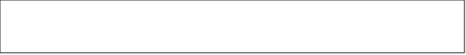Q4. When did you last use a pharmacy? (Please tick one answer only)
- In the last week
- In the last two weeks
- In the last month
- In the last three months
- In the last six months
- Longer than six months

Q5. How do you usually get to the pharmacy? (Please tick all that can apply)
- Walking
- Public Transport
- Car
- Motor Bike
- Taxi
- Bicycle
- Mobility Transport
- Used online pharmacy
- Other (please specify):

Q6. How long does the journey to your pharmacy usually take?
- 5 minutes or less
- 6-10 minutes
- 11-15 minutes
- 16-20 minutes
- 21-25 minutes
- 26-30 minutes
- 31 minutes or longer
- Not applicable (please choose this option if you usually have your dispensed prescription via delivery or online pharmacy)

The following questions are about the Pharmacy and ease of access to it.

Q7. Thinking about the location of the pharmacy, which of the following is most important to you? (Please tick all that apply)
- It is close to my doctor’s surgery
- It is close to my home
- It is close to other shops I use
- It is close to my children’s school or nursery
- It is easy to park nearby
- It is near to the bus stop / train station
- It is close to where I work
- It is close to/in my local supermarket
- None of the above
- Other (please specify):

Q8. How easy is it to get to your usual pharmacy? Please tick one answer only.
- Very easy
- Quite easy
- Neither easy or difficult
- Quite difficult
- Very difficult
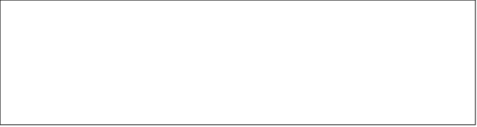If you answered quite difficult or very difficult, why?:
Q9. Do you have a disability, a health condition and/or other access needs that could affect how easily you access your chosen pharmacy?
- Yes
- No
- Don't know

Q10. If you have a disability, a health condition and/or other access needs, can you access your chosen pharmacy?
- Yes
- No
- Don't know
If no, can you please explain your answer here:
Q11. If you have mobility issues, are you able to park your vehicle close enough to your pharmacy?
- Yes
- No
- Don't know
- Not applicable

Q12. If you have mobility issues, are you able to access your chosen pharmacy?
- Yes
- No
- Don't know
- Not applicable

Q13. Does your pharmacy deliver medication to your home if you are unable to collect it yourself?
- Yes – Free of charge
- Yes – with a delivery charge
- No - they don’t deliver
- Don’t know/ I have never used this service

Q14. Can you remember a recent time when you had any problems finding a pharmacy that was open to get a medicine dispensed, to get advice or to buy medicines over the counter?
- Yes
- No (Go to Q16)
- Not sure

Q15. If Yes, what did you need to do? (Please tick one answer only)
- To get medicine(s) on a prescription
- To buy medicine(s) from the pharmacy
- To get advice at the pharmacy
- Other (please specify):

Q16. How satisfied are you with the opening hours of your pharmacy?
- Very satisfied
- Somewhat satisfied
- Neither satisfied nor dissatisfied
- Dissatisfied
- Very dissatisfied
What is the reason for your answer?:
Q17. How many times recently have you needed to use your usual pharmacy when it was closed?
- I haven’t needed to use the pharmacy when it was closed (Go to Question 21)
- Once or twice
- Three or four times
- Five or more times

Q18. What day of the week was it?
- Monday to Friday
- Saturday
- Sunday
- Bank Holiday
- Can’t remember

Q19. What time of the day was it?
- Morning
- Lunchtime (between 12pm and 2pm)
- Afternoon
- Evening (after 5pm)
- Can’t remember

Q20. What did you do when your pharmacy was closed?
- Went to another pharmacy
- Waited until the pharmacy was open
- Went to a hospital
- Went to a Walk in Centre
- Called NHS 111
- Other (please specify):

About any medicines you receive on prescription.

Q21. Did you get a prescription dispensed the last time you used a pharmacy?
- Yes
- No (Go to Q27)
- Can't remember (Go to Q27)

Q22. Did you get all the medicines that you needed on that occasion without waiting?
- Yes (Go to Q27)
- No
- Can't remember

Q23. If you had to wait when picking up your prescribed medication, did the staff at the pharmacy tell you how long you would have to wait for your prescription to be prepared?
- Yes
- No, but I would have liked to have been told
- No, but I did not mind
- Can't remember

Q24. If not all your medicines were available on that visit, how long did you have to wait to get the rest of your medicines?
- Later the same day
- The next day
- Two or more days
- More than a week
- Never got it

Q25. Was this a reasonable period of time for you?
- Yes
- No
- Not applicable

Q26. What was the main reason for not getting all your medicines on this occasion? (Please tick one answer only)
- My GP had not prescribed something I wanted
- My prescription had not arrived at the pharmacy
- The pharmacy did not have the medicine in stock to dispense to me
- Other (please specify):

About times when you needed to talk to the pharmacist

Q27. Have you had a consultation with the pharmacist or asked their advice recently?
- Yes
- No (Go to Q31)
- Can’t remember (Go to Q31)

Q28. What advice were you given? (ONE answer only)
- Lifestyle advice (e.g. stop smoking, diet and nutrition, physical activity etc.)
- Advice about a minor illness or health problem
- Medicine advice
- Contraception services
- Emergency contraception advice
- Blood pressure monitoring
- Referred to other service
- Other (please specify):

Q29. Where did you have your consultation with the pharmacist?
- At the pharmacy counter
- In the dispensary or a quiet part of the shop
- In a separate room
- Over the telephone
- Other (please specify):
Q30. How do you rate the level of privacy you had when speaking with the pharmacist?
- Excellent
- Very good
- Good
- Fair
- Poor
- Very poor

The next questions are about your level of satisfaction with your usual pharmacy

Q31. How do you feel about the range of services available at the pharmacy? (tick one)
- I wish pharmacies could provide more services for me
- I am satisfied with the range of services pharmacies provide
- Don’t know

Q32. Can you please tell us, what is important to you when choosing a pharmacy in terms of products and services?

 | Important | Neither important nor unimportant | Unimportant | Don’t know/Not applicable
Delivery of medicines to my home | ☐ | ☐ | ☐ | ☐
Cost of products at pharmacy | ☐ | ☐ | ☐ | ☐
Privacy when speaking to the pharmacist | ☐ | ☐ | ☐ | ☐
Collection of prescriptions from my doctors | ☐ | ☐ | ☐ | ☐
Range of services offered | ☐ | ☐ | ☐ | ☐
Range of products available | ☐ | ☐ | ☐ | ☐
Friendly staff | ☐ | ☐ | ☐ | ☐
Waiting times | ☐ | ☐ | ☐ | ☐
Opening times | ☐ | ☐ | ☐ | ☐
Knowledgeable staff | ☐ | ☐ | ☐ | ☐
Having the things I need | ☐ | ☐ | ☐ | ☐

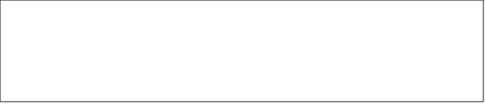Q33. Please tell anything else that has influenced your choice of pharmacy?
Q34. Can you please tell us, how satisfied you are with the services and products offered by your regular pharmacy?
 | Very satisfied | Fairly satisfied | Neither satisfied nor dissatisfied | Fairly dissatisfied | Very dissatisfied | Don’t know/not applicable
Overall satisfaction | ☐ | ☐ | ☐ | ☐ | ☐ | ☐
Delivery of medicines to my home | ☐ | ☐ | ☐ | ☐ | ☐ | ☐
Cost of products at pharmacy | ☐ | ☐ | ☐ | ☐ | ☐ | ☐
Privacy when speaking to the pharmacist | ☐ | ☐ | ☐ | ☐ | ☐ | ☐
Collection of prescriptions from my doctors | ☐ | ☐ | ☐ | ☐ | ☐ | ☐
Range of services offered | ☐ | ☐ | ☐ | ☐ | ☐ | ☐
Range of products available | ☐ | ☐ | ☐ | ☐ | ☐ | ☐
Friendly staff | ☐ | ☐ | ☐ | ☐ | ☐ | ☐
Waiting times | ☐ | ☐ | ☐ | ☐ | ☐ | ☐
Opening times | ☐ | ☐ | ☐ | ☐ | ☐ | ☐
Knowledgeable staff | ☐ | ☐ | ☐ | ☐ | ☐ | ☐
Having the things I need | ☐ | ☐ | ☐ | ☐ | ☐ | ☐

Q35. Please tell us anything else that has influenced your overall satisfaction.
Q36. How would you describe your experience of your local pharmacy and their services over the last 12 months? Please explain in the box below.
About You
We would like to ask you some questions to help improve our understanding of different experiences. Please answer as little or as much as you want. You can always tick ‘prefer not to say’. All questions are optional.

Q37. Are You?
- Male
- Female
- Non-Binary
- Prefer not to say

Q38. How Old are you?
- 16-20 years
- 21-30 years
- 31-40 years
- 41-50 years
- 51-60 years
- 60-69 years
- 70 years or over
- Prefer not to say

Q39. Are you a Carer?
- Yes
- No

Q40. Do you have any of the following (Please tick all that apply)
- Physical impairment
- Visual impairment
- Hearing impairment/ Deaf
- Mental health impairment/ mental distress
- Learning difficulty
- Long term illness that affects your daily activity
- Prefer not to say
- Other (please specify):
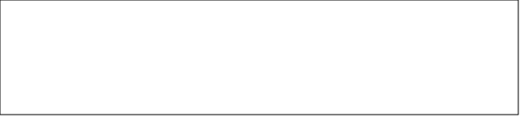
Q41. If you have ticked any of the boxes above, or you have cancer, diabetes, or HIV this would be classed as ‘disability’ under the legislation. Do you consider yourself to be ‘disabled’?
- Yes
- No
- Don't know
- Prefer not to say

Q42. Which ethnic group do you belong to? (Please tick the appropriate box)
- Asian or Asian British - Bangladeshi
- Asian or Asian British - Chinese
- Asian or Asian British - Indian
- Asian or Asian British - Pakistani
- Asian or Asian British - Other Asian
- Black or Black British - African
- Black or Black British - Caribbean
- Black or Black British - Other Black
- Mixed or Multiple ethnic groups - White and Asian
- Mixed or Multiple ethnic groups - White and Black African
- Mixed or Multiple ethnic groups - White and Black Caribbean
- Mixed or Multiple ethnic groups - Other Mixed or Multiple ethnic groups
- White - English, Welsh, Scottish, Northern Irish or British
- White - Irish
- White - Gypsy or Irish Traveller
- White - Roma
- White - Other White
- Other ethnic group - Arab
- Other ethnic group - Any other ethnic group
- Prefer not to say

Q43. Do you have a religion or belief?
- Yes
- No
- Prefer not to say

Q44. If "Yes" please tick one of the options below:
- Buddhist
- Christian
- Hindu
- Jewish
- Muslim
- Sikh
- Other (please specify):

Q45. How would you describe your sexual orientation?
- Heterosexual
- Homosexual
- Bisexual person
- Pansexual
- Prefer not to say

Q46. Do you live in the gender you were given at birth?
- Yes
- No
- Prefer not to say

Appendix 6: Public Survey Respondent Demographics
The responses to the public survey have been used throughout the PNA. The following tables detail the key demographics of respondents. There was a total of 204 respondents.
Note: not all respondents provided a postcode or partial postcode. As such, analysis is only based on those responses which could be allocated to a location.
Age Group | Respondents
18-34 years | 7.9%
35-44 years | 14.2%
45-54 years | 14.2%
55-64 years | 25.5%
65 years and over | 25.0%
Not available | 7.4%
Prefer not to say | 5.9%
Sex | Respondents
Male | 17.2%
Female | 75.5%
Prefer not to say | 7.4%
Disability | Respondents
Mental Health Condition | 2.9%
Long-Standing Illness or Health Condition | 10.3%
Sensory Impairment (Hearing, Sight or Both) | 2.9%
Physical Disability | 7.4%
No Disability | 73.5%
Prefer not to say | 2.9%
Religion | Respondents
Christian | 61.8%
No Religion/Agnostic/Atheist | 19.1%
Prefer not to say | 16.7%
Other | 2.5%

Note: due to small numbers the categories used in the public survey have been collapsed into 4 groups due to small number disclosure rules
Ethnicity | Respondents
White British | 92.2%
Other ethnic group | 2.5%
Prefer not to say | 5.4%
Note: due to small numbers the categories used in the public survey have been collapsed into 2 groups due to small number disclosure rules

Appendix 7: 60-day statutory Consultation Letter and Questionnaire
 | Our Ref | IO/HL
 | If you telephone please ask for | Diane Bolton-Maggs
 | Date | 28 March 2025
 | E-mail address | publichealth@sthelens.gov.uk
Dear Sir / Madam

Pharmaceutical Needs Assessment (PNA) Consultation
Invitation to Participate

During the reorganisation of the NHS the responsibility for production of the Pharmaceutical Needs Assessments (PNAs) transferred to the Health and Wellbeing Boards (HWB) which are hosted by local authorities.

St Helens People’s Board is developing a new PNA. This is a statutory responsibility, as set out under the NHS (Pharmaceutical Services and Local Pharmaceutical Services) Regulations 2013(SI 2013 No. 349).

A PNA is a document which records the assessment of the need for pharmaceutical services within a specific area. As such, it sets out a statement of the pharmaceutical services which are currently provided, together with when and where these are available to a given population. The same Regulations require NHS England to use the PNA to consider applications to open a new pharmacy, move an existing pharmacy or to commission additional services from pharmacy.

The People’s Board have established a PNA Task & Finish Group to oversee the development of the new PNA. This group includes membership from our partner organisations, Healthwatch and the Local Pharmaceutical Committee.

As part of the development process, the Regulations require that all HWB undertake a formal consultation on a draft of its PNA. The key outcomes for this consultation are:

- To encourage constructive feedback from a variety of stakeholders.
- To ensure a wide range of primary care health professionals provide opinions and views on what is contained within the PNA.
Taking this into account, we would like to invite you to participate in this consultation, which will run from 12pm Friday 28th March to 12pm Friday 30th May 2025.

The draft PNA can be found on our website by via the following link:

www.sthelens.gov.uk/consultations

- Submitting responses: You may choose one of the following options to submit your response:

- Complete the survey online at www.sthelens.gov.uk/consultations

- Complete the form sent with this letter and return it electronically via email to: publichealth@sthelens.gov.uk

- Complete the form and return it by post to the following address: Public Health, St Helens Borough Council, St Helens Town Hall, Victoria Square, St Helens. WA10 1HP
St Helens Borough Council has decided to run this consultation electronically in order to limit the environmental impact of this consultation. However, if you require a paper version of the PNA, please contact Aylish MacKenzie at publichealth@sthelens.gov.uk who will arrange to provide this within 14 days of your request.

All feedback received by 12pm on Friday 30th May 2025 will be collated and presented to the PNA Steering Group, for consideration on behalf of St Helens People’s Board. A consultation report will be included within the final PNA document. This will provide an overview of the feedback received and set out how the comments have been acted upon. An updated PNA including consultation process and responses will be presented to St Helens People’s Board and published no later than 1 October 2025.

We look forward to receiving your feedback on the draft PNA.

Yours faithfully

*Signature
Ruth du Plessis
Director of Public Health
PNA Sponsor, St Helens People’s Board
St Helens Borough Council

St Helens Pharmaceutical Needs Assessment
Consultation Response Form

- Has the purpose of the PNA been explained sufficiently within section 2 of the draft PNA document?
Yes |  | No |  | Not sure
If “No”, please explain why in the box below:

- Does Section 3 clearly set out the scope of the PNA?
Yes |  | No |  | Not sure
If “No”, please explain why in the box below:

- Does Section 4 and 6 clearly set out the local context and the implications for the PNA?
Yes |  | No |  | Not sure
If “No”, please explain why in the box below:

- Does the information in Sections 5 & 7 provide a reasonable description of the services which are provided by pharmacies in St Helens?
Yes |  | No |  | Not sure
If “No”, please explain why in the box below:

- Are you aware of any pharmaceutical services currently provided which have not been included within the PNA?
Yes |  | No |  | Not sure
If “Yes”, please explain why in the box below:

- Do you think the pharmaceutical needs of the population have been accurately reflected in the PNA?
Yes |  | No |  | Not sure
If “Yes”, please let us know which service(s) in the box below:

- Do you agree with the key findings about pharmaceutical services in Halton?
Yes No Not sure
If “No” please explain why in the box below:

- Do you agree with the assessment of future pharmaceutical services as set out in sections 7?
Yes |  | No |  | Not sure
If “No”, please explain why in the box below:

- Community pharmacies & Dispensing Appliance Contractor only. Please can you review the information in Appendix 1 (Opening Hours) and Appendix 2 (Service Provision) for accuracy? If you identify any issues please provide details
 | Is the information Accurate? |  |  |  | If “No”, please provide details:
Opening Hours | Yes |  | No
Service Provision | Yes |  | No

- If you have any further comments, please enter them in the box below (question applies to all):
- About you - please can you provide the following information:
Name
Job Title
Pharmacy Name
Or
Organisation
Address

Telephone No.
Please confirm that you are happy for us to store these details in case we need to contact you about your feedback? | Yes No

Please return this feedback form:
- Via email to: publichealth@sthelens.gov.uk
- Via post to the following address: Public Health, St Helens Borough Council, St Helens Town Hall, Victoria Square, St Helens. WA10 1HP

Appendix 8: 60-day statutory Consultation Response
xx responses were received: this Appendix will be completed following the 60 data consultation

Questions | Responses |  | Response to comments
Q1: Has the purpose of the PNA been explained sufficiently within section 2 of the draft PNA document?
Q2: Does Section 3 clearly set out the scope of the PNA?
Q3: Does Section 4 & 6 clearly set out the local context and the implications for the PNA?
Q4: Does the information in Sections 5 & 7 provide a reasonable description of the services which are provided by pharmacies in St Helens?
Q5: Are you aware of any pharmaceutical services currently provided which have not been included within the PNA?
Q6: Do you think the pharmaceutical needs of the population have been accurately reflected in the PNA?
Q7: Do you agree with the key findings about pharmaceutical services in Halton?
Q8: Do you agree with the assessment of future pharmaceutical services as set out in sections 7?
Q9: Community pharmacies & Dispensing Appliance Contractor only. Please can you review the information in Appendix 1 (Opening Hours) and Appendix 2 (Service Provision) for accuracy? If you identify any issues please provide details
Comments |  | Response from Steering group

References

As of 2nd February, there is an application for consolidation at Four Acre Health Centre and St Helens Pharmacy at Four Acre Lane.
Billinge and Seneley Green, Blackbrook, Bold and Lea Green, Eccleston, Haydock, Moss Bank, Newton-le-Willows East, Newton-le-Willows West, Parr, Peasley Cross and Fingerpost, Rainford, Rainhill, St Helens Town Centre, Sutton North West, Sutton South East, Thatto Heath, West Park, Windle
Note PHE as an organisation split into the UK Health Security Agency (UKHSA) and Office for Health Improvement & Disparities (OHID) on 1 October 2021. OHID is an office of the Department of Health & Social Care. The Fingertips and other data tools are now part of OHID.
Regional and local authority data on immigration groups - GOV.UK
LGBT in Britain - Health (2018) | Stonewall
LGBT in Britain - Health (2018) | Stonewall
Appendix 1.pdf
As of April 2024. Data via https://opendata.nhsbsa.net/dataset/contractor-details data accessed June 2024
As of 1 May 2024. Data via https://digital.nhs.uk/data-and-information/publications/statistical/patients-registered-at-agp-practice/may-2024
The population in Peasley Cross and Fingerpost is 3,349
SHAPE - Shape (shapeatlas.net)
viii https://cpe.org.uk/quality-and-regulations/other-regulatory-and-terms-of-service-requirments/plps-regulations-may2023-amendment/
https://www.accessable.co.uk/
. how we assess some of the key access features and key terms used in the access guides please click here.
https://researchbriefings.files.parliament.uk/documents/CBP-9997/CBP-9997.pdf
https://dmscdn.vuelio.co.uk/publicitem/8b197cbb-7e42-465e-afda-253725975cd0
sthelens.gov.uk/media/4100/St-Helens-People-s-Plan-2021-2026/pdf/final-st-helens-peoples-plan-21-26_1.pdf?m=637895979929530000
NHS England » Core20PLUS5 (adults) – an approach to reducing healthcare inequalities
cpe.org.uk
. Todd A et al (2014) The positive pharmacy care law: an area-level analysis of the relationship between community pharmacy distribution, urbanity and social deprivation in England British Medical Journal 4:e005764. doi:10.1136/bmjopen-2014- 005764
. https://digital.nhs.uk/data-and-information/publications/statistical/quality-and-outcomes-framework-achievement-prevalence-and-exceptions-data/2020-21
. https://gp-patient.co.uk/analysistool
. Robards J., Evandrou M., Falkingham J., Vlachantoni A. (2012) Marital status, health and mortality Maturitas. 2012 Dec; 73(4): 295–299
. Hagen D., Goldmann E. (2020) Association between marital status and mental health among cohabitating same-sex couples in the UK European Journal of Public Health, Volume 30, Issue Supplement_5, September 2020, ckaa165.961, https://doi.org/10.1093/eurpub/ckaa165.961
. Public Health England, Royal Society of Public Health (2016) Building Capacity: Realising the potential of community pharmacy assets for improving the public’s health

