Marine Sector Market Sounding Briefing Document
Lennox Point

Introduction
Portsmouth City Council (PCC) is leading the ambitious and innovative development proposals for Lennox Point and Phoenix Quay that will deliver regeneration and an iconic gateway to the city of Portsmouth.

The vision for Lennox Point is to develop a car-free waterfront neighbourhood that reconnects people’s lives and work with the sea. The new, climate-responsive neighbourhood will have sustainability embedded in every element of its design. And, it will be home to an environmentally conscious community who will benefit physically and mentally from living and working at Lennox Point.

Phoenix Quay is a marine employment and green marine technology hub being proposed as part of Lennox Point. It will create quality employment and skills opportunities in Portsmouth, and will reinforce Portsmouth's place in the heart of the Solent maritime economy.

Further details can be seen at www.lennoxpoint.com.

1 Site Location
Lennox Point, including Phoenix Quay, is being proposed at Tipner West and Horsea Island East, off the M275 in Portsmouth.
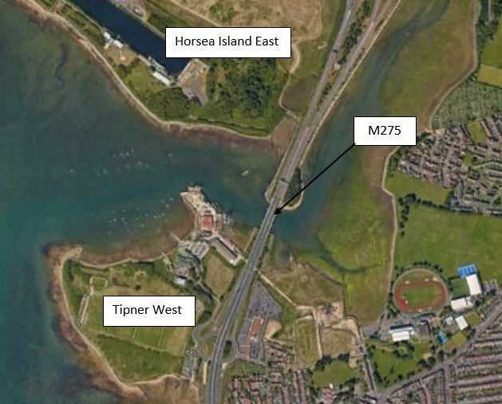
Purpose
PCC would like to engage across the breadth of the marine employment, advanced manufacturing sector and related supply chains. This engagement is planned to provide an update on the development proposals for the marine employment space and invite any interested parties to provide feedback, to achieve the following objectives:

- To raise awareness of this significant opportunity for the marine and maritime employment sectors;
- To understand which specific sectors of the marine and advanced manufacturing market would be interested in developing their business at the site;
- To test market appetite for the commercial delivery options (e.g. supply chain/businesses in the marine sector, main tenants, developers and/or investors, potential operators of the marine hub/boatyard etc.); and
- To seek feedback on specific requirements to help shape the concept development proposals.

Please read this document in full before responding as completely as possible to the questionnaire.

Preamble
This market sounding does not form part of any regulated procurement process. Any comments, indications of interest, participation or non-participation by a supplier prior to the commencement of a procurement process will not influence the selection and/or award decision forming part of any future procurement process, nor will they be taken as a supplier’s committed position. For the avoidance of doubt, this questionnaire is not a call for competition.

All responses will be carefully considered and taken into consideration when finalising our strategy but will not bind PCC to any particular approach to the procurement. PCC reserves the right to amend the strategy at any time.

Information within this document remains the property of PCC and may be used only for the purpose of informing a response to this market sounding exercise. By agreeing to complete this questionnaire, you and your organisation also agree:

To refer any communications received from third parties regarding the content or participation in this market sounding exercise to the PCC Team, email business@lennoxpoint.com.

Not to make any public statement in relation to the consultation without the prior written approval of PCC.

PCC will treat all information provided by potential suppliers in confidence. Any personal data supplied to PCC as part of the survey (including third party communications about the survey forwarded to PCC) will be processed in accordance with PCC Data Protection privacy notice: Data Protection privacy notice - Portsmouth City Council.

If you do not wish to be involved in this exercise, then please contact us to let us know.

Lennox Point Marine Sector Proposals
The Lennox Point development at Tipner West will include a comprehensive, ‘regionally significant’ marine employment hub that will support the identified growth potential of the Solent’s marine, maritime and advanced manufacturing sectors.

The marine sector employment proposals of the Concept Masterplan include the following components:
- Minimum 9.5Hectares site area
- Major boat lifting facility (in excess of 600-700 tonnes)
- Deepwater access channel at a minimum 3m below Chart Datum providing all-tide access
- Generous open yard storage areas, located on Tipner West site complimented by large boat sheds and a range of marine employment premises – workshops, offices, stores etc.
- Secondary marine employment space for a range of supply chain uses on the Horsea Island East site
- Maritime campus providing facilities for research, training and skills focused on the marine and maritime sector.

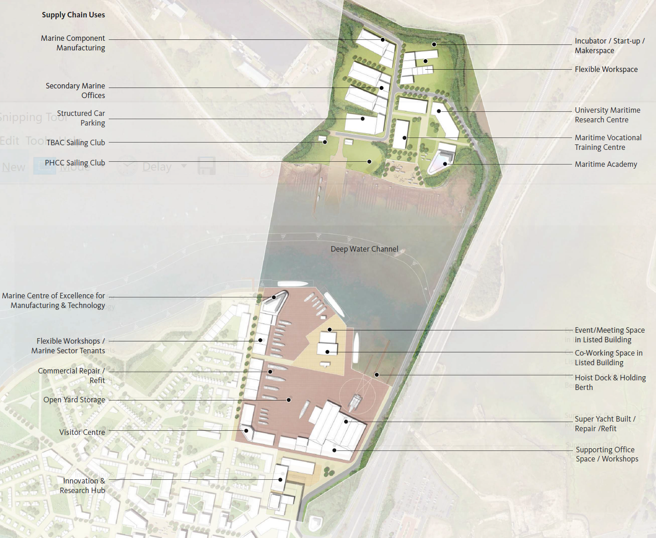
2 Concept Marine Sector Proposals

The target for marine employment floorspace derived from an assessment of the sector’s need is some 58,000m² (excluding the maritime campus). The current breakdown of employment floorspace provided by the Concept Masterplan as it relates to the marine employment site is described further below.

Tipner West
The main marine employment component is focused on Tipner West taking full advantage of the natural shelter from prevailing winds and being positioned adjacent to the M275 motorway. The existing access channel serving Tipner Point will be dredged to provide deep water and all-tide access, connecting to the deeper water in Portsmouth Harbour. The basin area immediately to the west of the M275 Motorway bridge provides berthing and a hoist dock from where a large vessel lift-out facility will be deployed for vessel lift-out and relaunching. This facility is the key ‘access to water’ function that underpins the marine employment proposals for Phoenix Quay.

Importantly the boatyard includes a significant area of open yard space around 4Hectares that, it is envisaged, will be vital to the expansion of marine employment activities and businesses. This yard space will support boat storage for short-term, medium term and long-term projects, with the additional flexibility to deal with a range of activities, enhancing the reputation and attractiveness of the site to both major marine businesses and supply chain activity.

The Concept masterplan currently identifies a total floorspace of 27,700m² of employment space on the Tipner West marine employment land. The envisaged mix of marine employment property includes:
- Boatsheds
- Workshops/light industrial units
- Stores
- Offices

Horsea Island East
There are two major marine employment components on Horsea Island East:
- Supply chain uses (Warehousing/manufacturing; offices; incubator space); and
- Maritime learning campus (Research; training; maritime skills academy).

The Concept Masterplan identifies a total floorspace of marine employment space on the Horsea Island East land amounting to 31,000m², note this excludes the education and skills campus in the south east corner of the site.

Development programme
The design development and consent phase for the overall development is anticipated to extend through 2023 with a commencement on site in 2024. The overall development programme is likely to extend to around 10 years. An extensive element of the marine employment proposals is envisaged to be delivered in the first phase, i.e. 2024/25.

Development and Operation
PCC has an open mind with respect to the development and operation of the marine employment proposals. One option is for PCC to develop and operate and at the other end of the spectrum would be keen to hear from parties interested in taking on the development opportunity and/or operations.

A range of commercial delivery options also exist for individual businesses (e.g. supply chain businesses in the marine or advanced manufacturing sector, main tenants, developers and/or investors, potential operators of the marine hub/boatyard etc.)

Freeport and Enterprise Zone Status
The marine employment proposals at Lennox Point sit within the recently announced Solent freeport bid area and it is anticipated that the site will benefit from a reduced tax and regulation zone once the full details of the freeport status are confirmed.

Feedback Request
Input and feedback is requested in relation to the proposals described herein and we would be grateful for your consideration of the survey at the following link:
https://www.smartsurvey.co.uk/s/LXPMarineMarketSounding/ .

It is recognised that the comprehensive nature of the proposals and the diverse requirements of the potential businesses that might be attracted to the marine employment hub will vary considerably and we understand that not all questions will be relevant to your particular business and interest. Where questions are not relevant please proceed to the next relevant question.

Please submit your completed response form by 1700hrs (BST) on Tuesday 29 June 2021.

PCC may use the information provided to invite organisations to attend a one-to-one meeting to further understand the appetite and feedback of parties. Your confirmation of interest in attending a follow-up meeting is included within the survey.

