Decision Making
Who is the guidance for?
In 2020, the NFCC’s Community Risk Programme (CRP) through its Definition of Risk (DOR) project, delivered a national definition of risk, a glossary of risk-related terms and a conceptual risk framework for the UK Fire and Rescue Service, to help bring national and local consistency to community risk management planning.
According to the CRMP Approved Fire Standard, fire and rescue services must:
Make decisions about the deployment of resources based on the prioritised risk levels and planning assumptions involved. This should be carried out with consideration to internal and external resource availability (people, financial and physical) including collaborative, cross-border and national resilience assistance. Consideration should also be given to other strategic influences such as consultation feedback, stakeholder engagement and political objectives
In 2020, the NFCC’s Community Risk Programme (CRP) through its Definition of Risk (DOR) project, delivered a national definition of risk, a glossary of risk-related terms and a conceptual risk framework for the UK Fire and Rescue Service, to help bring national and local consistency to community risk management planning.
It is important to note that the whole CRMP is underpinned by three key themes that should support, influence, and inform each individual component throughout the whole process:
- Data and Business Intelligence.
- Equality / People Impact Assessment (EqIA).
- Stakeholder and Public Engagement.

These themes should be utilised to ensure each component within the process has been developed using a broad range of community and organisational intelligence, and links are made throughout this guidance.
Individuals within a Fire Service who work to develop a CRMP may differ between fire services and may differ from one cycle of CRM planning work to the next. With these acknowledgements in mind, a series of competency frameworks have been developed which aim to clearly articulate the requisite competencies (behaviours, skills, knowledge, experience, and techniques) required to undertake CRM planning. Within the competency frameworks the requisites are outlined for strategic level staff members, as well as risk analysis and implementation level staff members.

Overview
Decision-making is the process of making decisions about whether to change or maintain controls on the risk.
Prevention, Protection and Response are recognised broad types of control within the fire and rescue service. They help to express the various types of control activities that the Service needs and help to explain how and why resources are being deployed. In many fire and rescue services, ‘Prevention’, ‘Protection’ and ‘Response’ are also organisational units with their own relationships to different aspects of risk. This could be the structure used to assign owners to risks. This helps community risk management planning by putting accountability for decisions about controls within these organisational areas.

Risk Evaluation / Decision Criteria
Benchmarks that define the significance of the risk analysis process, determined by the levels involved and overall organisational risk appetite.
Risk Evaluation
Comparative terms, such as “high risk”, “medium risk” or “low risk” are different evaluations of the risk level. Such evaluations can only be made by combining specific risk measures and risk criteria in a specific context. To be clear, the relevant risk metric and context should be specified, e.g. “high risk of fire for a multi-storey office in London”.
Risk evaluations are highly context-sensitive. Hence there is no such thing as “high risk” in general. Risk evaluation will be informed by the fire services operating context and strategic objectives outlined the CRMP Scope. Nevertheless, there are a few commonly used risk measures and risk criteria, which are valid in many contexts. One such set was defined by the HSE for industrial safety. Instead of high, medium and low risk, it uses the terms intolerable, tolerable and acceptable risk.
Decision Criteria / deciding controls.
This is the step in the process where decisions are made about allocating resources to maintain or change controls based on decision criteria.

Decision criteria are the ‘benchmarks that advice on cost/risk/benefit tradeoffs. When selecting controls, the direct and associated costs and benefits should be considered, along with any disadvantages. Consider too, the potential for a control activity to replace a current, perhaps less efficient, one. You should consider questions such as:
- what physical assets do we need, and where?
- what skills and competencies do we need, and where?
- do we need access to specialist resources?
- what organisational systems do we need?

See the Economic and Social Value of UK Fire and Rescue Services for the valuation of various protection, prevention, and response controls.
Decision Criteria is distinctly linked to the Fire Data Lifecycle (see Data and Intelligence guidance)’, with the effective allocation of resources to reduce community based on up to date, relevant and credible data. Data informs decision making, but those who make the decisions are not always those who analyse the data. Data is used to advice those who make the decisions about the content of the CRMP so cross-team, cross-function and cross-organisational working will be essential.
Importantly, the DoR Report (forthcoming) states that modern risk assessment typically recognises that statistics of past incidents do not fully capture risks, and that subjective views can be a valid input to a risk assessment. Decision-makers should therefore bear in mind that perceived risks, which might include other definitions of risk or prioritise other risk metrics, might lead to different conclusions. If appropriate, these differences can be explored through sensitivity tests. Other differences can be explored through social scientific studies of risk perceptions and subjective views about risk-based decisions.
Controls are not necessarily always about reducing the likelihood and consequences of the hazardous event. While a fire and rescue service will not plan to increase risk to gain benefits, as commercial organisations may do, it does make complex trade-offs that may increase one type of risk while reducing another. For example, allowing small risks to increase to free up resources that can be used to reduce larger ones.
This means that community risk management planning needs to consider a wide range of control activities that are required. Therefore, this may mean considering equipment and asset needs, people and competency needs, and about how to work with partners and other agencies. Selecting the most appropriate control involves balancing the costs and efforts of implementation against the benefits gained. Legal, regulatory, and other requirements such as social responsibility and the protection of the environment should also be considered. If risks have been assessed as unacceptable, the decision criteria may require control regardless of cost.

When selecting to maintain or change controls, the values and perceptions of stakeholders should be considered and the most appropriate ways to communicate and consult with them. Where controls can impact on risk elsewhere in the Service, or with stakeholders, these people should be involved in the decision when time permits.

Though a range of possible controls might be equally effective, some might be more acceptable to some stakeholders than others. However, CRMP decision making is likely to be taken by a person or organisation outside of the FRS that was not responsible for undertaking the consultation (see the Community Risk – Stakeholder and Public Engagement Guidance). The decisions are likely to be based on a recommendation from the FRS. rather any decisions-making papers should be submitted once the consultation report has already been published and decision makers have had sufficient time to consider the findings.

Plan the Deployment of Further Controls
These are measures that maintain or modify a risk, including preventative and management controls. When additional controls are required, an assessment should be made to identify if any further hazards have been created that need to be mitigated.

This stage is planning the deployment of resources for community risk management (although the actual deployment, i.e., the implementation of the resources, is part of ongoing service management). The plan should state the priority order in which controls should be implemented and resources deployed.
The risks are not modified until controls are implemented and resources deployed. The deployment plan should set out how the controls will be implemented. It should include:
- the reasons for the selection of the controls, and the expected benefits to be gained.
- those who are accountable for approving the plan and those responsible for implementing it.
- specific actions,
- resource requirements including contingencies.
- performance measures and constraints.
- reporting and monitoring requirements.
- timing and schedule.
- any necessary expenditure authority.

Deployment plans should be integrated with management processes and discussed with appropriate stakeholders. Decision makers and other stakeholders should be aware of the nature and extent of the residual risk profile after the deployment of resources. This should be documented and subjected to monitoring, review and, where appropriate, further control or resources might need to be applied.
The deployment plan itself might generate risk, particularly if it involves physical or procedural modifications to existing arrangements, or it has implications to certain stakeholders. Therefore, it should be considered for risk assessment, and modified if necessary.
The scale of work involved in some resource deployment might warrant the development of specific projects. These should be managed in accordance with recognised project management methodology, and therefore provide all the appropriate project management rigour.
Relevant stakeholders should be kept informed of progress with resource deployment. This might include making some monitoring information available.
It is worth noting that some factors can prevent immediate or prompt deployment of resources, such as:
- a need for consultation with stakeholders likely to be affected
- the time required to plan the detail of the control and then obtain budgetary approval
- reliance on the same workforce to implement several controls.

Example: fires in a built environment
Below is the diagrammatic presentation of the links between risk analysis links to specific risk groups (in this example it is societal risk) and the subsequent decision making, and possible controls mapped to the risk evaluation.

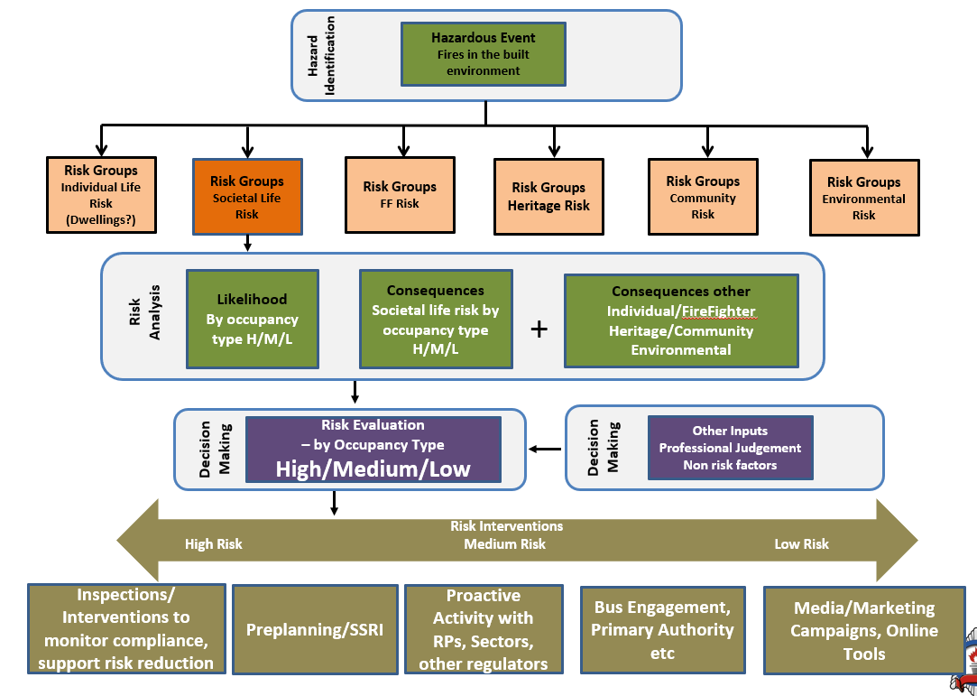
The diagram below provides examples of potential intervention decisions mapped to the broader controls for each risk group:
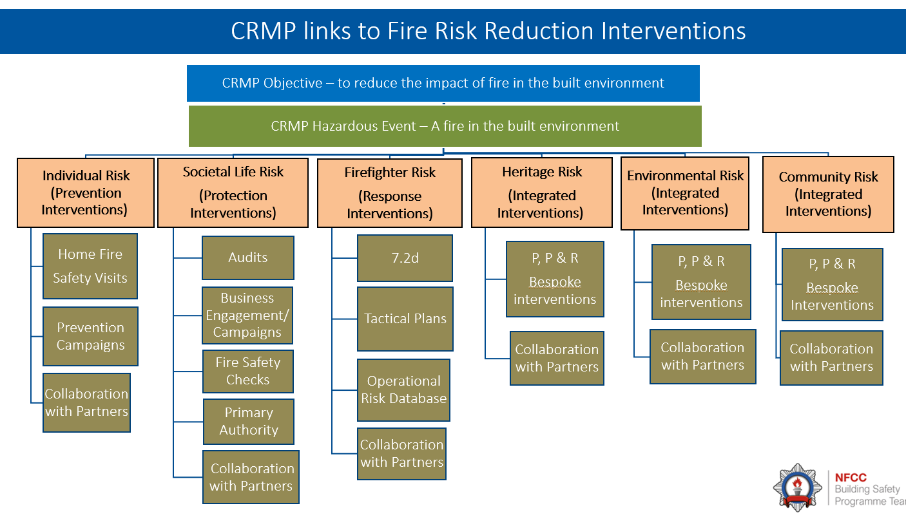
Any control decisions needs to fully considers and understands the needs and expectations of diverse communities and groups - see the Equality and Impact Assessment guidance

